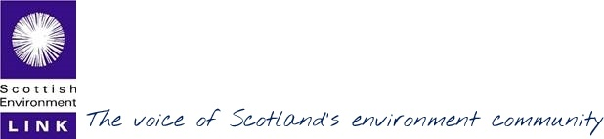
Annual Report Summary April 2017 to March 2018
Full Annual Report and Accounts here
Scottish Environment LINK is the forum for Scotland’s voluntary environment organisations representing a range of environmental interests with the common goal of contributing to a more environmentally sustainable Scotland.
Member organisations 2017-18
Amphibian and Reptile Conservation  Association for the Protection of Rural Scotland  Badenoch & Strathspey Conservation Group  Bat Conservation Trust  British Ecological Society – Scottish Policy Group  Buglife – the Invertebrate Conservation Trust  Bumblebee Conservation Trust  Butterfly Conservation Scotland  Cairngorms Campaign  Friends of the Earth Scotland  Froglife Trust (Scotland) | Hebridean Whale & Dolphin Trust  Marine Conservation Society  National Trust for Scotland  North East Mountain Trust  Nourish Scotland  Planning Democracy  Plantlife Scotland  Ramblers Scotland  RSPB Scotland  Royal Zoological Society of Scotland  Salmon & Trout Conservation Scotland  SCAPE Trust  Scottish Allotments and Gardens Society  Scottish Badgers | Scottish Campaign for National Parks  Scottish Countryside Rangers’ Association  Scottish Farming and Wildlife Advisers’ Group  Scottish Geodiversity Forum  Scottish Raptor Study Group  Scottish Wild Beaver Group  Scottish Wild Land Group  Scottish Wildlife Trust  Soil Association Scotland  Trees for Life  Whale and Dolphin Conservation  Woodland Trust Scotland  WWF Scotland

Strategic Theme 1 - A Sustainable Scotland
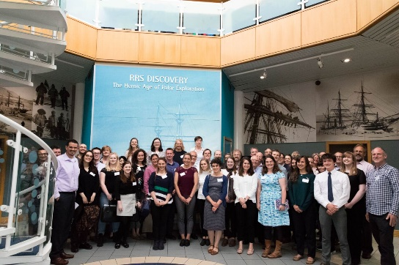
The risks posed by Brexit remained top priority with LINK’s contributions on Brexit process planning at UK and Scottish levels focussed on securing the principles, policies and structures that we need for a positive future. At the June 2017 Sea Scotland Conference we heard the Cabinet Secretary reaffirm Scottish Government’s commitments not to roll back environmental protections post-Brexit, and acknowledging the important contribution and relevance of environmental NGOs.
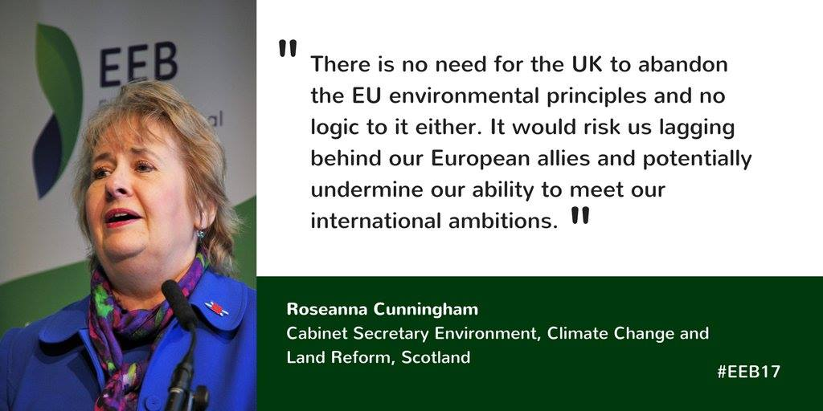
Changing Landscapes, the conference which LINK co-hosted with the European Environment Bureau in November 2017 was an opportunity for Scotland to showcase its environmental credentials at a European level, and to explore with stakeholders across the UK and EU how, collectively, we can continue to pursue ambitious environmental policy at a time of change.
LINK’s engagement with the Scottish Parliament’s Legal Continuity Bill during its three-week passage in March 2018 helped to ensure that environmental principles missing from the tabled Westminster Bill were included in Scottish legislation, and secured a commitment to robust environmental governance measures in Scotland. LINK anticipates new legislation to fulfil these commitments and is ready to engage.
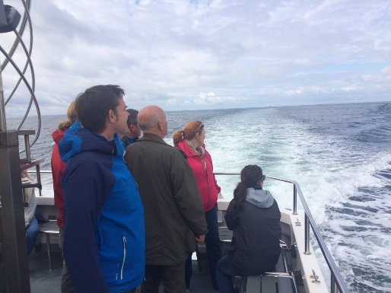
In January, Government committed additional resources to develop 4 new Nature Conservation Marine Protected Areas, including for mobile species - basking sharks, Risso’s dolphins and minke whales.
This budgetary intervention was inspired by a boat trip for MSPs from the Environment, Climate Change and Land Reform Committee which LINK organised in summer 2017 to raise awareness of the importance of MPAs.
Plans to establish an environmental rights centre in Scotland to broaden understanding of legal rights, give access to legal remedies and affordable legal services have been taken forward following publication of the feasibility report.
LINK’s contributions to the review of the National Performance Framework led to improved environmental outcomes and indicators. We continue to press for sustainable development to be the purpose of the NPF.
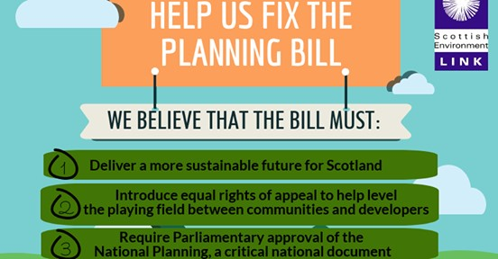
LINK contributed to and welcomed progressive initiatives from Government including the moratorium on fracking, plans for a Just Transition Commission and a Scottish National Investment Bank, all measures that could help move Scotland onto a lower carbon path.
LINK members were extremely disappointed with the proposed measures in the new Planning Bill as presented to Holyrood in December. LINK has been working with MSPs to improve it and to counter measures that are detrimental to the role of land use planning for sustainable development. These concerns are shared by MSPs from across all opposition parties.
Strategic Theme 2 - A Strong Voice for Scotland’s Environment
LINK continued its strong engagement at Scottish, UK and EU levels to ensure environmental protections are not weakened or lost as a result of Brexit. Although navigating and influencing the Brexit process has been hugely demanding, LINK has focussed its advocacy on the wider environmental agenda.
LINK continued to mainstream environmental issues across the Scottish Parliament, providing evidence to a variety of Parliamentary Committees: Rural Economy & Connectivity; Public Audit & Post Legislative Scrutiny; Finance & Constitution; Delegated Powers & Law Reform; Economy, Jobs & Fair Work; Local Government and Communities; Justice; as well as to the Environment Climate Change & Land Reform Committee, on issues ranging from many aspects of the Brexit process, through biodiversity, planning, civil litigation, to the National Performance Framework.
On other fronts LINK articulated the breadth of support for more sustainable land use practices, encouraging greater join up between policies and economic drivers to align better with our collective ambition to reach UN Sustainable Development Goals. We held a joint workshop with Scottish Land & Estates on the future of farming and coordinated an open letter to Government from 50 NGOs, farmers, rural groups and academics, urging action that can be taken now towards climate-neutral farming, and commissioned a public poll assessing public attitudes about how future public subsidies should be targeted. We coordinated public e-actions to MPs on Brexit and the environment and to MSPs on the Planning Bill.
Funding for the environment is a growing concern. Our Fundraisers’ Forum joined forces with the Environmental Funders Network in December for the launch of Where the Green Grants Went: Scotland, a report commissioned by the William Grant Foundation, to which LINK and members contributed. The stark gap which the report shows between Scotland and the rest of the UK in funding for environmental improvements is a challenge we will address together.
Much of LINK’s strength of voice is directed via participation in a wide range of stakeholder groups, many sponsored by Government. With regret, we resigned from the Cleaner Air for Scotland Governance Group, due to its ingrained lack of ambition, after two years of close engagement and so as not to lend environmental credentials to a process failing people and the environment. In this case members agreed, more could be achieved outside of it.
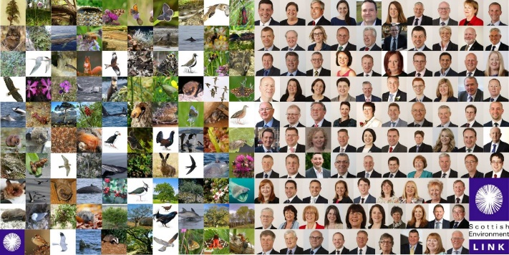
LINK’s Species Champions initiative is proving to be key in amplifying support for and awareness of the environment at strategic level. We now have over 100 MSP Champions in Parliament, speaking up for their chosen species and their needs in policy terms. Many Champions have committed to positive actions for their species over the summer of 2018.

Strategic Theme 3 - An Effective, Efficient & Accountable Network
LINK’s contributions to public policy and its implementation through its Groups on Governance, Economics, Marine, Land, and Planning has beneficially influenced legislation and public policy. We know from our assessments of the impact of overall effort, that there is growing awareness of the cross-cutting nature of environment and sustainability, some areas are farther ahead than others. We continue to develop our case, make best use of membership diversity, and make common cause with others.
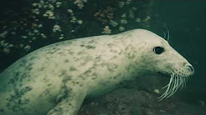
In November 2017 we celebrated 30 years of LINK, with a fabulous ceilidh and supper including many of our founders and European friends in Scotland for the Changing Landscapes conference.
This video (left) was made to capture the spirit of the network and perspectives on what three decades of member organisations working together has achieved.
LINK had very good news from charitable trusts this year in support of core services (from the William Grant Foundation) continuation of marine work (from the John Ellerman Foundation) and for a new project on the circular economy (from the Friends Provident Foundation from April 2018). The Esmée Fairbairn Foundation has awarded a grant (from summer 2018) to increase advocacy capacity during the crucial years of Brexit. We thank Scottish Natural Heritage and Scottish Government too for their continued support of core services and Scottish Government and Agencies for support with the Changing Landscapes conference and associated EEB events held in November.
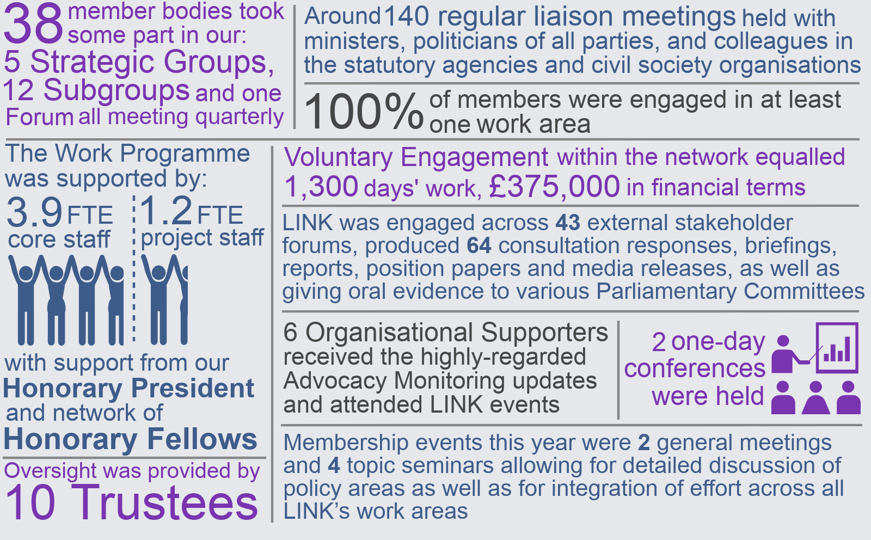
Financial Summary

LINK’s work is underpinned by the subscription income, additional financial contributions and voluntary time from member organisations, which together account for 62% of all contributions.
Thanks to all of LINK’s core and project funders over the period.

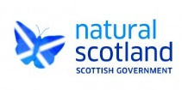
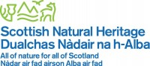
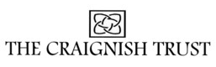

You will find the full Annual Report and Accounts on our website

