11 May 2017

Mr Murray Ferguson
Director of Planning and Rural Development
Cairngorms National Park Authority
14 The Square
Grantown on Spey PH26 3HG

Dear Murray,
Hilltrack in Glen Clova
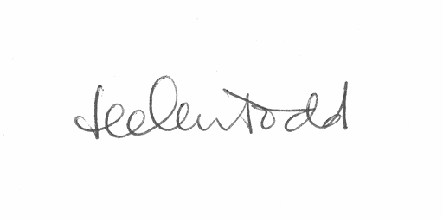
I am writing on behalf of the LINK Hill Tracks Group regarding a track which has appeared to the north east of the Glen Clova Hotel. Although we are not certain of the date of the construction of this track, one of our contacts says they think it is very recent indeed; certainly our monitoring of tracks since Prior Notification came in has not picked it up. As you will see from the attached photos the track has a significant detrimental visual impact on the hillside even when viewed from low in the Glen.
A small scale hydro project in the exact vicinity was approved by the Park in 2010 (09/117/CP). The papers on the website for this project say little as to whether a track would be required for construction. There isn't a construction method statement posted on the website but condition 4 of the Decision Notice refers to the need for an addendum to the construction method statement addressing, amongst other things, 'temporary tracks and proposals for restoration'. In addition, Condition 15 refers to the need for a 'scheme of landscaping and restoration'.
Was this track constructed to facilitate the creation of the hydro scheme? If so, given that the hydro scheme is very small and the planning conditions refer to temporary tracks, we assume that it should be removed. If this is the case, what is the timescale for its removal?
If it isn't for the hydro scheme, it should have required full consent or been submitted as a Prior Notification. There are grouse butts in the area and we think it would be difficult to justify a track there for agricultural purposes as it would seem very easy to deal with any sheep on that hillside without a track. If it has been created without the required permissions, we think the Park should insist on its complete removal as it is an unacceptable visual intrusion at the point where visitors approach the wilder part of the glen.
Thanks for your help in this matter and I look forward to hearing from you.
Yours sincerely

Helen Todd
Co-convener, LINK Hilltracks Group

