Nature in Scotland – ‘Agreeing the Evidence Base’
A Short Paper to inform Scottish Environment LINK-SNH discussions, November 2018

There is only mist, wind, rain, the cry of the curlew and the slow clouds above damp moorland. That is the real Scotland.
H. V. Morton
The bald unpalatable fact is that the Highlands and Islands are largely a devastated terrain, and that any policy which ignores this fact cannot hope to achieve rehabilitation.
Frank Fraser Darling, West Highland Survey, 1944.

INTRODUCTION
This short paper aims to frame and inform discussions between Scottish Environment LINK and SNH in relation to the future of biodiversity conservation, its funding, and how the eNGO sector and the government family in Scotland can coordinate more effectively in future.
Below we outline our understanding of discussions and issues raised over the last year or so. We hope the meeting on 8 November will provide more opportunity for clarification.
LINK members value the work of SNH as the key Scottish agency helping to deliver conservation projects and to protect and enhance nature, alongside developing evidence bases and providing advice for policy-making. We are therefore keen to explore these issues in a constructive way and come to a mutual understanding.

BACKGROUND
There has been a series of meetings between LINK representatives and senior SNH staff through 2018, which LINK appreciates.
In these meetings, a key LINK request has been for a shared dialogue on and approach to strategic arrangements for biodiversity in Scotland post-2020.
The SNH response - notably via very clear statements by Sally Thomas at the 2018 SBS Stakeholders’ Conference – indicates that before that dialogue can develop, from the SNH perspective, we must ‘agree the evidence base’ as a pre-requisite.
That condition partly stems, as LINK understands it – though we’d welcome any correction or clarification – from the concerns voiced by the Scottish Parliament Environment Climate Change and Land Reform (ECCLR) Committee about the “difference in tone” between SNH reports on biodiversity in Scotland, and the State of Nature report.
The State of Nature (SoN) report is a triennial publication produced by a broad coalition of eNGOs across the UK. There have been two reports to date, 2013 and 2016, and the next is being drafted now, due for publication in 2019. It includes an overall UK assessment of the state of species and habitats, with dedicated sections for each of the UK countries. The report pools data and expertise from more than 50 nature conservation and research organisations to give an overview of the state of nature in the UK and in its seas, Crown Dependencies and Overseas Territories.
SNH staff have been invited to, attended, and have contributed to, SoN Partnership meetings in 2018 (David O’Brien is the representative). David has outlined SNH’s concerns at the previous SoN reports and their construction and has provided some helpful points of detail on specific areas of contention (see below).

Evidence and science-based policy-making
LINK members believe that evidence-based and science-led decision-making are and should remain core principles shared across ENGOs, NDPBs, agencies and Scottish Government.
However, there have been concerns among LINK partners, at several past junctures, at a perceived tendency among NDPBs and agencies in Scotland, including SNH, to over-emphasise the ‘successes’ when reporting on trends in biodiversity. Areas where greater effort is needed to meet stated goals receive less emphasis, sometimes without proper analysis of why results have fallen short of expectations or what will be done to address this. This runs counter to the aforementioned core principles.
For example:
- SNH reporting on protected area condition under the National Indicator ‘proportion of Scotland’s protected sites in favourable condition’:
The SNH assessment now amalgamates features assessed as being in favourable condition, with ones that might become so in future (‘unfavourable recovering’ and ‘unfavourable recovering due to management change’ - URDTM).
This makes a significant difference to the indicator. In March 2018, the proportion of features publicly reported as being in favourable condition was 79.7%. However, the proportion of features that had a current favourable assessment was just 66.2%. Some form of remedial management has been undertaken on the remainder, but this is not, as is the underlying assumption, any guarantee of a future favourable assessment. SNH data show that over the past four years less than half of features placed in the URDTM category have in fact reached recovering (let alone favourable) status.
We are concerned that this approach may have similarly compromised Scotland’s reporting against Aichi target C11 (protected areas). The last interim assessment (see further comments below) reports this target as being exceeded.
However, the above concerns pertain; the proportion of features reported as in favourable condition has declined since 2007; and it is, in our view, unsafe to assume that the other ‘tests’ of Target C11 (effective and equitable management, ecological representativeness and connectivity) are being met, as in the assessment report – particularly given the delay in progressing the 2016 SPA Review recommendations.

- Shifting baselines:
Another way in which government and agency communications have sometimes, in LINK partners’ views, obscured ecological realities of longer-term declines in the state of our environment, is through ‘shifting baselines’: for example, trends in Scotland’s Natural Capital Asset Index were originally generally portrayed as in figure 1a; more recently however, the standard graphic presented by SNH is as in figure 1b:
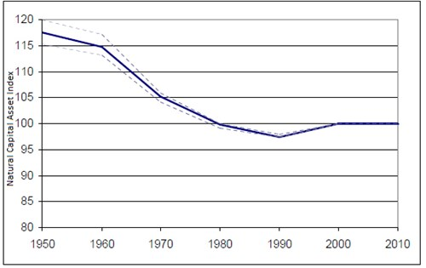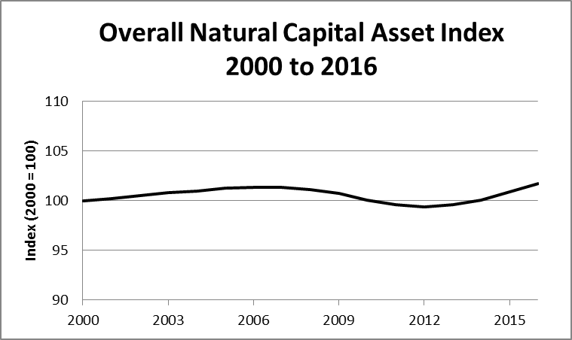
Fig. 1a Fig.1b
A key tension in this regard is that for statistically simple and straightforward investigation of trends, strictly coherent, comparable and consistent runs of data are undoubtedly best. We understand this logic may be invoked to justify the NCAI ‘shifting baseline’.
However, if we restrict biodiversity trend analyses to those with strictly consistent data runs alone, they will unavoidably always tend to derive from relatively short series of data, with relatively recent start dates.
Ecological processes and trends that occur – as many do – over decades or even centuries are then simply missed - and become invisible to policy makers. To compound that effect, moreover, shorter data runs have intrinsically less statistical power to detect trends.
SNH have criticised the SoN approach as ‘incorporating advanced analytics of ad-hoc records’ rather than a straightforward trend analysis of strictly time-series analogous data runs. The SoN approach is necessary, however, to allow the data that is available to reveal the ecological realities of wildlife trends at the relevant and appropriate timescales. That data needs to be analysed carefully, sometimes using advanced techniques, to reveal the trends. We find this criticism odd, as we would have expected SNH to welcome new and valid analytical developments that allow best use to be made of less systematic collections of biological records.

- Day-to-day practice:
These LINK concerns about larger-scale reporting have on occasion been compounded by day-to-day operative approaches that again, in our view, may over-accentuate positives. In 2017 reporting against Scotland’s Biodiversity Route Map, for example, a request went out from SNH to lead partners on the key projects, with a short note at the end saying: “If I do not hear back from you by 17th February 2017 your actions will be recorded as either on target or met/exceeded”. We approached SNH requesting that this be changed so that when no report is received by the deadline the progress report would simply record “No new update to report”. Our suggestion was adopted, for which we are grateful – but there remains a residual unease among the eNGO sector in this regard.
In summary:
ENGO unease stems from the risk that the positive emphasis sometimes adopted to highlight ‘successes’ may result in failure to properly recognise the strategic imperative to do better for biodiversity in future. For example, the SNH Aichi report concluded that Scotland is meeting only 7 our 20 targets, with 12 targets requiring more action and one (on funding) moving away from target. The press release accompanying the report led with the statement “Scotland leads the way in international nature targets”.
As such, a positive emphasis on ‘successes’ alone without this being tempered by other evidence revealing a more sobering reality risks becoming accepted and reflected in forward strategies, public policy and budgeting, potentially to the long-term detriment of national biodiversity. Thus, the recent Scottish Government discussion paper ‘Developing an Environment Strategy for Scotland’ pays credit to the rich, diverse and unique character of Scotland’s natural heritage - but it fails, in our view, to properly acknowledge long term losses and the crisis that many of these species, habitats and landscapes are in.

SNH concerns on State of Nature report
At the same time, SNH’s recently expressed concerns at the previous State of Nature Reports appear to centre on a perception of an over-emphasis on reporting underperforming or failing biodiversity indicators by the eNGO partners in SoN reports. Specific concerns raised by SNH include: a lack of clarity on methods used in the SoN report; transparency on data sources and the application of statistical confidence; insufficient allowance and recognition of species where no significant change is recorded. We understand that these and other concerns are under discussion and resolutions are being sought.
As, we believe, an important step towards that resolution, and in addressing the wider issues at play in these discussions, the methods used in the State of Nature Report have recently undergone formal peer review and are now published in the scientific journal Ecological Indicators.
We hope this will improve the confidence with which SNH views the SoN report methods, findings and conclusions. We further hope that this will help provide SNH with greater clarity on the scientific basis and evidence used, and as such the wider relevance of the State of Nature Report. The result of this exercise should be greater understanding of the evidence and what this tells us, as well as implications for policy.
We would also note that even the SoN report methods are insufficient to fully capture the ecological change wrought in Scotland across centuries and millennia, as invoked by Fraser Darling in the quote at the head of this paper, and by numerous ecologists before and subsequently - expanding on Fraser Darling’s ‘bald’ statements, McVean & Lockie describe much of the Highlands as “an inherently infertile region devastated by deforestation and repeated burning, and then opened to heavy and uncontrolled grazing”. Such issues are most recently being invoked most recently in line with the ‘rewilding agenda’. This is a pertinent example of long-term biodiversity loss in Scotland which can never be fully captured at species levels by formal, quantitative approaches, including those adopted by the SoN report, and certainly not by relying solely on short, simple data series that extend back a few decades at most. LINK partners do not seek to frame our environmental ambitions in terms of wholesale reversion to post-glacial conditions in Scotland. Yet we emphasise that we must accommodate such long-term changes in our strategic thinking about the future of biodiversity in Scotland if we are to maximise the potential whilst avoiding the traps of shifting baselines and short-term assessments.

Next Steps
It is perhaps a natural tendency, deriving from the divergent functions and responsibilities of the relevant organisations, for environmental NGOs to emphasise areas of concern regarding species and habitats whereas, in contrast, government departments, NDPBs and agencies, being responsible to officials for those species and habitats, will be more inclined to emphasise policy ‘successes’.
We fully acknowledge however that this is not a simple dichotomy. SNH reporting is by no means always ‘overly positive’. Notwithstanding the protected areas target reporting and media work outlined above, the most recent Aichi Target Interim Report document is overall, in our view, an excellent example of accurate reporting from SNH, with the honest scoring against Target 20 (biodiversity funding) a particularly welcome element. LINK organisations in turn, of course, do seek to emphasise positives in nature conservation as and when appropriate.
LINK partners would appreciate, and stand willing to work towards, a more trusting relationship with SNH regarding evidence and how it is reported, not least for the strength of voice which that would create across the environment sector. The ‘evidence-base’ is a complex entity that can be viewed in multiple ways and with varying emphases. ‘Agreeing the evidence-base’ will therefore need to emerge as a dynamic part of a conscious and sustained dialogue, rather than as a hard SNH pre-condition on which such dialogue is predicated.
Indeed, we perceive that the dialogue has, in some ways, begun - with, for example, the very welcome verbal report on SNH thinking as we move towards 2020, given to the SBS Species and Habitats Action Group in early October. We will be interested to see whether and how the LINK views expressed at that meeting will be incorporated in the SNH process. Perhaps the SBS Science Support Group could be engaged in developing, informing and mediating that dialogue.
Whilst we see the prospect of a sudden, imminent and complete ‘agreement on the evidence base’ as perhaps a challenging aspiration, we certainly do still seek that strategic dialogue as we move towards 2020. The network - specifically the Wildlife Subgroup of LINK, which includes most of the LINK partners with a core focus on nature conservation - is aware of and concerned about the sharply reduced strategic involvement of non-government interests in the Scottish biodiversity process. We note the shift from a Scottish Biodiversity Committee, chaired by the Cabinet Secretary and attended by senior eNGO representatives, to the current arrangement whereby the final arbiter on biodiversity in Scotland is the Environment and Economy Leaders’ Group, which comprises entirely officials and agency/NDPB staff, with no direct eNGO representation.
If the future of biodiversity in Scotland, leading up to 2020 and beyond, is a shared concern and a collective endeavour, in which the role of science and evidence matters, we suggest that a more collective and mutually trusting approach needs to develop. Key funders such as the HLF, upon which we will all depend for future resources, are explicit that they seek coordinated and agreed approaches from the whole sector on our shared priorities. In such a multi-dimensional and intrinsically complex field as the environment in Scotland, this is a challenge. LINK is ready to enter the necessary strategic dialogue to meet it as a helpful and, in terms of delivery, arguably an essential partner – but one that remains deeply concerned about the increasingly negative impact humanity is having on the natural world, in Scotland and beyond.

LINK, October 2018

https://www.rspb.org.uk/globalassets/downloads/documents/conservation-projects/state-of-nature/stateofnature2016_scotland.pdf
We note, incidentally, that methods used in generating the NCAI have never, to our knowledge, been subjected to peer review for scientific publication (as the State of Nature Report methods have, see p3). We suggest it would be helpful were that to happen, especially if the index is to be utilised by policy makers in future.
https://www.climatexchange.org.uk/research/indicators-and-trends/indicators/nb14-natural-capital-asset-index/
https://www.nature.scot/professional-advice/planning-and-development/valuing-our-environment/natural-capital-asset-index
https://www.sciencedirect.com/science/article/pii/S1470160X18304746?via%3Dihub
McVean, D.N. & Lockie, J.D. (1969). Ecology and Land Use in Upland Scotland. Edinburgh: Edinburgh University Press
https://www.mcsuk.org/who-we-are/our-successes - https://e-sgire.org/events/2018/09/shiant-isles-recovery-project-celebrates-success/

