BRIEFING ON NPF/SCOTLAND PERFORMS AND RELATED AREAS

CONTENTS

Summary

1 Introduction

2 The National Performance Framework

3 The Wider Context
3.1 Sustainable Development and Sustainable Economic Growth
3.2 GDP and Beyond GDP
3.3 The System of National Accounts

4 Alternative Measures of Wellbeing and Sustainability
4.1 Assessing wellbeing
4.11 Quality of life indicator sets
4.12 Composite quality of life indicators
4.13 Indicators of subjective wellbeing
4.14 Modified economic indicators

4.2 Assessing sustainability
4.21 Ecological Footprint
4.22 Four Footprints
4.23 Natural Capital Asset index
4.24 Environmental Performance Index
4.25 Ecological Rucksack

4.3 Frameworks
4.31 Joint Task Force on Measuring Sustainable Development
4.32 NEF model
4.33 OECD Better Life Index
4.34 Oxfam’s Doughnut
4.35 ONS

5 Evaluation of indicators and initiatives

6 Flourishing Scotland
6.1 LINK Project objectives
6.2 Opportunities and challenges
6.3 Suggestions for work programme

ANNEX 1: Specification
BRIEFING ON NPF/SCOTLAND PERFORMS AND RELATED AREAS

SUMMARY

The aim of this paper is to brief LINK’s Economics Taskforce, to indicate opportunities for LINK’s Flourishing Scotland project and to increase the scope for LINK members to engage in the debate about the National Performance Framework. It will discuss the Scottish Government’s National Performance Framework and related issues of importance to LINK. The shortcomings of GDP as an indicator and possible alternative measures are reviewed. The paper concludes with some suggestions for LINK’s Flourishing Scotland Project.

The National Performance Framework, developed in 2007 and reviewed in 2011, is an ‘outcomes based’ tool to support the delivery of the Government’s vision and priorities. It is currently being reviewed by a Roundtable on which LINK sits. LINK would like the framework to more closely reflect the principles of sustainable development with more prominence given to environmental indicators and less emphasis placed on ‘sustainable economic growth’ and GDP. A briefing to that effect supported by bodies across the voluntary sector was submitted to the Roundtable in Feb 2014.

Although nearly universally used, GDP has many shortcomings as an indicator of societal success and the ‘beyond GDP’ movement has been gathering momentum in recent years. There are many initiatives that have developed alternative indicators or indicator sets to assess wellbeing which can be divided in to 4 main types:

- Quality of life indicator sets or dashboards.
- Composite quality of life indicators - aggregating these indicators into a composite social indicator of quality of life.
- Indicators of subjective wellbeing –measuring self-reported life satisfaction.
- Adjusted economic indicators - attempting to develop monetised accounts of the factors that affect wellbeing.
In addition, there are measures that attempt to give an indication of sustainability or future wellbeing. In order to appreciate the ‘whole picture’ for policy purposes it is necessary to use more than one of the above types of measure. There have been a few attempts to produce frameworks to illustrate the connections between resources, processes and wellbeing and the related assessments needed.

LINK’s Flourishing Scotland project aims are closely tied to reforming the NPF and how it is used. We await the outcome of the Roundtable to see to what extent the revised NPF meets LINK’s aspirations and represents a comprehensive framework for policy purposes.

Although we must continue to push along our NPF reform agenda, because of the sensitivity of the Roundtable, the Flourishing Scotland project could shift its advocacy focus to a more general ‘beyond GDP’ message. A clear message should be developed and responses to ‘tricky’ questions thought about. One to one meetings should continue and a media strategy needs to be developed. We also need to produce information for our members and decide how to engage them and build more consensus for change with the wider policy community.

1. Introduction

This paper is written as part of Scottish Environment LINK’s Flourishing Scotland Project. As outlined in the specification (Annex 1), this paper will provide an overview of the state of play regarding the development of the National Performance Framework and related issues of importance to LINK. It will give an overview of NPF, its development, revisions and current status, before exploring GDP, and its shortcomings, and other wider measures of wellbeing and societal success. Linking to this, the opportunities for achieving LINK’s Flourishing Scotland project objectives will be discussed and suggestions made with regard to the work programme, inputs needed and scope for LINK members to participate.

LINK’s Flourishing Scotland project evolved from a LINK report, published in 2012 Environment and the Economy; helping Scotland to Flourish http://www.scotlink.org/files/policy/PositionPapers/LINKHelpingScotlandFlourish.pdf which articulated LINK concerns with regard to the National Performance Framework.

2. National Performance Framework

The National Performance Framework (NPF) was developed by the Government in 2007 and updated in 2011. It is a tool to support the delivery of Scottish Government’s Purpose and priorities and is based on delivering outcomes that improve the quality of life for people in Scotland. The Framework sets out the Government’s ‘Purpose’ which is supported by 8 high level ‘Purpose targets’ and 16 ‘National Outcomes’, which together describe the Government’s aspirations for Scotland. Fifty ‘National Indicators’, covering areas such as health, justice, environment, economy, and education with associated measures provide a means to assess progress. It is a complex cross-cutting matrix with many parts of the framework relating to a range of other parts. It is considered an innovative tool that can be used to guide and evaluate policy and encourages partnership working across government.

Thus the NPF is of utmost interest to LINK. It has the potential to be a powerful tool to both guide policy making and hold government to account. If it were to reflect the emphasis and hierarchy of sustainable development and include robust environmental indicators, it could be instrumental in the shaping of policies to better address environmental concerns.

Although Scotland has received international acclaim for its NPF, there are weaknesses. The NPF was largely based on ‘Virginia Performs’, with no public consultation. Although there have been revisions to some indicators in consultation with other partners, the Framework lacks legitimacy and ‘ownership’ by the public. It has also been under-used within Government and by the Parliament. What’s more, in its current form, it is not delivering sustainable development. The wording of the ‘Purpose’, setting out the direction and ambition for Scotland, lays down ‘sustainable economic growth’ as the vehicle to a flourishing Scotland – ‘creating a more successful country, with opportunities for all of Scotland to flourish, through increasing sustainable economic growth’. This Purpose was set out in the 2007 Spending Review and has remained unchanged.

The Carnegie UK Trust looked in some detail at the NPF in the context of other initiatives and made several recommendations:
- The NPF be embedded in legislation and its use in policy making be reviewed;
- Government engage with the public and civic society in a refresh of the Framework, and
- The Framework is used to facilitate a holistic evaluation of wellbeing.

In 2013 the Scottish Government set up a Roundtable to revise the NPF. It is attended by MSPs, civil servants, academics and representatives from the Carnegie UK Trust, Scottish Environment LINK, New Economics Foundation and Oxfam. Notably, it does not include representatives of the business sector, a key player, which is a cause of concern. Three work streams have emerged:
- Engagement with Parliament (Budget scrutiny, embedding in legislation)
- Presentation and Communication (Website improvement and communication strategy)
- Improving indicators and participation (reviewing the scope of indicators and the need for consultation).

Work groups (dedicated to the three work streams) are due to report to the Roundtable in the late spring/early summer 2014. In February 2014 LINK submitted a briefing ‘Revising Scotland’s National Performance Framework’ to the Roundtable, supported by 37 organisations, including Oxfam, STUC, Church of Scotland. It called for the government to remove the reference to ‘growth’ from its purpose and to replace the purpose targets to reflect the range of social, environmental and economic factors that underpin our long term prosperity. The Briefing was welcomed by the Roundtable and they are considering its recommendations.

3. The Wider Context

What is sustainable economic growth and how does it relate to sustainable development? What does GDP actually measure, what are its shortfalls and what are the alternatives? The following sections will elaborate on these themes.

3.1 Sustainable Development and Sustainable Economic Growth

Sustainable development is an organizing principle for human life on a finite planet. It is based on a desirable state for human societies in which living conditions and resource-use meet human needs without undermining the sustainability of natural systems and the environment, leaving them intact for future societies. The term sustainable development rose to significance after it was used by the Bruntland Commission in its 1987 report Our Common Future, which defined sustainable development as: ‘development that meets the needs of the present without compromising the ability of future generations to meet their own needs’. The concept began to pervade policy after the United Nations Conference on Environment and Development in Rio in 1992, initially through the Rio Declaration and Agenda 21. More recently, five principles have emerged as the basis of sustainable development: living within environmental limits; ensuring a strong, healthy and just society; achieving a sustainable economy; using sound science responsibly; and promoting good governance. There is also a hierarchy as shown in the diagram, with the economy, science and governance serving the aims of a healthy society whilst keeping within environmental limits. The Scottish Government is signed up to these
principles.

Taken from: One Future Different Paths - The UK Shared Framework for Sustainable Development

‘These principles will form a basis for sustainable development policy in the UK. For a policy to be sustainable, it must respect all five principles. We want to achieve our goals of living within environmental limits and a just society, and we will do it by means of sustainable economy, good governance, and sound science.’

As mentioned, the main Purpose in the National Performance Framework lays down sustainable economic growth as the path to a flourishing Scotland. The Scottish Government defines sustainable economic growth ‘as building a dynamic and growing economy that will provide prosperity and opportunities for all, while ensuring that future generations can enjoy a better quality of life too.’ The Governments Economic Strategy details how the Government will deliver its commitment to sustainable economic growth and the Purpose Framework shows the key drivers of this growth (productivity, participation and population) and the key characteristics (solidarity, cohesion and sustainability) linked to deliver balanced sustainable growth alongside important social, regional and inter-generational equity objectives. The Government sees the Economic Strategy as sitting within the framework of sustainable development.

LINK has consistently argued against the use of the term ‘sustainable economic growth’, saying that it is confusing and ambiguous.

3.2 GDP and Beyond GDP

GDP is the aggregated added value of all the production in an economy, as reflected in market prices, and as estimated/imputed for public services. The System of National Accounts (SNA) provides an internationally agreed standard of how to compile measures of economic activity.

There are three ways of calculating GDP, the income, output and expenditure methods. All should sum to an identical amount. In Scotland, data from 300 separate indices are collated, and then aggregated to form a weighted quarterly index of ‘gross value added’ (GVA). At a regional level, GVA is the output measure used and differs from GDP as it measures output at basic prices rather than market prices, i.e. GVA does not take subsidies and taxes into account.

Gross National Product (GNP) measures what is produced by enterprises owned by a country’s citizens, where as GDP measures what is produced within a country’s borders. Net Domestic Product (NDP) is GDP minus the depreciation of capital goods.

Although it is used by governments across the world as an indicator of progress, there are a number of specific problems with GDP as an indicator of wellbeing:
- It does not capture value of unpaid services, such as voluntary work or care for family members, and it is difficult to capture the true value of public services;
- It includes defensive expenditures such as expenditures resulting from natural disasters or accidents;
- It does not measure the impact of externalities, such as air quality or congestion as a result of increased traffic;
- It measures the flows of activity, but not the value of assets (stocks/debts/wealth);
- It does not take account of inequalities. For example, consumption by someone in poverty is likely to lead to a much greater increase in wellbeing than the same consumption by someone not in poverty.

The shortcomings of GDP have been acknowledged for some time but it is only in recent years that this debate has gained momentum and received significant attention from international institutions and governments. In 2007, the OECD hosted a conference on Measuring and Fostering the Progress of Societies, culminating in a declaration by the OED, EC, UN and UNDP and the World Bank. Also in 2007, the EC, the European Parliament, Club of Rome, OECD and WWF hosted Beyond GDP – another international conference aiming to clarify which indices are most appropriate to measure progress. In 2009 the EC released its roadmap ‘GDP and Beyond: Measuring Progress in a Changing World . In 2008, President Sarkozy set up a high level Commission on the Measurement of Economic Performance and Social Progress, often referred to as the Stiglitz Commission. The resulting report made detailed recommendations on improvements to measurements. In 2010, the Director Generals of Europe’s National Statistical Offices, including the UK, signed the Sofia Memorandum, recognising the importance of measuring progress, wellbeing and sustainable development and mandates further work by Eurostat. In 2011, the UN General Assembly unanimously adopted Resolution 65/309, which invites Member States to pursue the elaboration of additional measures that better capture the importance of the pursuit of happiness and wellbeing in development with a view to guiding their public policies.

In parallel on-going work is modifying the system of national accounts to include some aspects of the environment.

3.3 The System of National Accounts (SNA)

The System of National Accounts (SNA) is the internationally agreed standard set of recommendations on how to compile measures of economic activity. The SNA describes a coherent, consistent and integrated set of macroeconomic accounts in the context of a set of internationally agreed concepts, definitions, classifications and accounting rules. The System of Environmental-Economic Accounting (SEEA) follows a similar accounting structure as the SNA, expanding it for producing internationally comparable statistics on the environment and its relationship with the economy.

A revised version of SEEA was adopted by the UN in 2012 as an international standard to be used throughout the world. In May 2014 a new EU regulation amended the European SEEA adding three new modules on environmental protection expenditure accounts, environmental goods and services accounts and physical energy flow accounts. The European Strategy for Environmental Accounts (ESEA) aims to ensure data quality and harmonisation. Member states already deliver data of three existing modules: emissions, environmental taxes and material flows. The three new modules will become obligatory in 2017.

Further developments are under way on a conceptual framework for SEEA experimental ecosystem accounting, being coordinated by the UN Statistics Division, the European Environment Agency and the World Bank WAVES global partnership.

4 Alternative measures of wellbeing and sustainability

A large number of initiatives have sought to develop methods for assessing societal success and wellbeing. BRAINPOol has developed a spreadsheet summarising 95 indicators / indicator initiatives. Information is provided on aspects such as the type of indicator, the organisation behind the initiative and the domains measured. It reveals the broad variety of indicators presently in use and the range of initiatives that have been developed. The following sections will summarise some of these.

4.1 Assessing wellbeing

Alternative measures of wellbeing have generally followed one of four quite distinct approaches:
1. Quality of life indicator sets or dashboards;
2. Composite quality of life indicators - aggregating these indicators into a composite social indicator of quality of life;
3. Indicators of subjective wellbeing – reporting life satisfaction;
4. Adjusted economic indicators attempting to develop monetised accounts of the factors that affect wellbeing.

4.11 Quality of Life indicator sets
This is the most common approach taken by Governments and was promoted by the Stiglitz-Sen-Fitoussi report. The advantage of indicator sets is they allow one to assess progress against individual indicators at any time. However, their main limitation is that they don’t give an overall direction. The National Performance Framework includes a dashboard of indicators. Other examples include the DEFRA Sustainable Development Indicators, published in 2013, the Office for National Statistics Measuring National Wellbeing project and the OECD Better Life Index. The most recent development is the publication of the 8 + 1 dimensions of quality of life by Eurostat in March 2014. It includes 8 objective and one subjective dimension which, together, provide an overarching framework for the measurement of wellbeing to be considered at the same time because of the potential trade offs between them.

4.12 Composite quality of life indicators
One way of addressing the multiplicity of indicators is to aggregate them into a single composite quality of life indicator. A well known example is the UN Development Programme’s Human Development Index (HDI). The HDI is composed of three elements: income per capita, life expectancy, and access to education. Oxfam’s Humankind index is another composite indicator. A recent initiative, the Social Progress Imperative, produces the Social Progress Index (SPI), rating 132 countries on more than 50 indicators. The main advantage of the composite quality of life indicators is that they offer a single point of comparison on the basis of a given set of factors. One of the drawbacks of them is that they tend to be based on mixed units, rather than in monetary terms and have therefore been considered secondary to the System of National Accounts (SNA) and GDP.

4.13 Indicators of Subjective Wellbeing
Subjective wellbeing reflects people’s own perceptions of their wellbeing. Subjective wellbeing assessments tend to give you one number such as the average satisfaction score of the population or the percentage of people that are happy or satisfied at any given time. The most extensive database on reported life satisfaction is the World Database of Happiness compiled in the Netherlands. Data shows little correlation between happiness and GDP, especially in developed countries. One theory is that the pursuit of growth has undermined some of the institutions (such as family, friends, community) that contribute to people’s long term wellbeing. The UK Office for National Statistics has added 4 questions to assess subjective wellbeing to the Integrated Household Survey as part of their Measuring National Wellbeing Programme (MNW). There has been considerable debate about the usefulness of such indicators but analysis has shown them to be valuable if disaggregated to reveal wellbeing inequalities.

4.14 Modified economic indexes
Modified economic indexes are based on neoclassical welfare economics and include non-market commodities, positive and negative, to yield an aggregated macro indicator in monetary terms. The most widely used has been the Index of Sustainable Economic Welfare (ISEW), originally developed by Daly and Cobb in 1989 and revised in 1990. This was later renamed the Genuine Progress Indicator (GPI) and had a further incarnation as the Measure of Domestic Progress (MDP).

In the 1990s several European countries began building national ISEWs. Some of these studies revised the model, partly due to methodological criticisms and partly because of local priorities or data limitations. Jackson and McBride (2005) give an overview of a number of country ISEW initiatives and how they vary. This obviously means that trends in ‘green GDP’ across Europe are difficult to summarise. However, in spite of the differences, the country studies are consistent in showing their adjusted indices growing more or less in line with GDP until the mid 70s or early 80s after which the adjusted measures tend to stabilise or decline, in spite of continuing growth of GDP.

Criticisms of IESWs or other ‘green GDP’ indexes include methodological difficulties in combining different entities and measuring some of the environmental and social components; the selectiveness around deciding what to include; and the substitutability implied within natural capital and between capital forms. Jackson and McBride (2005), acknowledging weaknesses in the model, suggest a concerted international effort to build a modified accounting framework.

4.2 Sustainability measures

The Stiglitz report recommended keeping sustainability measures, those that assess the levels of capital stocks on which future wellbeing depends, separate from current wellbeing measures to avoid confusion. To take his analogy, a single number that combined the current speed with the remaining fuel of a vehicle would not be of any help to the driver.

4.21 Ecological footprint
The Global Footprint Network, a not-for-profit organisation, compiles national footprint accounts to measure the ecological resource use and resource capacity of nations over time. It uses yields of primary products (from cropland, forest, grazing land and fisheries) to calculate the area necessary to support a given activity. Biocapacity is measured by calculating the amount of biologically productive land and sea area available to provide the resources a population consumes and to absorb its wastes, given current technology and management practices. Ecological Footprint is not a complete measure of environmental pressure but measures one key dimension that contributes to the sustainability or unsustainability of human activities. Based on approximately 6,000 data points per country per year, the accounts calculate the Footprints of 232 countries, territories, and regions from 1961 to the present.
As one would expect, although claiming to provide the most comprehensive aggregate indicator of human pressure on ecosystems currently available, the National Footprint Accounts are a work in progress. The limitations of the ecological footprint are discussed in detail on the footprint network website.

4.22 The Four Footprints
Friends of the Earth Europe have developed the Four Footprints approach. This encourages companies, nations, other organisations or individuals to measure their resource use:
- Land footprint – the real area of land used
- Carbon footprint – the total amount of climate changing gases released
- Water footprint – the total volume of water used (or polluted)
- Material footprint – the tonnage of materials used
Further work is needed to harmonise methodologies and improve data coverage and quality.

4.23 Natural Capital Asset index (NCA)
Scottish Natural Heritage produces the Natural Capital Index based on annual assessments of the status of Scotland’s ecosystems. ‘Scotland is the first country to publish such a detailed attempt to measure annual changes in its natural capital based on an evaluation of ecosystem service potential’. Natural Capital is defined as the stock of natural systems which yields a flow of valuable services into the future.

Ecosystem area is multiplied by ecosystem quality for 7 ecosystems:
Coast, Freshwater, Cropland, Woodland, Green-space, Grassland, Moorland. These broad habitat definitions are consistent with those used for the UK National Ecosystem Assessment, which has informed the NCA. For the overall index, the individual habitat indices are combined with an ecosystem service weighting attached to each. Analysis shows that, between 2000 and 2010, there was an improvement in woodland, freshwater, coast and urban green-space, whilst moorland, grassland and cropland declined.

4.24 Environmental Performance Index
The Environmental Performance Index (EPI), Yale University, is constructed through the calculation and aggregation of 20 indicators using national-level environmental data. These indicators are combined into nine issue categories, each of which fit under one of two overarching objectives: Environmental Health and Ecosystem Vitality. Environmental Health measures the protection of human health from environmental harm. Ecosystem Vitality measures ecosystem protection and resource management.
The issue categories are extensive but not comprehensive. After more than 15 years of work on environmental performance measurement and six iterations of the EPI, global data are still lacking on a number of key environmental issues. These include: freshwater quality, toxic chemical exposures; municipal solid waste management; nuclear safety; wetlands loss; agricultural soil quality and degradation; recycling rates; adaptation, vulnerability, and resiliency to climate change; and desertification.

4.25 Ecological Rucksack
Developed by the Wuppertal Institute for Climate, Environment and Energy, the Ecological Rucksack describes the resource requirement of producing products and offering services. Five different rucksacks have been delineated to describe the overall natural resource intensity of products. These correspond to the five environmental spheres of: water, air, soil, renewable biomass and non-renewable materials. The concept has been developed into a ‘Material Input per Service Unit’ concept to estimate the environmental impacts caused by a product or service.

4.3 Frameworks

As outlined, each of these approaches is different, assessing and presenting different aspects of wellbeing in various ways. They have strengths and weaknesses and none alone provide an adequate framework to guide policy. How can we combine these to provide all the guidance needed to successfully guide and evaluate government activity and policy.

4.31 Joint Task Force on Measuring Sustainable Development (TFSD)
The Joint UNECE/Eurostat/OECD Task Force on Measuring Sustainable Development published its Framework and suggested indicators to measure sustainable development in May 2013. It aims to harmonise the different ways in which sustainable development has been measured and provide a list of potential indicators based on a sound conceptual framework. Based on the Bruntland definition of sustainable development, a distinction is made between the three conceptual dimensions of human wellbeing: the wellbeing of people living here and now; the wellbeing of people living in the future; and the wellbeing of people living in other countries. The TFSD suggest three indicator sets. The two larger indicator sets represent two ways of structuring SD indicators – a conceptual categorization (here and now, later, and elsewhere) and a thematic categorization (e.g. education). The third indicator is smaller, with 24 indicators, and is proposed as a more concise way to communicate with policy makers or the public.

4.32 NEF model
The New Economic Foundation (Adballah et. al., 2012) propose a framework for measuring societal wellbeing with three spheres. They suggest that, for each sphere, in-depth measures are needed for policy making, as well as headline indicators to provide an overview of progress.

The framework focuses on three spheres:
- Our goals in terms of wellbeing for all;
- Our resources, including our limited ecological resources;
- The human systems which should be designed to achieve wellbeing outputs. Within this economic performance is specifically mentioned as the system with the biggest policy focus and in need of the biggest change.

As well as in-depth measurement within each of the spheres, the following 5 key headline indicators are suggested to provide an overall picture:
Use of limited ecological resources
Wellbeing for all
Goals
Resources
Economic performance
Performance of other systems
Human systems
Sustainable wellbeing
- Measure of environmental pressure per capita (resource sphere);
- Measure of the percentage of the population flourishing (goals sphere);
- Measure of economic performance – how the economy is doing in delivering sustainability and wellbeing for all (economic part of the human systems sphere);
- Measure or set of measures of the other human systems;
- Measure of wellbeing per unit of environmental pressure, such as the Happy Planet Index, connecting the resources and goals sphere.

4.33 The OECD Better Life Index
The OECD Better Life Index is another initiative attempting to put wellbeing objectives into the context of sustainability.

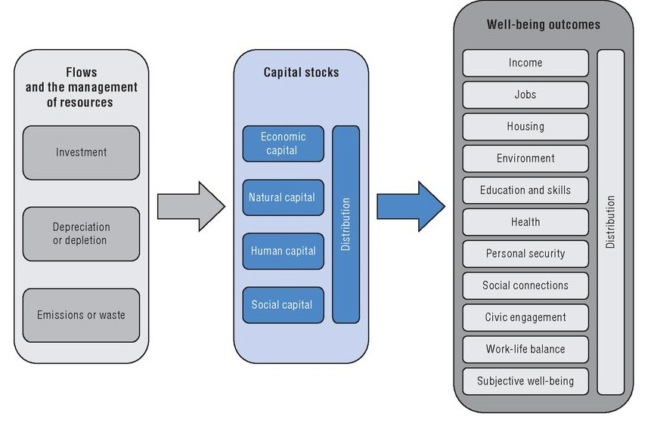
Linking capital stocks, flows and wellbeing outcomes in the OECD wellbeing framework.

It is based on the UNECE/Eurostat/OECD Task Force for Measuring Sustainable Development (TFSD) recommendation that a capital approach be used for assessing wellbeing in the future. The How’s Life, 2013 report discusses the definitions and scopes of different types of capital and how levels of these stocks can be assessed. It calls for a dashboard of both physical and monetary measures and the distribution of stocks between sectors, groups or special areas to be considered. Beyond indicators that enable ‘core’ capital stocks to be monitored, an additional set of ‘policy relevant indicators’ can provide information to decision makers about what can drive changes to capital stocks and assist policy makers in their management. The report notes that much analytical and statistical work is needed to select a concise set of indicators that accurately reflect those aspects of capital stocks, and their changes over time, which have the greatest relevance to future wellbeing.

4.34 Oxfam’s Doughnut
Oxfam’s doughnut approach brings together the aims of eradicating poverty with environmental sustainability. The diagram below shows nine Earth-system processes that are critical for keeping Earth in a stable state and which, taken together, constitute an environmental ceiling. In the middle is the social foundation below which lies unacceptable human deprivation. The space in between, the green ring, represents the ‘safe and just space’ in which humanity can operate. Some of these segments have been assessed and show that we have crossed three of the planetary environmental boundaries and fall below acceptable levels for several of the social criteria.

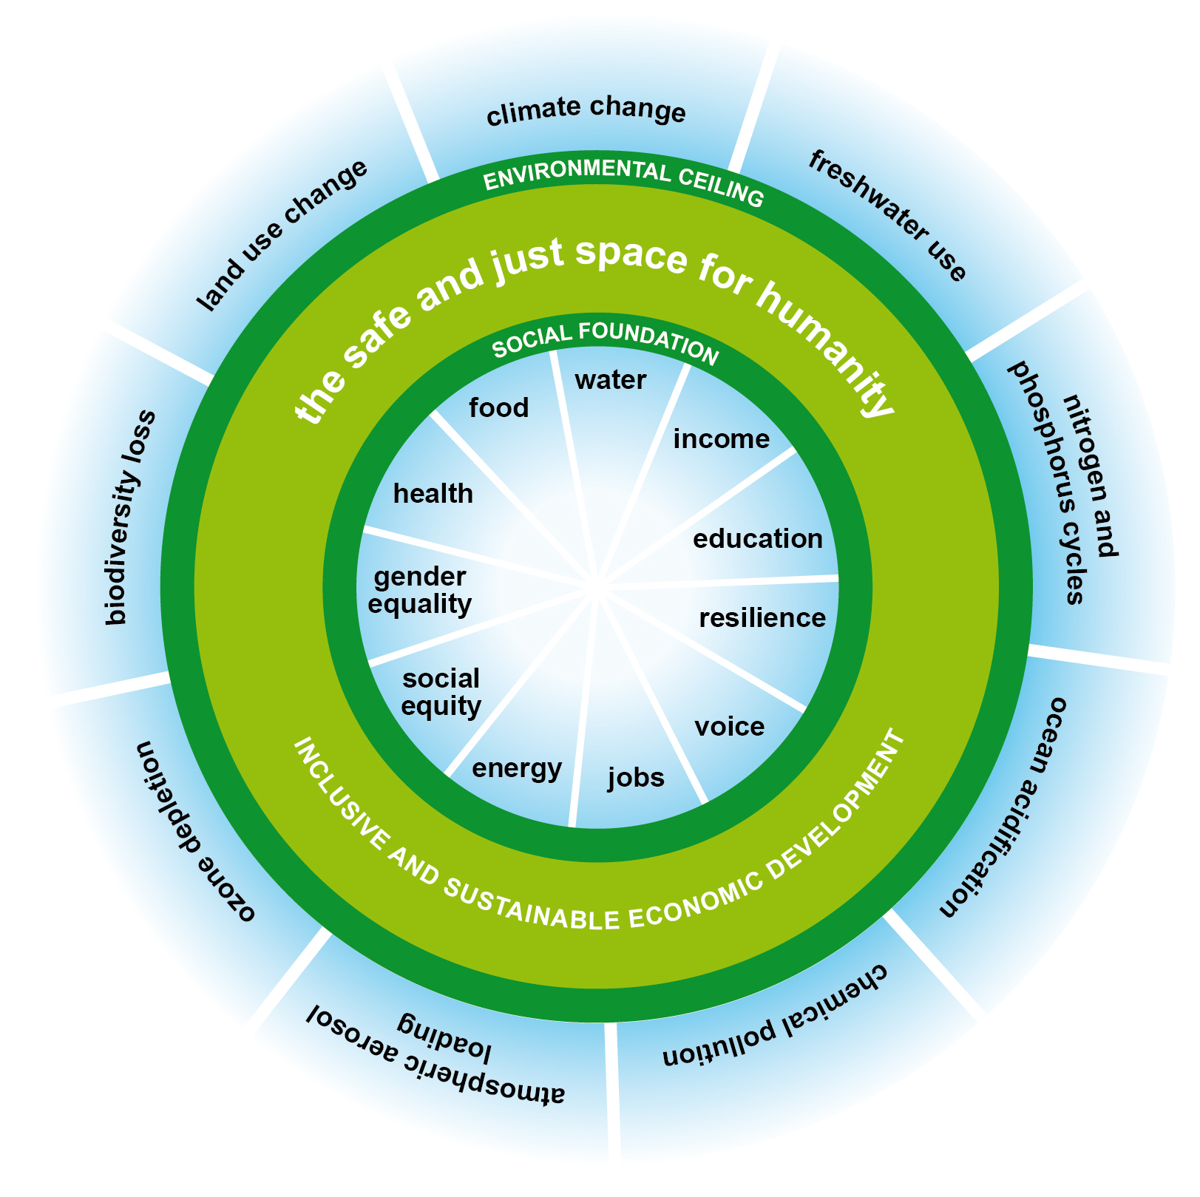

4.35 ONS
The Office for National Statistics is in the process of developing a framework to link an assessment of sustainability to its existing ‘measuring national wellbeing’ indicator set. This work will take into account the work of others, including OECD and the TFSD, together with Stiglitz recommendations.

5 Evaluation of Indicators and initiatives

Some of the shortfalls of various measures of wellbeing have already been mentioned. BRAINPOol looked at what makes some indicator initiatives more successful than others. In terms of media interest, it found that Bhutan’s ‘Gross National Happiness’ initiative, with its media friendly ‘happiness’ theme, attracted more attention that other comparable initiatives. Also indicators that benefit from delivering simple and meaningful concepts (even if they are measuring complicated things) are attractive to the media, such as the Human Development Index or Ecological Footprint.

The project also identified a number of features that contributed to indicators being used in policy and practice:
- Indicators need to have real relevance to policy makers and need to measure something policy makers feel they can influence;
- Salience for a broader audience is also important and entails simplicity and good communication;
- Indicators need credibility and legitimacy;
- A participatory approach should be used when developing the indicators.

The March 2014 BRAINPOol conference looked at two areas, one of which was ‘creating a beyond GDP narrative which resonates and inspires confidence with the public’. Speakers suggested that current narratives about wellbeing and sustainability are politically weak, but beyond GDP approaches do connect some politically strong concepts such as good jobs, security, community and equality.

6 LINK Flourishing Scotland Project
6.1 Project Objectives

The LINK Flourishing Scotland Project aims ‘for other measures to be equal to GDP in the NPF and for the improved NPF to be used more effectively as a tool for long-term decision making about resource expenditure along SD lines. ……..
The aim is for Scotland Performs, where progress against the NPF targets and indicators are measured, to be interrogated regularly by Parliament and the media to assess progress against SD objectives.’

6.2 Opportunities and Challenges

The Flourishing Scotland aims are closely tied to reforming the NPF and how it is used. In order for the NPF to reflect sustainable development, it should be viewed through a sustainable development lens. In its current form, the NPF does seek to include four of the five sustainable development principles (governance is missing) and, if indicators are improved, the environment could be adequately reflected. What is missing is a reflection of the hierarchy of the sustainable development principles. A change in the structure of the Framework, with the headline environmental and wellbeing indictors being ‘above’ economic indicators could amend this and put economic activity in its rightful context.

The Roundtable offers huge opportunity for revisions to be made to the NPF and its use in line with much of what LINK is seeking. There is agreement within the Roundtable on the weaknesses and missing areas in the indicator set and interest in those proposed in the LINK Briefing annex. There is less assurance on whether the Roundtable will address the wording of the main Purpose of the NPF or the emphasis given to GDP. Due to the sensitive nature of the Roundtable process, wider LINK advocacy on reforming the NPF is being carried out very softly. The absence of business on the Roundtable could also pose a serious risk to its eventual success - when the NPF is relaunched, it needs broad support and failure to have included the business community may jeopardise this.

6.3 Suggestions for work programme

The Roundtable offers an opportunity for the Flourishing Scotland project and the LINK representative on the Roundtable should use the Policy Officer to source information/research if it could help in any way to increase the impact of LINK input to discussions.

Because of the sensitivity of the Roundtable, the Flourishing Scotland project, whilst continuing with soft advocacy and keeping close tabs on the reform of the NFP, should consider shifting advocacy focus to a more general ‘beyond GDP’ message.

Research shows that one to one meetings and the media are the most effective ways to convey messages and so efforts should be focused here. Suggestions are to develop a clear succinct message, make sure we have responses for ‘tricky’ questions and think of ‘stories’ which might be of interest to the media and snappy lines that could be used for a social media campaign. We should work closely with our allies and consider joint events or campaigns where possible. One to one meetings should continue and a campaign and media strategy developed. We also need to produce information for our members and decide how to engage the wider policy community.

ANNEX 1

Short spec for Briefing on FS work on NPF and Scotland Performs

Purpose:

To provide LINK’s ETF with an overview of the state of play regarding the development of the NPF and the related issues of importance to LINK.

The content should include information relating to specific aspects of the Flourishing Scotland project like indicators of sustainability and (mis)use of GDP; and the opportunities for achieving objectives and the obstacles and challenges to that. It should include also an initial view of the wider territory, e.g. the variety of measures of wellbeing and environmental impact which exists. It should conclude with suggestions about the work programme and the inputs needed (within and without LINK) and the scope for LINK members to participate.

http://www.scotland.gov.uk/About/Performance/scotPerforms
http://vaperforms.virginia.gov/
Wallace, 2013. Shifting the Dial in Scotland. Carnegie UK Trust.
Presentation by Anne-Marie Conlong at GLADS seminar, 25 Feb 2014. http://www.scottishinsight.ac.uk/Programmes/Wellbeing2014/GLADSGoodLivesAndDecentSocieties.aspx
Wallace, J. (2013). Shifting the Dial in Scotland. Carnegie UK Trust.
http://www.scotlink.org/documents/briefings/
Bruntland Commission, 1987. Report to the World Commission on Environment and Development. United Nations.
Scottish Executive, 2005. Choosing Our Future: Scotland’s sustainable development strategy. Available at http://www.scotland.gov.uk/Publications/2005/12/1493902/39032
Defra, (2005). One Future Different Paths – The UK shared framework for sustainable development. London. Defra
http://www.scottish.parliament.uk/S4_ChamberDesk/WA20121120.pdf
http://www.scotland.gov.uk/Resource/Doc/357756/0120893.pdf
http://unstats.un.org/unsd/nationalaccount/
Wakefield, S. (2011). SPICe Briefing: Alternatives to GDP. Edinburgh: SPICe.
http://www.oecd.org/site/worldforum06/
http://ec.europa.eu/environment/beyond_gdp/background_en.html
http://ec.europa.eu/environment/beyond_gdp/EUroadmap_en.html
Stiglitz, J., Sen, A. and Fitoussi, J. (2009). Report by the Commission on the Measurement of Economic Performance and Social Progress. OECD. Available at http://www.stiglitz-sen-fitoussi.fr/
http://www.brainpoolproject.eu/about-2/background/
http://unstats.un.org/unsd/envaccounting/seearev/
BRAINPOol (Bringing Alternative Indicators into Policy) is a project funded by the European Union FP7 funding stream looking at the barriers to, and opportunities for, the use of beyond GDP indicators in policy http://www.brainpoolproject.eu/
http://www.brainpoolproject.eu/indicators-and-initiatives/
https://www.gov.uk/government/publications/sustainable-development-indicators-sdis
http://www.ons.gov.uk/ons/guide-method/user-guidance/well-being/index.html
http://www.oecdbetterlifeindex.org/
http://epp.eurostat.ec.europa.eu/statistics_explained/index.php/Quality_of_life_indicators
http://hdr.undp.org/en/statistics/hdi
http://policy-practice.oxfam.org.uk/our-work/poverty-in-the-uk/humankind-index
http://www.socialprogressimperative.org/about/the-imperative
Jackson and McBride, (2005). Measuring Progress? A review of ‘adjusted’ measures of economic welfare in Europe. CES working paper 11/05. University of Surrey.
http://www.ons.gov.uk/ons/rel/integrated-household-survey/integrated-household-survey/index.html
Abdallah, A. (2011). Pursuing rising national well-being: a sisyphean challenge? London: NEF.
See Lawn, P. (2005) An assessment of the valuation methods used to calculate the index of sustainable economic welfare, genuine progress indicator and sustainable net benefit index. Environment, Development and Sustainability (2005) 7. Newmayer, E. (1999). The IESW: not an index of sustainable economic welfare. Social indicators research 48 (1).
Jackson and McBride, (2005). Measuring Progress? A review of ‘adjusted’ measures of economic welfare in Europe. CES working paper 11/05. University of Surrey.
http://www.footprintnetwork.org/en/index.php/GFN/
http://www.footprintnetwork.org/en/index.php/GFN/
https://www.foeeurope.org/conference-report-four-footprints-policy-practice-110214
http://www.snh.gov.uk/docs/B814140.pdf
http://epi.yale.edu/
http://www.unece.org/fileadmin/DAM/stats/documents/ece/ces/2013/SD_framework_and_indicators_final.pdf
Abdallah, S. et. al. (2012). The Happy Planet Index: 2012 Report. A global index of sustainable wellbeing. London: NEF.
Taken from How’s Life 2013. Measuring Wellbeing. Available at http://www.keepeek.com/Digital-Asset-Management/oecd/economics/how-s-life-2013/measuring-the-sustainability-of-wellbeing-over-time_how_life-2013-10-en#page1
http://policy-practice.oxfam.org.uk/publications/a-safe-and-just-space-for-humanity-can-we-live-within-the-doughnut-210490
http://www.brainpoolproject.eu/success-factors/
http://www.brainpoolproject.eu/the-way-forward/
taken from the Stage 2 application from LINK to Friends Provident

