**Note of the LINK Networking meeting held on 2 June 2021 online.**

**Attending**: Charles Dundas (Chair), Clare Symonds (PD), Tim Ambrose (Treasurer, SWLG, CC), Eila MacQueen (AS), Vicki Swales (RSPB), Calum Duncan (MCS), Rebecca Millar (NTS), Andrew Stark (RSPB), Pat Monaghan (Hon Fellow), Annie Robinson (CIEEM), Arina Russell (WTS), Catherine Gunby (Fidra), David McKay (SAS), Janine Ballantyne (NTS) , Erin Shott (PL), Isobel Mercer (RSPB), Mike Daniels (JMT), Paul Walton (RSPB), Sam Collin (SWT), Matthew Crighton (FoES), Lloyd Austin (RSBP), Patrick McGlinchey (RSPB), Diarmid Hearns (NTS), Andrew Midgely (RSPB), Alan McDonnell (TFL), Eddie Palmer (SB)

Staff: Deborah Long, Vhairi Tollan, Anne Funnemark, Miriam Ross, Rachael Fairbairn, Juliet Caldwell, Karen Paterson, Phoebe Cochrane, Alice Walsh, Fanny Royanez.

**Apologies:** Helen Todd (RS), John Thomson (SCNP), Craig Macadam (Vice-Chair, Buglife)

**1. Welcome and introduction** (Charles Dundas)  
Charles welcomed everyone, who introduced themselves including their affiliations with the various LINK Groups. This meeting would look at the plans of the Groups over the next eight months, how these inter-relate, where our efforts can be best placed, getting input from all on successful tactics, and others we need to work with, and member body priorities.

**2. Update on today’s context** (Deborah Long)  
Deborah explained how the meeting would be run, use of Miro board and the chat function as well as discussion. All would be merged in the meeting note.

Operations: Over the past year we have used zoom very well, group meetings were well attended, tended to be more inclusive, we propose these continue to be online. Face to face meetings will happen for receptions and such events that require it. We hope to have meetings with government and agency partners mostly online, though these will be a mixture. For future networking meetings, we will ask your views in the survey at the close of the meeting. We do not propose to run mixed meetings as they are unsatisfactory. The LINK zoom account will be retained for Group meetings and for use by members, and are bookable via staff. There will be no meeting room in Perth, though small meetings can be held in the office. At this point we are unsure about use of the Edinburgh meeting room. **Members’ views were invited**.

Last year we launched the strategy, dividing our work under headings of Land, Sea and Society. The UK now has a different relationship with Europe, and there is a majority in Scottish Government/Parliament that wants to be in Europe. We need to work with that as it develops, the keeping pace with EU commitment; potentially a second Independence Referendum, the ongoing Covid situation and economic recovery.

Opportunities ahead.

|  |  |
| --- | --- |
| Working with others | Working with others to pump up the volume of voices; |
| Equality, diversity and inclusion: | Our sector is one of the least diverse in the UK: we know we need to change and do more with support & working together. See the survey [report](https://www.scotlink.org/publication/equality-diversity-and-inclusion-policies-and-procedures-link-member-survey-results-march-2021/) on the members’ website. We hope to be able to provide support to members here with a funded project. |
| Green recovery from Covid19: new Parliament; new approach | Sector viability and working with Govt and business  Maintaining a laser focus on a green and blue recovery – not a return to business as usual. Linked to the climate and nature emergency. |
| Climate and nature emergency rhetoric: | we need to turn it into action on both emergencies |
| European and Global context: | |
| EEB resources and opportunities | EEB: work plan priorities that read across on trade, environmental rights; CAP; fisheries; protected areas on land and at sea; biodiversity and more. These are really useful resources to get an insight on what is happening in Europe. EEB [website](https://eeb.org/): and [meta newsletter](https://meta.eeb.org/) page. |
| Biodiversity CoP15: China: October 2021 | Biodiversity: building on Edinburgh Declaration; FFSN & ELUK target work |
| Climate CoP26: Glasgow November 2021 | Climate: nature based solutions, including Nature networks. |

The Group plans have some cross- cutting themes: nature targets; the global goal for nature and people on which we are working with the other Links on a common voice as it will be UK at COP 15. Please also make the most of this very useful [infographic](https://www.scotlink.org/wp-content/uploads/2021/04/TIMELINE-FOR-OUR-FUTURE.pdf) recently produced with the Natural Capital Forum.

Nature networks, green neighbourhoods, our film, briefing, and panel event recording are resources (all available [here](https://www.scotlink.org/link-campaigns/nature-networks-matter/)). Access to nature and helping people get out and enjoy nature; work on our [manifesto](https://www.scotlink.org/publication/manifesto-2021/), and what we hope to see coming from that.

**3. Update on Parliament priorities going forward** (Vhairi Tollan)

The election returned SNP as largest party with 64 seats, short of a majority though still able to form a government. There are 64 seats in the opposition. This is not so different from last time. Three key developments are:

1. Turnover, a lot of MSPs stood down or failed to be re-elected.   
2. New cabinet appointed looks very different. Fergus Ewing was replaced by Mairi Gougeon. Roseanna Cunningham’s portfolio has changed, with Michael Matheson as the Cabinet Secretary for Net Zero, Energy and Transport; Máiri McAllan as the new Minister for Environment, Biodiversity and Land Reform. LINK has written to all. We will be seeking meetings over next few weeks with them and with opposition spokespeople.   
3. There may be a cooperation agreement between SNP and the Greens. There is a lot of overlap between the environment and rural sections of our manifesto and the Green manifesto, so there are opportunities there. Talks should be concluded by end June. We will see how it plays out in the Programme for Government. We have produced a series of [introductory briefings](https://www.scotlink.org/publication/introductory-environment-briefings-for-msps/) on key topics, the ‘5 things you need to know about….’ to be shared with MSPs over next few weeks to introduce them to LINK’s priorities.

Snapshot of what we expect in the next year:   
Some of the regulations that flow from the Continuity Act. Environmental principles, and guidance on keeping pace with the EU. We will be working with the other Links (Environment LINKs UK) and the Greener UK Coalition on post Brexit issues.   
The National Planning Framework 4 to be introduced to Parliament early in autumn.   
Cop 26 in Glasgow November, we expect some policy announcements in the run up.   
Other relevant SNP manifesto commitments:   
Economic transformation strategy  
Consultation on grouse moor management,   
Review of the National Marine Plan,   
More on Regional Land Use Partnerships,  
Good Food Nation and Circular Economy Bills,   
Possible Wellbeing and Sustainable Development Bill.   
  
Mairi Gougeon replacing Fergus Ewing may mean some developments on future farming policy.   
There will be the annual budgets, and Covid recovery measures.   
Nature Recovery targets: we have an opportunity to make noise ahead of COP 15 in October, and the update of the Scottish Biodiversity Strategy.   
If Greens and SNP reach an agreement we can expect Indyref 2. The Governance Group will update the old Referendum Challenge document, and we have a [position statement](https://www.scotlink.org/publication/link-position-statement-on-independence-referendum/) ready to go. The GG is keeping an eye on timings and political developments. There are potentially a lot of opportunities for us there.

Discussion covered:  
There is scope for new ministerial appointments should the SNP and Greens reach a cooperation agreement;  
Scotland’s Rainforest is mentioned in the SNP manifesto and Arina is confident that advocacy plans line up;   
Vhairi will shortly be following up initial letters to the Cab Secs and Ministers for meetings;   
Committees are expected to be announced quite soon;  
Special advisors will be appointed;  
There will be a consultation on the governance and the draft strategy of Environmental Standards Scotland in the autumn. LINK has established good engagement and will be meeting officials again in June.   
Can we increase pressure for nature targets ahead of COP 15? The Fight for Scotland’s Nature action is live, and we will use that to take the message to Mairi McAllan later in the summer. As a global issue its about demonstrating that action in Scotland going would be keeping pace.   
SNP manifesto has some commitments on taking forward findings of farmer-led groups led by F Ewing which were closed to us. We hope that having Mairi Gougeon as his replacement may improve matters.   
There is an SNP manifesto commitment to a new Land Reform Bill which will introduce a public interest test for large scale land ownership and a pre-emption in favour of community buy-out. Also intent to increase Community Land Fund; rural repopulation is an aim.   
Can we do something to bring the simple clarity of Net Zero to biodiversity loss? Our work with ELUK is relevant and work in the Wildlife Group to consider what nature positivity looks like, will feed into our advocacy at UK and Scottish levels. This is of interest to the Marine group eg on nature positive fishing.

**4. Successful tactics used in last 12 months**  
All contributed to the brainstorm session on the Miro Boards on successful tactics used in the last year.

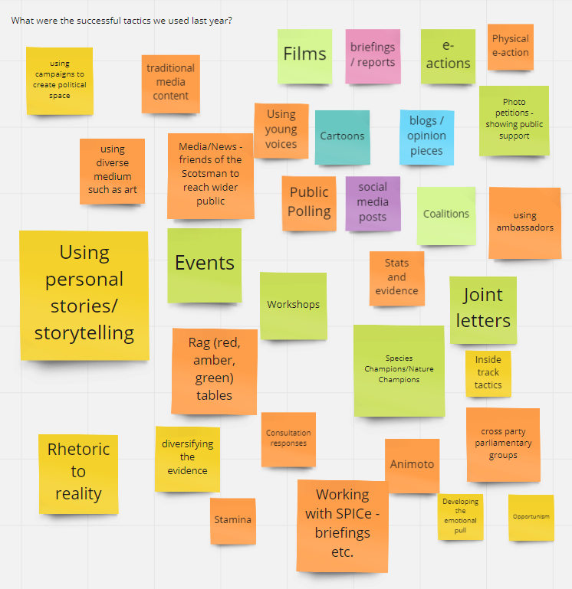

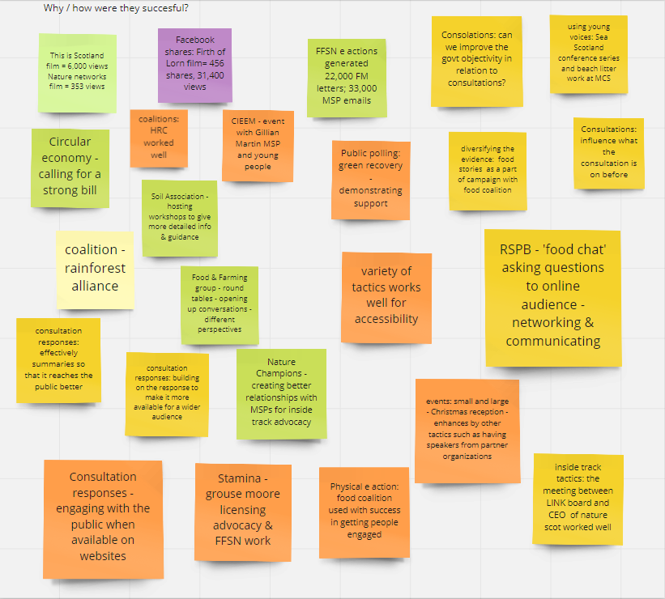

**5.** **Identify priorities going forward.**

|  |  |  |  |
| --- | --- | --- | --- |
| **Groups** | **Priority Action** | **Other group involvement** | **External Involvement** |
| Land Use & Reform | Influence LUS3 via consultation responses and meetings; implementation plan | Food and Farming on agriculture policy | Scottish Land Commission, Cab Sec for Rural Affairs, New Deputy Director ScotGovt. |
| Land Use & Reform | Influence RLUPS via pilot RLUP involvement, meetings & highlighting x policy links with agri, NPF4, LUS3 and others | Wildlife, F&F, | Pilot RLUPs as appropriate/feasible, SLC |
| Land Use & Reform | monitor development of SNP LR manifesto commitment | None | SNP ministers, SLC |
| Landscape | advise on 30x30 target and Protected Areas work led by Wildlife Group | Wildlife | None, led by another group |
| Landscape | Protected landscapes and seascapes; National parks, Regional parks and access | Wildlife, Marine | Blue Marine Foundation |
| Landscape | input on wildland into NPF4, led by Planning Group | Planning | None, led by another group |
| Landscape | renewable energy spatial strategy | Marine |  |
| Wildlife & Freshwater | advocacy to achieve legislatively underpinned nature targets | FFSN; ELUK Targets Group | ELUK target work; SG Env Dir, NS; SG biodiversity structures; Edinburgh Declaration signatories |
| Wildlife & Freshwater | updated Scottish Biodiversity Strategy and new implementation plan | Marine, F&F | SG Env Dir, NS; SG biodiversity structures; |
| Wildlife & Freshwater | maintain profile of keeping pace commitment re EU Biodiversity Strategy - 30x30 & NN | Governance | SG Env Dir, NS; Cab Sec Europe; Minister Env |
| Wildlife & Freshwater | integrate nature networks into NPF4, RLUPs, LUS & relevant policies through provision of info resources, experts and advice | Planning; Land use | Promotion of materials as needed |
| Wildlife & Freshwater | 30x30 target briefing and support | Marine, Land Use | NS, Env Directorate |
| Wildlife & Freshwater | Nature Champions relaunch and roll out | All groups and interested members | Working to exceed 80% MSP sign up |
| Wildlife & freshwater | secure long term funding for nature from public and private sources through partnership working and advocacy | Green Recovery, SEFF | NS; SEPA; SFNC, other new contacts |
| Wildlife & Freshwater | collate & submit RBMP response | Hon Fellows; marine; aquaculture | Scottish Water; SEPA |
| Economics & Green Recovery | Focus on ensuring Green Recovery rhetoric covers entire green and blue strategy: needs nature and climate at heart: | Marine, Wildlife; F & F |  |
| Economics | Work on the economic strategy |  | Wellbeing Economy Alliance |
| Economics | Circular Economy bill | Marine | CE coalition |
| Economics | Green new deal and investment | Green Recovery: 5 tests |  |
| Economics | Fiscal policy & levers | All groups, Governance |  |
| Economics & Green Recovery | Compiling an ongoing and growing list of green recovery projects, over the next year or so. | All Groups | NS; Env Dir; EFN and funders |
| Economics & Green Recovery: | Advocacy work for Green jobs skills analysis commitment in P4G: hold to account | SEFF, Wildlife SDtG report | Parli committees; funders |
| Economics & Green Recovery: the assessment sheet | Promote 5 tests into every group so they are applied to all policy areas where Govt money is spent or claims of job creation / protection/ skills development: eg Infrastructure Investment Plan, deer eg thru short briefing and link to and link to the assessment sheet | All groups | External audiences as required |
| Economics & Green Recovery | Net nature gain: agree simple message - how will all SG plans and proposals produce net nature gain across all portfolios | Wildlife; marine | External audiences |
| Woodland, Deer, Wildlife Crime | Werrity | Wildlife, Governance | MSPs, Minister |
| Woodland, Deer, Wildlife Crime | Nature Champions | Wildlife | MSPs |
| Woodland, Deer, Wildlife Crime | Natural Injustice report | Governance | MSPs |
| Deer | Deer report implementations & recommendations of | Woodlands | MSPs; Ministers; NatureScot; Scottish Forestry; Forest Land Scotland |
| Woodlands | Woodland expansion thru natural regeneration; commissioning work on how effective the scheme is | Deer, Wildlife | Scottish Forestry |
| Woodlands | completing the evidence for natural regen | Deer, Land use | NatureS; Scottish Forestry |
| Woodlands | promoting the value of nature friendly forestry; UKFS review; high value timber |  | Forest Policy Group; local community groups in south of Scotland; Community Woodlands Association; SEPA; Confor |
| Woodlands | supporting the Alliance for Scotland's Rainforest advocacy aims/supporting Saving Scotland's Rainforest delivery | Wildlife, Deer | MSPs |
| Marine & Aquaculture | Sea Scotland event |  | Coastal communities network; academics; consultants; NatureScot |
| Marine & Aquaculture | tying into FFSN & nature targets | FFSN |  |
| Marine & Aquaculture | 30x30 marine perspective; completing MPA network and getting management in place |  |  |
| Marine & Aquaculture | MPA consultations |  | Our seas members; CCN |
| Marine & Aquaculture | Future Fisheries management strategy |  |  |
| Marine & Aquaculture | Salmon Interactions working group response |  | Marine Scotland; NatureScot; SSPO |
| Planning | NPF4, consultations responses - narrow down - engaging in parliamentary scrutiny process | Land Use, Wildlife, Marine |  |
| Planning | Commenting on the infrastructure and investment plan | Economics; Green recovery |  |
| Planning | watching brief on regional spatial strategies; local development plans |  |  |
| Planning | understand how to integrate work on land use and planning | Land use and land reform |  |
| Food and Farming | Aim - healthy soils & sustainable agriculture systems |  |  |
| Food and Farming | influence future rural policy towards environmental public goods | Wildlife, and Wildlife Crime | Academic advisory panel, FPG, civil service leads |
| Food and Farming | key legislative opportunities; Good Food Nation bill etc. | Aquaculture | Scottish Food Coalition; Organic Stakeholder Group |
| Food and Farming | post 2024 agricultural /rural support system | Woodland, Nature champions |  |
| Food and Farming | pathways to sustainable farming | Woodland | Soil Association, Farming for 1.5 |
| Governance | implementation of continuity act | All groups | Scot Gov, various agencies & public bodies |
| Governance | governance review consultation on the Continuity Act |  | ERCS, other legal actors interested in Env court, HRC |
| Governance | supporting work on nature recovery targets | FFSN, Wildlife, Marine |  |
| Governance | campaigning for a human right to a healthy environment |  | ERCS, HRC |
| Governance | Rhetoric to reality report | Green Recovery; all groups |  |
| Governance | supporting economics - fiscal levers | Economics |  |
| Governance | Political engagement on a cross-sectoral basis, election, new govt, parliament and committees, party conferences, indy ref 2 actions |  |  |
|  |  |  |  |
|  |  |  |  |

**6. Key member plans ahead.**

JMT: held a meeting with eNGO landowners and Forest Land Scotland, on carbon management on their land, emissions and sequestration, looking at funding mechanisms, and increasingly on Corporate Social Responsibility potential, and where Govt landowners are in their thinking. The action is for NatureScot to reflect and join up on work going forward. Looking at an energy rating and carbon tax, natural carbon sequestration. In the transition to net zero land has a huge part to play.

NTS: Getting back on an even keel and re-opening post Covid. There new chief executive, Philip Long, is keen that NTS keep an independent line, critical of government where appropriate. There is a new corporate strategy setting the course for the next 10 years, they will be engaging with other organisations during it. They will be reviewing internal climate change and nature policy, Rebecca and Janine are looking at what others are doing, so look out for email.

Scottish Badgers: have formed a closer alliance with the Badger Trust in England and Wales, finding the same issues with the various governments and nature agencies. In England they are trying to move away from only being associated with the cull, which is likely to continue for at least 4 more years. SB involved in the Natural Injustice report, coming out soon. In a dispute with NS currently.

Soil Association Scotland: developing a new three year strategy. The overarching policy focus is the necessary shift to agroecology, and diets. Food not Feed programme, about reducing the amount of land used for intensive livestock production and more focus on plants for human consumption. A farmer led tree planting revolution; and a focus on ultra-processed foods. The Good Food Nation Bill, expansion of Food for Life scheme; and the SNP manifesto pledge to double organic farmland.

CIEEM: conference in October, Greening our Grey, call for papers just out, it would be great to have LINK member contributions. [Events](https://events.cieem.net/Events/Event-Listing.aspx) upcoming on natural capital lab, and on tree health in Scotland. All welcome to sign up to weekly [CIEEM news](https://cieem.net/enews-sign-up/) for regular information.

RSPB: working on new corporate strategy to be launched shortly. Within it expect to have a focus on securing Nature Recovery Targets, and policy and advocacy remaining central along with on-the-ground activities. No seismic change in dealing with LINK, but big focus on Equality Diversity and Inclusion. [Biodiversity Intactness index](https://www.rspb.org.uk/globalassets/downloads/about-us/48398rspb-biodivesity-intactness-index-summary-report-v4.pdf) to challenge the Scottish Government compares countries around the world. The 4 UK countries are at the bottom, Scotland is better than the rest of the UK. The report will be a useful tool to press for ecosystem restoration.

MCS: strategy refresh focus on blue carbon, see [report](https://media.mcsuk.org/documents/BlueCarbon_Report.pdf), and relaunched and rebrand 4 country approach as a UK charity. Scottish focus [here](https://www.mcsuk.org/about-us/where-we-work/our-focus-in-scotland/).   
  
WTS: will have a new director starting August. The trust launched a state of woods and trees [report](https://www.woodlandtrust.org.uk/publications/2021/04/state-of-uk-woods-and-trees-2021/), state of nature in woods with very good Scotland data included. Available for everyone to use, stats on ancient woodland, will use for NPF4. The [Alliance for Scotland’s Rainforest,](https://savingscotlandsrainforest.org.uk/) lots of effort in there with partners, will use COP 26 as a lever to secure restoration, for SNP to follow through on its manifesto commitment. Paper on rhododendron a growing problem, focus on west coast, to raise awareness, and will be uploaded to the alliance website.

Trees for Life: their judicial review on NatureScot beaver licensing started 4 June.

Fidra: working on the UK Reach chemical strategy, keeping a watching brief, waiting to see when corporate evidence comes out. They will be [great global nurdle](https://www.nurdlehunt.org.uk/) hunt in October, used to lobby for change to plastic pellet problem.

Pat Monaghan (Honorary Fellow) alerted members to 3 free public online lectures run by the [Royal Philosophical Society of Glasgow](https://royalphil.org/), on climate in the run up to the COP 26; the first on 28 July on climate change. There are Q&A sessions after the talks which will be given by Pete Smith University of Aberdeen , Francesca Oswoska, NS, and from Barbara Young, chair of the Woodland Trust. Details of all of them will shortly be on the website.

Lloyd Austin (Honorary Fellow) noted that the [Environmental Rights Centre for Scotland](https://www.ercs.scot/) will on 3 June, and in due course will be formally transition to a stand-alone organisation, potentially a new member body of LINK. Everything looks positive to date with the work programme and staff. All are welcome to sign up as a member and a supporter. RSPB, FoES and LINK itself been very crucial to setting it up as the Legal Strategy Group which has now formally dissolved. Any remaining LSG issues will be taken up by the Governance Group.

**7. Conclusion and next steps**   
Deborah thanked everyone for participating. We have seen there are a good variety of mechanisms we can use, how to learn from others, and we will do a bit more thinking about how our Groups can relate to Groups more easily. We have a lot of opportunities coming up, both COPs, the new Government and Ministers. There are new civil servants in post and new relationships to build there. There is a new openness to working with us, which we should use. We have support from Miriam as campaigns coordinator, providing support also to some of our groups. We are recruiting for a new Communications Manager post. The work Vhairi and the Advocacy team are doing is very proactive. Deborah urged all to use the resources like the ‘5 things’ briefings. The Discretionary Project Fund is available for group needs.

The next networking meeting on 6 October. There is a lot going on, the Nature Champions launch and the ERCS launch on 3 June, the Sea Scotland conference on 8 June. Events are listed on the [website](https://www.scotlink.org/news/events/) – the non-public ones are viewable only when logged in as a member. The festive reception is on 16 December.