**Changing Tracks**

**The case for better control of vehicle tracks in Scotland's finest landscapes**

**A report for Scottish Environment LINK**

**Melanie Nicoll**

**September 2018**



**Contents**

1. Foreword by Joyce McMillan, Honorary President, Scottish Environment LINK 5

2. Executive summary 6

3. Background to the Hill Tracks Campaign 11

4. The Prior Notification system 20

*4.1 Guidance available to applicants* 22

5. Monitoring the new system 23

6. Observations from the monitoring process 26

*6.1 Qualifying use – a grey area* 26

*6.2 Is the Prior Notification process given due attention?* 30

*6.3 More than “maintenance”?* 34

*6.4 Grounds for refusal?* 40

*6.5 The Prior Notification system – good enough for our most important landscapes and our natural heritage?* 43

7. Principles of public engagement 47

*7.1 Denied a voice: Prior Notifications and public comment* 47

*7.2 Public access to Prior Notifications – the importance of full transparency* 48

*7.3 The importance of timely publication of Prior Notifications* 49

8. Compliance with the Prior Notification system 52

9. Conclusions 54

10. Recommendations 57

11. Appendix 58

**This report was written for Scottish Environment LINK on behalf of the LINK Hill Tracks Campaign, whose members are:-**

* Association for the Protection of Rural Scotland
* Badenoch and Strathspey Conservation Group
* Cairngorms Campaign
* National Trust for Scotland
* North East Mountain Trust
* Ramblers Scotland
* RSPB Scotland
* Scottish Campaign for National Parks
* Scottish Wild Land Group

C:\Users\calum\AppData\Local\Microsoft\Windows\INetCache\Content.MSO\5AC15022.tmpThe Campaign is also supported by non-LINK members Mountaineering Scotland and the John Muir Trust.





Funders

The Campaign gratefully acknowledges the funding it has received to support the preparation and publication of this report from the Scottish Mountaineering Trust, British Mountaineering Council Access and Conservation Trust and the Scottish Environment LINK Discretionary Project Fund.





**Acknowledgements**

**The Campaign wishes to recognise the immense contribution and support it has received from the many individuals and organisations who have been involved in, or contributed in other ways to, the production of this report and to the Campaign. The Campaign is especially grateful to the members of the public who volunteered their services to help monitor planning authority websites in their spare time and who gathered the material which has informed this report. Their input has been invaluable. The Campaign also thanks members of the public who have alerted the Campaign to tracks of concern and submitted valuable photographic evidence which has enabled the Campaign to alert planning authorities to potentially unauthorised or damaging work and encouraged them to investigate or take enforcement action where appropriate.** The Campaign is grateful to planning authorities for engaging with it over the monitoring period and responding to its various queries.

**Images**

**The Campaign is grateful to the many members of the public and Campaign group members who have submitted the images used in this report. Images have been presented anonymously to protect the identity of contributors. All images remain the copyright of Scottish Environment LINK for the purposes of this report.**

**Case Studies**

**This report includes a number of case studies that have been selected from a large number of possible examples to illustrate aspects of the Prior Notification system that are explored in this report. They have been used purely for the purposes of informing the debate about the adequacy of the Prior Notification system and not to imply criticism of a particular landowner or planning authority. The information contained in the case studies is accurate to the best of the Campaign’s knowledge.**

**Report also available online at** [www.scotlink.org/workareas/hill-tracks](http://www.scotlink.org/workareas/hill-tracks/)

**Copyright ©Scottish Environment LINK, 2018**

**Published by Scottish Environment LINK**

**For further information about this report please contact:-**

**Scottish Environment LINK**

13 Marshall Place  
Perth  
PH2 8AH

Tel: 01738 630 804

# 1. Foreword by Joyce McMillan, Honorary President, Scottish Environment LINK

It’s a great pleasure to welcome the publication of this report by the LINK Hilltracks Campaign, and to congratulate everyone involved on their hard work over many years to place environmental concerns and priorities at the heart of discussion on the future of Scotland’s hill tracks.

This report follows the Campaign’s earlier “Track Changes” document of 2013, which recommended a shift away from the Permitted Development Rights approach to agricultural and forestry tracks, and the introduction of a requirement for full planning permission for such tracks, enabling closer scrutiny of new track developments, and opportunities for the public and local communities to become involved in the process.  The 2013 report was published against the background of a rapid expansion in the number of driveable tracks across Scotland’s upland areas, which had raised concerns about their growing impact both on Scotland’s renowned scenic beauty and grandeur - the protection of which is a high priority for the Scottish Government - and on other vital areas of environmental concern such as peatland protection, biodiversity, and the preservation of Sites of Special Scientific Interest.

In response to campaigning on this issue, in December 2014 the Scottish Government brought into force a requirement not for full planning permission, but for the lesser requirement of Prior Notification of track developments in advance of construction.  The LINK Hilltracks Campaign has been monitoring the impact of this new requirement on key upland areas over the last three years; and this report details those findings, with substantial recommendations for future legislative and administrative change.

Overall, the report concludes that, while there have been some positive outcomes from the 2014 legislative change, it falls short of the oversight needed properly to protect Scotland’s landscape and environment, and to meet the Scottish Government’s own goals for the conservation and celebration of some of Scotland’s most important economic, cultural and spiritual assets.

In particular, the Prior Notification system is perceived as confusing, and is interpreted very differently across different planning authorities in Scotland. The anomaly remains that, while ordinary householders require full planning permission for alterations to the external structure and appearance of their homes, landowners can still often create visually intrusive and permanently damaging tracks across beautiful hillsides, and even iconic views, with very limited consultation or regulation.

This report therefore represents a vital contribution to the continuing debate on how to conserve Scotland’s priceless landscapes and natural heritage, while allowing for reasonable development, and making sure that those involved in development primarily for leisure and tourism purposes cannot avoid the planning process by simply designating tracks as “agricultural”.  This is an area where campaigners, government, landowners and developers must finally share the same long-term goal, of balancing the use and enjoyment of our land and landscape with its long-term nurture and conservation.  And the Hilltracks Campaign, the reports it has produced, and the willingness of government and other stakeholders to enter into debate with it, represents a textbook example of how strong, well-informed and dedicated civil society groups can work to advance debate on key issues, to act as a counterbalance to short-term vested interests where those exist, and, in the end, to inform and strengthen the kind of good governance that helps create a better future for us all.

Joyce McMillan

# 2. Executive summary

1. Off-road constructed vehicle tracks (often referred to as “hilltracks”) can ease access for land management purposes but can also have major visual and environmental impacts, particularly on the wilder landscapes for which Scotland is so highly-regarded.
2. Poorly-sited and constructed tracks have been a concern to conservation organisations and outdoor enthusiasts for many years. This is reflected in decades of campaigning, culminating in the publication by Scottish Environment LINK in 2013 of a major report “Track Changes”.[1]
3. Hilltracks continue to be built and the cumulative impact of constructed tracks on our landscapes is increasing given the number of tracks that are also now being built in connection with hydro power schemes, wind farms and other developments.
4. For historic reasons, tracks built for agricultural or forestry purposes have benefitted from Permitted Development Rights and this continues to be the case, in spite of the advent of heavy machinery and its capability to re-engineer hillsides and important landforms. This has left the countryside vulnerable to significant damage in the absence of tighter planning control.
5. The LINK “Track Changes” report argued that agricultural and forestry tracks should not enjoy Permitted Development Rights and should be subject to a requirement for full planning permission to ensure they are subject to the closest scrutiny and to give the public the opportunity to comment on and help inform planning authority decisions.
6. In spite of the evidence presented in “Track Changes”, the Scottish Government rejected the call for full planning control, settling instead on the lesser requirement for “Prior Notification.” It considered that this would increase protection for the Scottish countryside.[2] The new legislation came into effect in December 2014.[3]
7. This report is a follow-up to “Track Changes” in the light of the recent changes to the legislation. It considers the extent to which the new system has addressed campaigners’ concerns and meets the government’s current objectives relating to responsible land use and management, and community engagement in planning. It draws on the results of monitoring by the Campaign of Prior Notifications for agricultural and forestry tracks in key upland areas over the last three years.
8. There are several aspects of the Prior Notification system, as distinct from the full planning system, that leave Scotland’s landscapes particularly vulnerable. The evidence gathered during this study has led us to conclude that the introduction of Prior Notification has created a confusing system, with insufficient controls and little democratic oversight, which is allowing visual and environmental damage to continue.
9. ***A confusing system***

* The Prior Notification system for agricultural and forestry tracks has introduced a further, distinct planning process that is considered complicated and confusing by various stakeholders, including applicants, planning authorities, campaigners and the wider public;

1. ***Democratic deficit***

* the lack of a sufficiently robust definition of agricultural or forestry use results in potential for abuse of the system, particularly in relation to tracks claimed to be for agricultural use when their primary purpose is almost certainly sporting (in which case a full planning application should be submitted);
* there is very limited opportunity for public engagement when compared to a full planning application, in that public comment is not invited;
* there is a disparity in the system, whereby a homeowner has to undertake a rigorous procedure to achieve an alteration to their home’s appearance, which contrasts markedly with the current situation in that a landowner can create an obvious and permanent scar in our finest landscapes without full public accountability.

1. ***Out of control: landscape and environmental damage continues***

* there is insufficient scope for planning authorities to adequately control or refuse agricultural and forestry tracks, particularly where they suspect tracks may not qualify for Permitted Development Rights; this can make it difficult to uphold important national and local policies and priorities in relation to, for example, peatland protection;
* whilst vehicle track proposals for National Scenic Areas do not qualify for Permitted Development Rights and are subject to a requirement for full planning permission, other nationally-important landscapes and habitats, including National Parks, Scotland’s flagship Wild Land Areas, Sites of Special Scientific Interest and Natura sites, all of which have been recognised as important for aspects such as landscape, biodiversity, habitats and species, do not have the same protection;
* some applicants appear not to take the Prior Notification requirements seriously, submitting poor quality applications with minimal detail. This suggests that Prior Notifications are taken less seriously than full planning applications and can lead to poorly-sited and designed tracks and poor construction techniques;
* the lack of a fee for Prior Notifications means that planning authorities cannot recover any of their costs in processing them in spite of the additional workload this generates;
* it is also an anomaly that “borrow” pits for the extraction of construction materials are not covered by the Prior Notification system in spite of their impacts.

1. It is recognised that some tracks improve recreational access for the public and some may be of benefit in this respect, although this very much depends on their method of construction and whether the surface is suitable for cycling and walking, and many people would prefer not to see more built tracks extending into the hills. In addition, some “road-style” tracks are built over the top of existing low-impact single tracks and informal paths, which had provided a more attractive, natural and enjoyable experience for recreational users. Where tracks are built and become recognised routes into hills, this recreational use is a by-product of their original purpose. It is important to note that tracks built specifically for recreational purposes are subject to a requirement for full planning permission.
2. The Campaign also recognises that the impact of some of the tracks built since the introduction of the new system may lessen with the passage of time. However, it seems likely from the Campaign’s monitoring that, in a significant number of cases, inadequate attention to siting, detail and best practice at the planning and construction stage are resulting in, and will result in, new tracks which have the potential to scar the landscape and have environmental impacts for decades to come.
3. The report concludes that the Prior Notification system has introduced a measure of control, where there was none before, with some positive outcomes. Overall, however, the new legislation falls short of the oversight needed to properly protect Scotland’s landscape and environment, with the result that built tracks of potentially questionable justification and with significant adverse impact are continuing to push further and further into Scotland’s iconic wilder landscapes.
4. The report also shows how the Prior Notification system fails to address the need for public engagement in the process, at a time of increasing public interest in how Scotland’s land is managed.
5. The Scottish Government regularly cites the importance of Scotland’s landscapes (“awe-inspiring”) and the beauty of its natural environment and the role these play in supporting key sectors of the economy, as well as their importance in a cultural context to Scotland’s national identity and social wellbeing.[4]
6. The Campaign therefore calls again for tighter control of tracks, specifically recommending that Permitted Development Rights be withdrawn from those claimed to be for agricultural purposes, as the Campaign’s monitoring shows a significant percentage of these are likely to be primarily for other purposes. The Campaign recognises this would impact on bona fide Prior Notifications for agricultural use, including crofting, but has been unable to establish how the definition of Permitted Development Rights for agriculture could be amended to retain Permitted Development Rights for genuine agricultural tracks. At the same time the Campaign considers that these tracks may also have local environmental and landscape impacts and would benefit from a greater level of public oversight than is currently the case under the Prior Notification system.
7. The Campaign considers that Permitted Development Rights could continue to apply to forestry tracks at this stage as the “qualifying use” issue appears to be less of a concern in comparison with agricultural tracks. The forestry regulatory regime also adds a level of additional scrutiny to many forestry tracks when compared to those for agriculture. Nonetheless, forestry and its associated tracks can have major landscape and environmental impacts, for example through poorly-sited and/or constructed tracks which can have adverse local impacts such as silting of watercourses etc. The Campaign considers there is no doubt that some forestry track proposals would benefit from much closer scrutiny at the planning stage and from the potential for public comment. However, monitoring has not conclusively shown that removing Permitted Development Rights alone would substantially improve outcomes and the Campaign suggests more study is required. There will be further opportunities to consider these issues during the forthcoming Forestry Strategy review. Options for reform of the Prior Notification system as it applies to forestry tracks are suggested in the recommendations at the end of this report.
8. In response to a high level of public interest in the impacts of tracks in the Scottish uplands more generally (for example, those associated with hydro-electric development, retention of temporary construction tracks and the use of all-terrain vehicles on sensitive landscapes and habitats), the Campaign has also prepared a separate appendix document.
9. The evidence presented in this report illustrates the growing pressures on Scotland’s landscape and environment and the contribution made by the proliferation of vehicular tracks to this ongoing attrition of wild qualities in our upland areas. Considered alongside the lack of democratic oversight and the associated problems with the Prior Notification system, we believe this report adds significant weight to the argument for tightening control on track construction. The Campaign’s recommendations at the end of this report set out how this should happen. Only then can the Scottish Government fully deliver on its aspiration and commitment to protect Scotland’s environment, amenity and heritage.

# 3. Background to the Hill Tracks Campaign

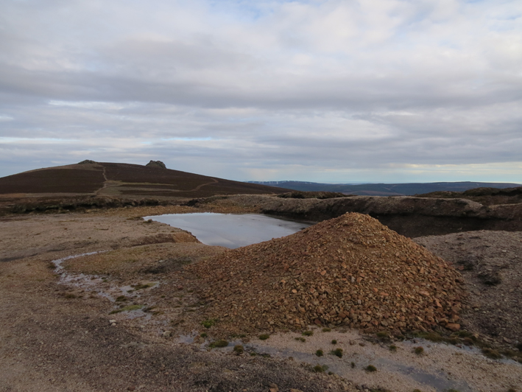

*Near Clachnaben, Glen Dye, Aberdeenshire, 2017*

1. For decades environmental and recreation groups have had concerns about the impact of and extent of vehicle tracks in Scotland’s uplands, including in Scotland’s National Parks and even to the summits of popular Munros.

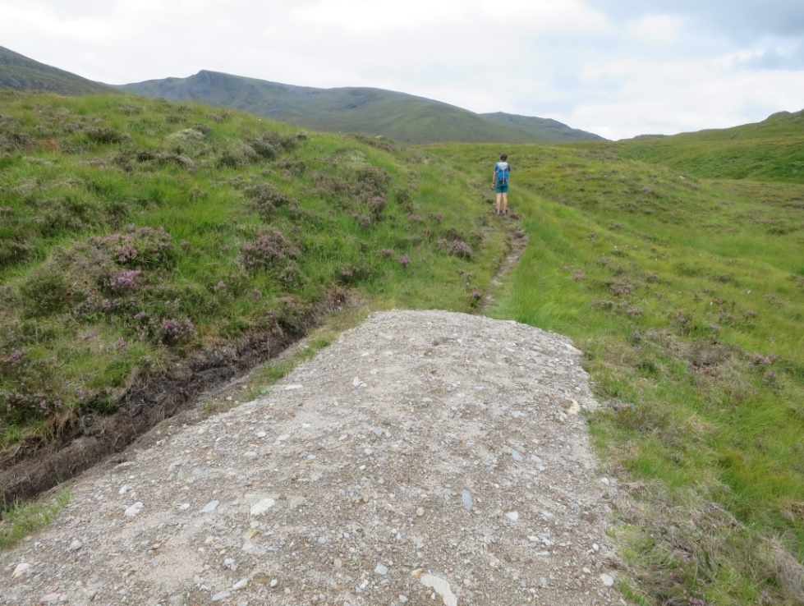

Ben Alder hills - track encountered by hillwalkers and assumed to be relatively recently   
 constructed: planning status unknown

1. Vehicle tracks may be legitimately required for land management purposes but they can have serious adverse visual and other impacts. In addition to the damage that can be caused by individual tracks, there is a cumulative impact, particularly in landscape terms, from networks of tracks encroaching into remote land where there is minimal evidence of human influence.
2. For historic reasons, land managers have for many years been able to construct vehicle tracks for agricultural or forestry purposes without having to apply for planning permission as tracks for these purposes benefit from Permitted Development Rights. These Rights date back to the post-war period, when the expansion and intensification of forestry and agriculture were felt to be of such national importance that a full planning application was seen as an unnecessary hindrance. Tracks for other purposes require full planning permission.
3. Since the war, the context in which such tracks are constructed has changed dramatically. The intensification of forestry and agriculture is no longer such a high political priority, the economic value of Scotland’s landscapes is both substantially greater and more widely appreciated, particularly to tourism, and the environmental impacts of upland tracks are far better understood.
4. Furthermore, with the development of larger and more powerful machines, tracks can be dug out very rapidly, often with little care exercised over local vegetation cover. Sensitive vegetation can also be damaged during the construction of associated “borrow pits” to create material for track construction, and unrestored borrow pits are often ugly scars in themselves.

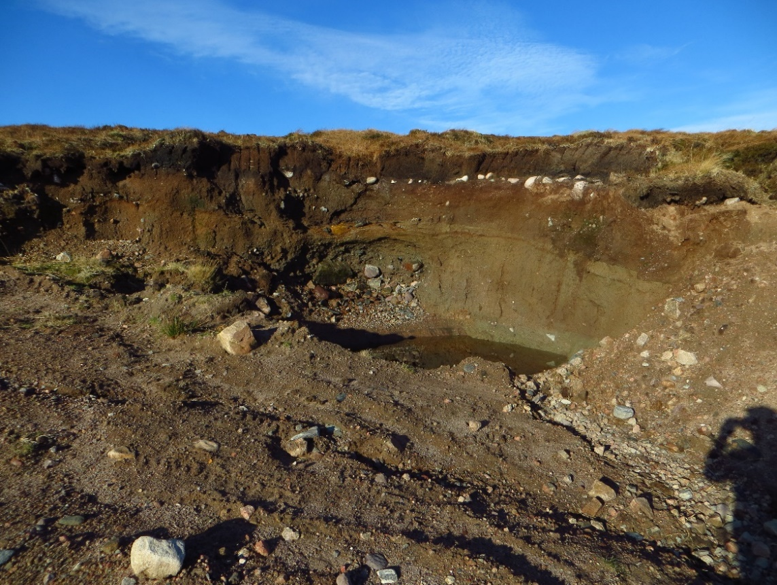

Long-standing track and borrow pit continuing to cause problems – Kervaig, Sutherland, March 2017

1. Despite being specifically targeted at agriculture and forestry, the legislation creating Permitted Development Rights did not adequately define forestry or agriculture purposes. This has made it possible for landowners to claim agricultural use and benefit from Permitted Development Rights to construct tracks which are, in fact, primarily for field sports as it can be difficult for planning authorities to challenge or disprove their claims that the tracks are required primarily for agricultural purposes.
2. Due to the devastating effectiveness of modern machinery, tracks are often used to completely change the character and purpose of many old historical paths that have existed in the Scottish hills and glens for centuries. Some of these are old stalkers’ paths and others have provided through routes for locals and visitors alike. From information sent to the Campaign by members of the public and from its own observations, it has been found that many of these paths are being altered by estates under Permitted Development Rights. If a Prior Notification is submitted, the applicant tends to claim “restoration” or “maintenance”, whereas what is happening on the ground can only be described as the destruction and loss of an historical artefact.

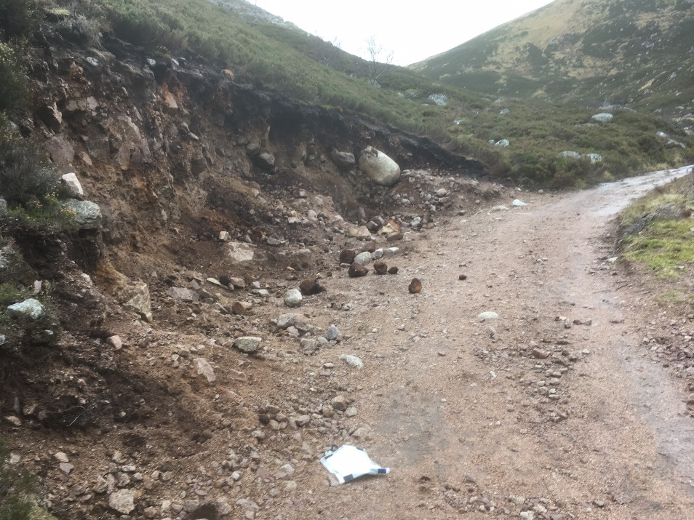

Loch Muick, Cairngorms National Park, December 2016

1. Tracks may never “blend in”, even after decades, and some cause long-term problems with vegetation never recovering and ongoing erosion.

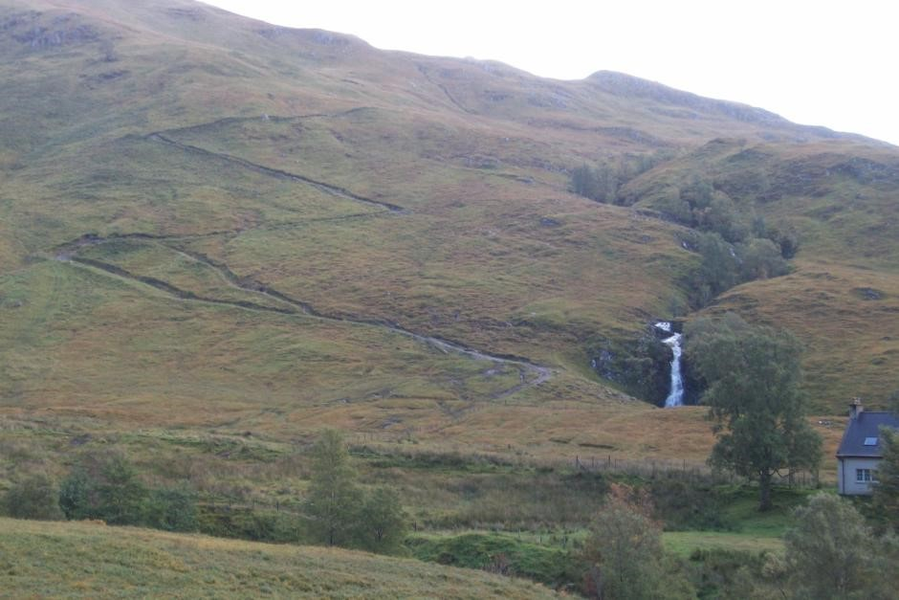

Long-standing track, Iron Lodge, Glen Elchaig, Wester Ross – photographed October 2015.   
 Images on [www.geograph.org.uk/photo/5193548](http://www.geograph.org.uk/photo/5193548) show this to be more than 25 years’ old;   
 note the short cut that has been created.

1. Removal of unlawful tracks following enforcement action, or to rectify past damage, is challenging, costly and time-consuming.

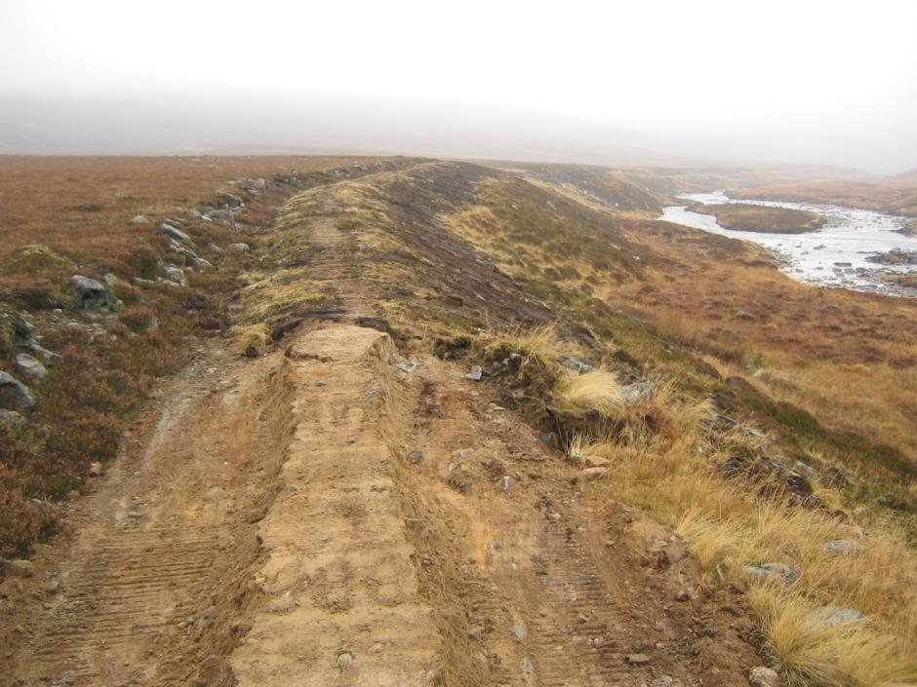

Glen Dee, former vehicle track after and during restoration back to footpath width.   
 Photo credit: National Trust for Scotland

1. Concerns about the adverse impact of poorly-constructed hilltracks and their exemption from planning control have been reflected in decades of campaigning by a number of outdoor and conservation organisations and individuals.
2. In 2007, a report[5] commissioned by the Scottish Executive carried out a review of an earlier Heriot Watt study into the General Permitted Development Order 1992 and confirmed that the legislation relating to track construction needed to be reviewed and updated.
3. To raise this issue up the political agenda, a campaign in 2010 led by Mountaineering Scotland gathered over 2500 signatures to a petition, gained support from a number of MSPs and led to a debate in the Scottish Parliament. In the meantime, Adam Watson’s book “Vehicle hill tracks in northern Scotland: an independent factual report on numbers, distribution, impacts, ground reinstatement” was published in 2011 and argued that:-

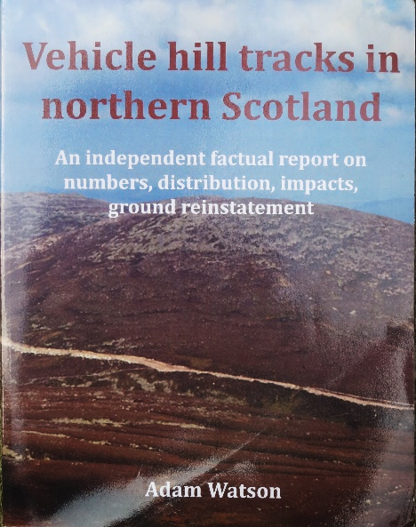

*“This is an opportune time for the present*

*technical report to be published ...it should*

*help elected politicians and government*

*ministers come to new regulations that are fair*

*to all and that minimise impacts on the Scottish countryside for the benefit of all.”*

1. Following this campaign activity, a Scottish Government consultation on Permitted Development Rights was held in 2011 which led to a further consultation[6], in 2012, recommending the removal of Permitted Development Rights, given the “compelling evidence” of the damage caused by tracks provided by respondents to the first consultation. Unfortunately, the Government later changed its mind on this issue and called for more evidence to be provided.

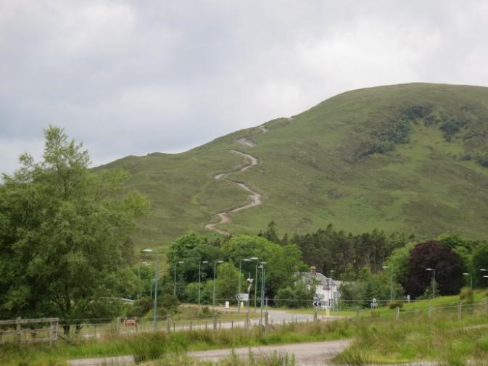

Track at Ledgowan, Achnasheen; photographed June 2017; more than five years after   
 construction it remains highly intrusive in this sensitive landscape

1. The LINK Hill Tracks Campaign has acted as an umbrella for environmental organisations concerned about the impacts of these tracks and has continued to press the case for tighter control. In 2013, in response to the government’s concern over a lack of evidence mentioned above, the Campaign published a major report “Track Changes”[7] which included extensive photographic evidence of the visual and environmental damage that can be caused by the construction of vehicle tracks in sensitive upland landscapes. These impacts include:-
2. serious and wide-reaching visual impacts, leading to the loss of visual and environmental amenity;
3. damage to sensitive vegetation and soils, especially in upland environments;
4. increased disturbance to wildlife;
5. the destruction of peatland and consequent loss of stored carbon;
6. initiation of erosion that often spreads over very large areas and causes silt run-off into waterways;
7. damage to, or destruction of, geological and geomorphological features;
8. devaluation of recreational opportunities

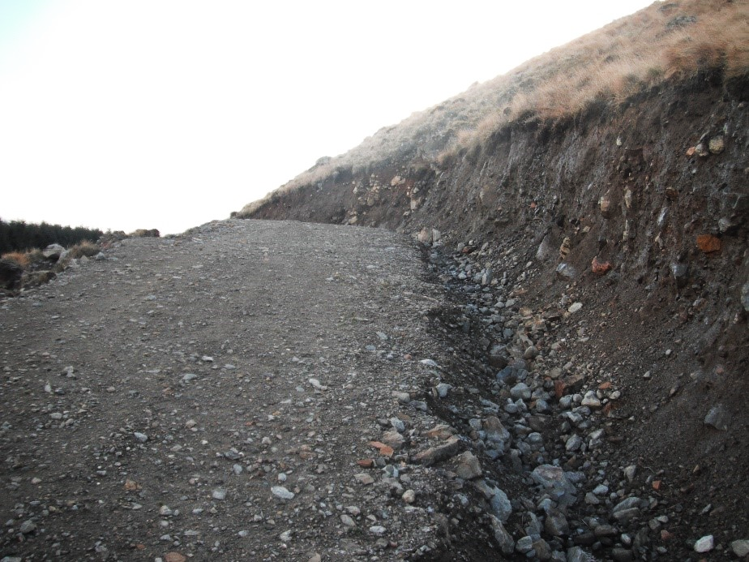

Forestry-related track of concern in Glen Clova, encountered by hillwalker (November 2017)   
 but later found to pre-date the Prior Notification system

1. *“Track Changes”* highlighted that:-
2. some tracks were being constructed under Permitted Development Rights for field sports which are not a qualifying agricultural use;
3. there had been a steady increase in environmental and aesthetic damage;
4. poor construction practices were widespread;
5. tracks can lead to scarring of landscapes including in National Parks and other designated sites;
6. inappropriate track construction was undermining government policy on peatland protection, wild land, sensitive environments and environmental justice;
7. there was potential for the planning system to be subverted by the use of Permitted Development Rights to construct tracks which are then used for subsequent, non-PDR developments with possible damage being caused to an area where development would otherwise have been ruled out;
8. there had been a consequent and rapid increase in the detrimental impacts borne by the wider community and other public interests without any opportunity for public scrutiny through the planning system.

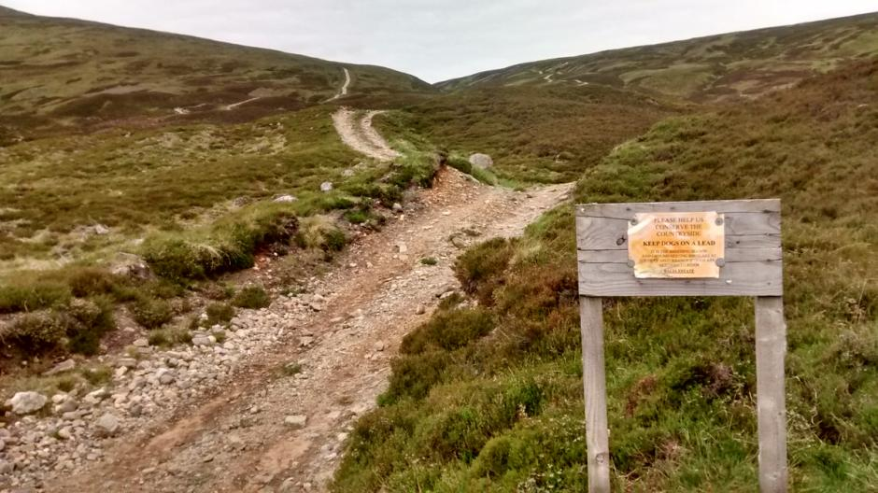

Sign by track at Drumochter urging walkers to help conserve the countryside, photo taken June 2017

1. “Track Changes” concluded that, for these reasons, Permitted Development Rights were no longer appropriate for agricultural and forestry tracks. It set out several broad options for changes to legislation to address these issues, emphasising that developments of the scale and impact set out in the report made a strong case for agricultural and forestry tracks to be brought into the full planning system;
2. In 2014, in response to the Campaign, the Scottish Government announced it would be introducing a requirement for Prior Notification of proposals for agricultural and forestry tracks.[8] It emphasised the role these new controls would play in increasing protection for the Scottish countryside, through giving planning authorities the opportunity to scrutinise proposals and powers to ensure that design, siting and appearance are acceptable. Reflecting the Campaign’s concern about the potential abuse of Permitted Development Rights to construct tracks for non-qualifying purposes such as field sports the Government reiterated that tracks other than for agricultural or forestry use would continue to require full planning permission. The new legislation came into operation in December 2014.[9]
3. The Campaign has played a key role in the monitoring of the Prior Notification system and in raising awareness of issues emerging from this, including:-
4. engaging and meeting with a wide range of stakeholders including Scottish Government and planning authorities, the two National Parks and other relevant interests;
5. producing suggested guidance on assessing proposals for tracks;
6. responding to several consultations on associated guidance and promoting to planning authorities the Campaign’s recommendations with respect to the Prior Notification process;
7. responding to an independent review of the new arrangements[10];
8. recruiting volunteers to assist in monitoring Prior Notifications and other track proposals as notified to planning authorities;
9. engaging directly with planning authorities in relation to the operation of the Prior Notification system in respect of specific examples which raised matters of concern and asking planning authorities to investigate cases of potentially unlawful track construction.

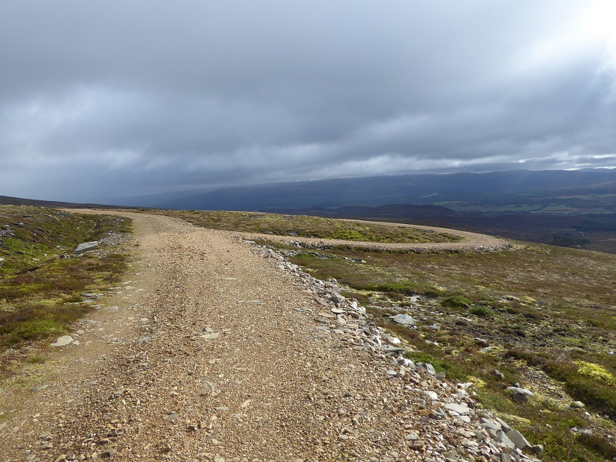

Carn an Fhreiceadain, Cairngorms National Park

1. The Campaign has been publicised through the websites of member bodies, other supporters and the outdoor media. It has secured media coverage through a variety of channels leading to discussion, public engagement and support. Copies of Campaign submissions, correspondence and media coverage can be viewed on the Campaign’s website.[11]

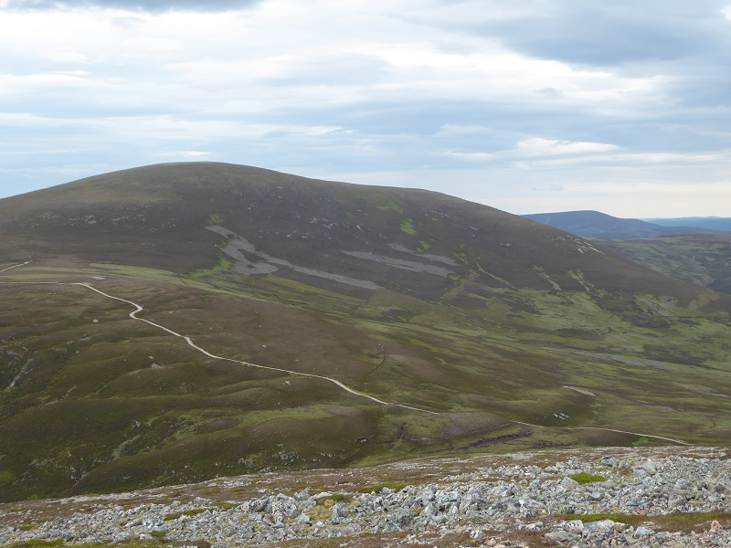

*Culardoch, Cairngorms National Park*

# 4. The Prior Notification system

1. The Prior Notification arrangements for agricultural and forestry tracks were brought into effect as a result of the Town and Country Planning (General Permitted Development) (Scotland) Amendment (No. 2) Order 2014 (SSI 2014 No. 300).[12]
2. Scottish Government Planning Circular Consolidated Circular on Non-Domestic Permitted Development Rights[13] provides guidance to how the legislation is to be implemented.
3. The new system requires any landowner wanting to build or substantially alter vehicular agricultural or forestry tracks under Permitted Development Rights to give the relevant planning authority “Prior Notification” of the proposed works. Landowners or their agents must submit details of their proposed works to the relevant planning authority, covering aspects such as design, manner of construction, proposed route and materials to be used.
4. A key principle of the system is that a proposed track must be necessary for an agricultural or forestry use or purpose. Exactly what constitutes agricultural or forestry use is not clearly defined, although certain criteria, including some exemptions from Permitted Development Rights under EIA regulations, are set out.
5. There are some variations in the treatment of agricultural and forestry tracks, notably that for forestry no minimum area of land is specified and different EIA regulations and procedures apply. For both agricultural and forestry tracks there are no Permitted Development Rights for vehicular tracks within National Scenic Areas unless for a forestry track as part of an approved afforestation scheme. If the construction or alteration of a track is likely to have a significant effect on a Special Protection Area (SPA) or Special Area of Conservation (SAC), it would not be permitted development unless the planning authority has given its written approval after concluding that it would not adversely affect the integrity of the SPA/SAC. Permitted Development Rights may also be restricted or removed by conditions attached to a planning consent or by an Article 4 Direction.
6. No fee was set for Prior Notifications relating to tracks, in contrast to full planning applications.
7. When processing a Prior Notification, planning officials must decide whether it meets the criteria for Permitted Development Rights. If the planning authority considers it meets those requirements, it has no remit to consider the principle of whether the development should be permitted as that has already been established under the General Permitted Development Order. However, if the planning authority does not consider that the proposed track is for agricultural or forestry use, it will generally require full planning permission.
8. Planning authorities have a 28 day window to process Prior Notifications and are encouraged under the Circular to process them as quickly as possible. If an applicant has not heard back from the planning authority within 28 days they may start work on the track.
9. When considering Prior Notifications, planning authorities are required to take into account the operational needs of the farming and forestry industries and “*the normal considerations of reasonableness.”* They must also consider aspects such as visual impact, flood risk, local amenity and environmental impacts to soils, water, wetlands etc.
10. The planning authority also has an option during the 28 day window to impose a requirement for “Prior Approval.” This gives the planning authority scope to give closer scrutiny to a proposal. If this is the case the applicant is not permitted to start work until Prior Approval is granted. If a planning authority makes a Prior Notification subject to a requirement for Prior Approval it is likely to request further information from applicants as part of this process. A planning authority has the power to refuse Prior Approval. There is a right of appeal in such circumstances.
11. There is no obligation on planning authorities to publish Prior Notifications online but the guidance suggests that this might be done “*in the interests of transparency and public awareness.”*

1. The flowchart below has been reproduced from the Scottish Government Circular and sets out the steps in the Prior Notification process.

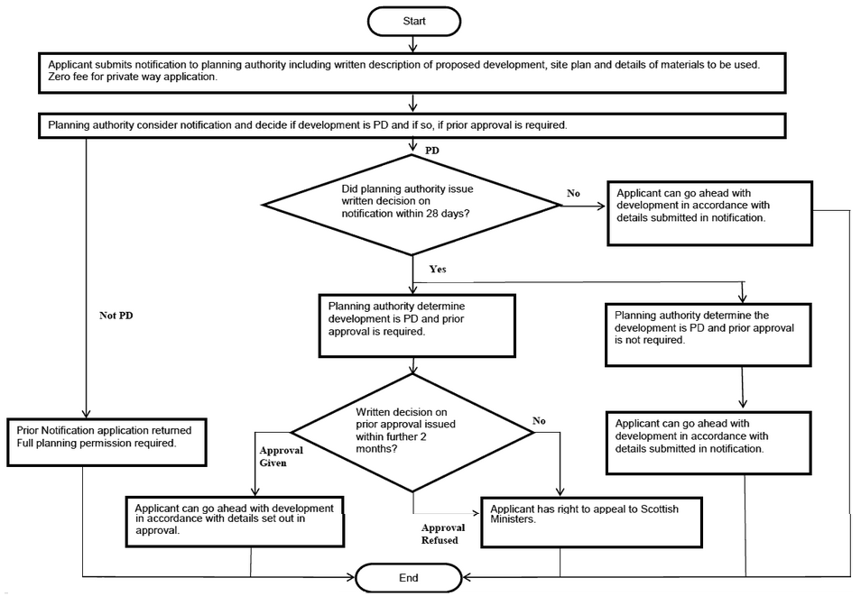

*Image reproduced from the Scottish Government Circular.[14]*

## *4.1 Guidance available to applicants*

1. **The Scottish Government issued a consultation on its guidance in April 2015. The Campaign responded to this**[15] and also submitted further comments on the guidance following the Scottish Government’s 2016 review of the Prior Notification system.[16] It considered that the exact wording and content of the guidance was important to ensure the Prior Notification system operated as effectively as possible. The Campaign shared its comments with planning authorities for dissemination to planning staff as it did not appear that the Scottish Government guidance was due to be updated.
2. Scottish Natural Heritage produced a “best practice” guide to constructed tracks in the Scottish uplands in 2005. This was updated in 2013, then again in 2015 to reflect the introduction of the Prior Notification system.[17] Summary guidance was also published in March 2017 “Key natural heritage considerations in track construction: a quick guide”.[18]
3. It is understood that only one local authority (Highland Council) has developed its own guidance to complement the Scottish Government guidance *– “Interim guidance on agricultural and forestry ways*”.[19] The Cairngorms National Park Authority published a planning advice note in spring 2015 referencing the new arrangements - *“Planning Advice Note: Planning Permission and Permitted Development Rights for Agricultural and Forestry Tracks*”.[20]
4. Scottish Land & Estates has also developed guidance for landowners and managers *– “Key natural heritage considerations in track construction”.* This highlights key considerations when planning and designing tracks under the new arrangements, cross-referencing to the SNH guidance for more detailed information.
5. The forestry industry references the Prior Notification system in its industry framework and documentation. It published a briefing note in November 2015 to help identify and outline what would be expected by way of alignment of information required by the existing forestry consenting procedures and the new requirement for Prior Notifications for forestry tracks.[21]

# 5. Monitoring the new system

1. Following the introduction of the Prior Notification system for agricultural and forestry tracks, the Campaign remained concerned that it would not be sufficient to ensure that all track construction was justifiable under Permitted Development Rights nor stop potentially damaging tracks from being built. There was also recognition of the need to monitor the effectiveness of the implementation of the December 2014 Order and the appropriate adoption of the new system.
2. To evaluate how the new system worked in practice the Campaign set up a project to monitor Prior Notifications for agricultural and forestry tracks. The Campaign recruited a team of volunteers who reviewed online weekly planning lists and passed details of Prior Notifications for vehicular agricultural or forestry tracks to a central co-ordinating point for recording and closer scrutiny where they were of particular interest or concern. When reviewing Prior Notifications, the Campaign considered the extent to which these met the qualifying criteria and the quality and adequacy of the information provided. In a limited number of cases, Prior Notifications were tracked through the system to see how these were treated by the planning authority and the outcome of that process.
3. Monitoring was focused on planning authority areas which included upland areas, and excluded those areas where it was considered there would not be, or would only be, very occasional Prior Notifications for agricultural or forestry tracks given their largely urban topography. In total 12 areas were monitored, including Scotland’s two National Parks. The areas monitored are shown in the table below.

***Table showing local authority/planning authority areas monitored by the Hill Tracks Campaign***

|  |  |
| --- | --- |
| ***Local Authority/Planning Authority Area*** | ***Notes*** |
| Aberdeenshire Council | *Includes part of Cairngorms National Park (note that the Cairngorms National Park Authority does not have its own full planning powers)* |
| Angus Council | *Includes part of Cairngorms National Park* |
| Argyll & Bute Council |  |
| Comhairle nan Eilean Siar |  |
| Dumfries & Galloway Council |  |
| Highland Council | *Includes part of Cairngorms National Park* |
| Loch Lomond and The Trossachs National Park Authority | *Has its own planning powers* |
| Moray Council | *Includes part of Cairngorms National Park* |
| Perth & Kinross Council | *Includes part of Cairngorms National Park* |
| Scottish Borders Council |  |
| South Lanarkshire Council |  |
| Stirling Council |  |

1. Volunteers were not asked to record agricultural Prior Notifications that could clearly be identified as low-level tracks associated with farm buildings or enclosed low-level fields. As such, the Campaign recognises that its monitoring does not present a complete picture of all the Prior Notifications for agricultural and forestry tracks submitted to the relevant planning authorities during the monitoring period.
2. It should also be noted that the Campaign had limited capacity to revisit all Prior Notification entries at regular intervals to review their progress through the system and their final outcomes. Records were updated where possible, generally where a case was of particular interest to the Campaign. The actual number of Prior Notifications that became subject to a requirement for Prior Approval may, therefore, be higher than the figures shown in this report.
3. Monitoring took place from mid-September 2015 to mid-April 2018, during which period more than 400 Prior Notifications were recorded, of which more than three quarters were for forestry purposes. These predominated in most planning authority areas, with the exception of Aberdeenshire, Angus and the Western Isles. No agricultural Prior Notifications were reported by the volunteers for two areas (Moray and Loch Lomond & Trossachs National Park). The split between agricultural and forestry tracks is a similar proportion to that found in the independent research carried out for the Scottish Government in 2016, a year after the introduction of the Prior Notification system. More than three quarters of the 279 Prior Notifications submitted to Scotland’s 34 planning authorities at that time were for forestry purposes.[22] The table below shows the breakdown by area and the relative proportions of agricultural and forestry tracks.

***Table showing total Prior Notifications observed (mid-September 2015 to 14 April 2018) with breakdown by area/type***

|  |  |  |  |  |
| --- | --- | --- | --- | --- |
| **Area** | **Number of PNs noted by area (% of total PNs)** | **Number of forestry PNs noted for area (% of area PNs)** | **Number of agricultural PNs noted for area (% of area PNs)** | ***Notes*** |
| Aberdeenshire Council | 49 (11%) | 23 (47%) | 26 (53%) |  |
| Angus Council | 13 (3%) | 7 (54%) | 6 (46%) |  |
| Argyll & Bute Council | 38 (9%) | 35 (92%) | 3 (8%) |  |
| Comhairle nan Eilean Siar (Western Isles) | 4 (1%) | 2 (50%) | 2 (50%) |  |
| Dumfries & Galloway Council | 85 (20%) | 78 (92%) | 7 (8%) |  |
| Highland Council | 60 (14%) | 46 (77%) | 12 (20%) | *+ 2 PNs for which it is not known if they were forestry or agriculture (%s do not therefore achieve 100%)* |
| Loch Lomond and The Trossachs National Park Authority | 30 (7%) | 30 (100%) | 0 (0%) |  |
| Moray Council | 17 (4%) | 17 (100%) | 0 (0%) |  |
| Perth & Kinross Council | 46 (11%) | 39 (85%) | 7 (15%) |  |
| Scottish Borders Council | 55 (13%) | 49 (89%) | 6 (11%) |  |
| South Lanarkshire Council | 11 (3%) | 10 (91%) | 1 (9%) |  |
| Stirling Council | 20 (5%) | 18 (90%) | 2 (10%) |  |
| **TOTALS (number)** | **428** | **354** | **72** | **2** |

1. Volunteers were also asked to report on full planning applications for tracks which might have an adverse impact on upland or remote landscapes. More than 50 full planning applications were recorded, including agricultural and forestry tracks that were subject to a full planning application due to being located within a National Scenic Area or not qualifying for Permitted Development Rights for another reason. A significant number of full planning applications were for the permanent retention of tracks associated with construction projects. Volunteers also identified a number of other development proposals including wind farms, hydro schemes and telecommunications mast installations which had associated tracks. All these are subject to full planning permission and/or other consenting arrangements but review of these has enabled comparison between the different consenting arrangements and also identified a number of general issues with respect to track design and construction.
2. The Campaign considers that the monitoring process has given a valuable evidence base that enables it to comment with some authority on how the Prior Notification system is working in practice. The Campaign is not aware of any other monitoring exercise being undertaken.

# 6. Observations from the monitoring process

## *6.1 Qualifying use – a grey area*

1. The key test for tracks to be exempt from a requirement for full planning permission is that they meet the criteria for Permitted Development Rights, namely that they are for agricultural or forestry use.
2. The Campaign has previously emphasised that the tracks generally of most concern are not those which are for genuine agricultural or forestry purposes. It remains, therefore, concerned about tracks for which agricultural use is claimed but which it is likely are primarily for field sports such as grouse moor management and deer stalking. For example, the Campaign has urged the Scottish Government to ensure that its current review of the environmental impact of grouse moor management practices includes consideration of the very significant environmental damage and detrimental landscape impact caused by the construction of hilltracks related to the growing intensification of this industry.[23]
3. The legislation is quite clear that tracks for sporting use require a full planning application. However, the Campaign considers that in practice it can be difficult for planning authorities to be confident that all tracks said to be for agricultural use are legitimately for these purposes. The Scottish Government Circular sets out certain criteria and conditions to help planning authorities in determining what constitutes qualifying use, giving some definition of “agricultural land.”[24] However, “agricultural *use or purpose*” is not specifically defined in a legal manner and there are no further or universal and precise guidelines to help with this. The Campaign considers that applicants may regularly claim justification for tracks for agricultural use on the basis that they are needed for sheep flock management/welfare but in situations where this is not the primary purpose of the track. Sheep may only be present as “tick mops” which, in the Campaign’s opinion, is not for genuine agricultural purposes. The Campaign has reviewed location plans for many tracks claimed to be for agricultural use which, when cross-referenced to OS maps and aerial photos, clearly show the presence of grouse butts, thereby raising concerns as to their likely primary use. Claims of agricultural use can also be made when the more likely purpose is deer stalking, potentially illustrated by the following statement which was noted in sales particulars for the Ledgowan estate near Achnasheen in Wester Ross. These tracks were highlighted in the “Track Changes” report for their negative landscape and environmental impact, despite being built ostensibly for agricultural purposes under Permitted Development Rights:-

*“Accessibility to the majority of the hill ground has been transformed by the construction  
of a network of hill roads. This significantly expands the scope of the stalking to enable  
 those of all levels of physical fitness ...”[25]*

1. When considering Prior Notifications for tracks, planning authorities are dependent on the integrity of applicants as to intended use and on the applicant providing sufficient detail about the purpose of the track for planning officials to reach a conclusion as to whether the works qualify for Permitted Development Rights. It has to be recognised that there may be a temptation for applicants to submit Prior Notifications with limited information about the purpose of a track in the hope that planning authorities accept that the proposal qualifies for Permitted Development Rights. Many of the Prior Notifications reviewed by the Campaign made only brief reference to the need for a track, in some cases simply stating “agricultural use” or that the land was on a registered agricultural holding. Feedback from one planning authority has previously noted that:-

*“it is not always straightforward to determine if a private way meets the criteria to fall*

*under PDR. If a developer is insistent, notwithstanding any suspicions to the contrary,*

*that a private way meets the relevant criteria then we may need to progress the*

*notification under the Regulations.”*

1. Feedback from another planning authority referred to the lack of clarity in the Scottish Government guidance as to what constitutes agricultural and forestry works. Whilst the planning authority concerned said that it would “refuse a submission” where it is clear at the outset that information is inaccurate (such as when tracks are intended for sporting use), it also noted that applications are routinely processed on the basis of the declaration of use the applicant has made. Furthermore, the planning authority said that it was unlikely to check the actual use of a track, such as through a site visit at a later stage, even if concern was raised by a third party.
2. The Campaign’s monitoring also identified a number of Prior Notifications which included reference to other potential benefits such as public access and recreational use, the safety and the welfare of estate staff, quicker access in the event of wildfires, and to assist in meeting deer cull targets and the potentially adverse impacts on habitats from failing to meet these. Whilst these uses might be considered reasonable or even desirable, they are not qualifying purposes in themselves and should not be used in an attempt to justify tracks under Permitted Development Rights. Unless these functions are secondary to a primary and genuine agricultural purpose of the track, the construction or alteration of such a track would require full planning permission.
3. There appears to be less of an issue about satisfying the requirement for Permitted Development Rights in the case of forestry tracks due to the additional regulations which apply to many forestry operations, for example the requirement for approved forest plans. This makes it possible to cross-reference to other documentation that helps to demonstrate that the intended use is as specified. This was confirmed in feedback from planning officials from one area who noted that qualifying purposes were generally clear where proposals related to forestry operations such as planting or felling. Nonetheless, the Campaign has seen some Prior Notifications which gave minimal information about intended use, which assumed that forestry use would be taken as read or which may have masked predominantly sporting use. A number of Prior Notifications for forestry tracks also made reference to the need to reduce deer numbers to protect woodland creation schemes or gave sporting use as a secondary use, in addition to the primary purpose of general forest maintenance/operations.
4. The following case studies highlight some examples which illustrate the challenges of the “qualifying use” aspect of the Prior Notification system.

**CASE STUDY 1**

|  |  |
| --- | --- |
| **Planning case reference** | **15/01398/AGN** |
| Location | Yetholm, near Kelso |
| Planning authority area | Scottish Borders Council |
| Date | November 2015 |
| Type | Prior Notification |
| Purpose | Applicant ticked box for “farm or forestry-related purposes”. Titled online as “formation of a forestry track”. Application form gives purpose as for “safer and easier access throughout the estate”. |
| Campaign observations | Inadequate justification given as to use - no further detail as to the nature of the forestry operations; safer and easier access throughout the estate is not a justification for Permitted Development Rights. |
| Campaign representation | None |
| Outcome | Planning authority did not appear to request further details about intended use. Prior Approval required and subsequently granted, with conditions specifying an alternative route to protect the character of the Cheviot Foothills Special Landscape Area. |

**CASE STUDY 2**

|  |  |
| --- | --- |
| **Planning case reference** | **APP/2016/1474 (one of several concurrent)** |
| Location | Invercauld, near Braemar |
| Planning authority area | Aberdeenshire Council (CNPA) |
| Date | May 2016 |
| Type | Prior Notification |
| Purpose | Repair of agricultural tracks, for sheep management. |
| Campaign observations | Campaign considered the track might be predominantly for sporting use - supporting information detailed sheep management requirements/agricultural use in some detail. Supporting information referred to “ancillary activities” including public access and moorland management, noting that whilst sporting pursuits are not agricultural use, it was considered desirable to improve existing tracks to prevent further damage to moorland. CNPA raised the possibility of sporting use following review of site plans, OS maps and aerial photography in relation to this Prior Notification and concurrent ones. |
| Campaign representation | None |
| Outcome | Prior Approval not required |

**CASE STUDY 3**

|  |  |
| --- | --- |
| **Planning case reference** | **15/03759/PNO** |
| Location | Dunnachton, Alvie |
| Planning authority area | Highland Council (CNPA) |
| Date | October 2015 |
| Type | Prior Notification |
| Purpose | “the formation of a hill track section to connect to the existing network”; reference to repair required. |
| Campaign observations | Inadequate detail given as to justification - application form simply specified that the track work was required to provide a useable track, extending an existing track. A box for “farm-related works” on the application form was ticked but no further details regarding proposed use were supplied. |
| Campaign representation | North East Mountain Trust; Scottish Wild Land Group |
| Outcome | Further information about agricultural use requested. Prior Approval required in relation to design/siting. Subsequently granted.  Report of handling notes that representations were received about intended use and that agricultural use and possible sporting use were not clear but stated that this line of enquiry was not pursued on the basis that the track was a deviation of part of an existing route rather than completely new and as the principle of moving stock from one side of the river to the other had been established by current practice. |

## *6.2 Is the Prior Notification process given due attention?*

1. The Scottish Government Circular sets out the application process to be followed for agricultural and forestry tracks under the Prior Notification system; this suggests that planning authorities should provide guidance to applicants as to what information they are required to submit, as well as stressing the importance of applicants supplying sufficient detail in support of their Prior Notification.
2. Planning authority application forms for Prior Notifications provide a template and checklist for gathering relevant information and the Campaign saw some evidence of Prior Notifications being returned to applicants as invalid where they were missing information or there were mistakes or inaccuracies in basic details. The Campaign recognises that some applicants take care to submit carefully considered Prior Notifications. However, the Campaign considered that too many of the Prior Notifications it reviewed provided the bare minimum of information and lacked sufficient detail to enable planning officials to properly assess proposals, both in terms of satisfying themselves as to qualifying use as well as with respect to important aspects such as siting, design and construction methods. This is an issue that is not exclusively a feature of Prior Notifications – the Campaign has also seen some full planning applications for tracks which lack sufficient detail. However, the Campaign is concerned that applicants may not take the Prior Notification system as seriously as the full planning application process. Independent research carried out for the Scottish Government in 2016 noted that *“there was a mixed response from planning authorities on the quality of prior notifications submitted”.[26]* Feedback the Campaign has received from several planning officials more recently has noted a continuing wide variation in the quality and detail of information submitted and the need to often ask applicants for additional or clearer information.
3. A lack of detail in Prior Notifications not only makes it harder for interested parties to be confident about whether track proposals qualify for Permitted Development Rights but also about whether sufficiently careful attention has been given to key considerations such as siting, design and construction, which are important in terms of minimising the impact of tracks.
4. The Campaign’s monitoring identified the following routine deficiencies in Prior Notifications:-
5. a tendency to give *minimal and generic information* *which does not reflect or take into account site-specific, local conditions,* such as how and where different types of track construction techniques will be needed to reflect variations in the terrain and/or substrate to be crossed. Many rely on a general reference to, or copies of, extracts from standard industry guidance;
6. *inadequate or difficult to interpret maps, site and location plans* - maps can be poor quality, often of an inappropriate scale or not scaled nor referenced to the Ordnance Survey system, making it difficult to place track locations in their geographical context. (One planning authority commented to the Campaign that clearer location and site plans were often needed and that it can be difficult to establish where the proposed sites are);
7. *low awareness of/lack of reference to the presence of natural heritage features, designated sites and Wild Land Areas* – there were several cases where tracks were proposed within nationally-significant Wild Land Areas or, in one case a National Scenic Area which would require a full planning application, but no reference was made to this;
8. *a tendency to overlook or to make inadequate provision for potentially significant issues* such as the risk of disturbance to ground nesting birds, bank stability issues from proposed stream crossings, the potential for riparian damage or silting of sensitive freshwater habitats, impacts on groundwater dependent terrestrial ecosystems (GWDTEs), the likelihood of the presence of peat and the need to conserve it etc.
9. *a lack of Access Management Plans, Design Management Plans, Construction Environmental Management Plans and Construction Management Plans* – all of these help to ensure all aspects of a development proposal have been fully considered at design and application stage as well as providing clear guidance for contractors when works are under way.
10. If planning authorities are not satisfied that they have received sufficient details or that alterations to the details submitted may be needed, there is provision in the legislation to make a Prior Notification subject to a requirement for the closer scrutiny of Prior Approval. The guidance suggests that Prior Approval can nonetheless be avoided through direct contact and discussion with the developer to resolve any concerns the planning authority may have. The Campaign assumes that the Scottish Government did not intend the option to require Prior Approval to be used to routinely address *poor quality* applications in terms of the level of detail and information submitted, rather that it be reserved for more substantive issues about design, siting, construction and mitigation of impacts on natural heritage features. However, there seems to be an unsatisfactory lack of clarity and consistency around the reasons for making a Prior Notification subject to a requirement for Prior Approval.
11. The research carried out as part of the Scottish Government’s review a year after the Prior Notification system had been introduced suggested that the main reason that planning authorities required a Prior Notification to be subject to Prior Approval was due to insufficient detail. Similarly, the Cairngorms National Park Authority noted in a Board paper in January 2016 that it felt that many Prior Notifications lacked the information necessary to allow it to make a meaningful assessment and that as a result it often recommended to the relevant planning authority that further information was needed along with Prior Approval.[27]
12. The Campaign noted a number of Prior Notifications where planning officials requested clarification, further details or additional documents. This was sometimes done within the 28 day period without a requirement for Prior Approval; at other times Prior Approval was required. In one case, an applicant was notified that Prior Notification had been refused owing to the sensitive location and potential impacts of their proposal and that it would therefore need to be subject to “further planning approval.” The applicant submitted a new Prior Notification (given a separate reference number) where more detail and justification for the proposals were set out. The Campaign assumes this might also have been dealt with through keeping the original Prior Notification open through requiring submission of more detailed information as part of the Prior Approval process as has been observed in other cases.
13. The following case studies illustrate some of the issues relating to the quality and adequacy of the information provided in Prior Notifications.

**CASE STUDY 1**

|  |  |
| --- | --- |
| **Planning case reference** | **17/00692/PNOT (CNPA 2017/0192/NOT)** |
| Location | Torbin Wood, |
| Planning authority area | Moray Council (CNPA) |
| Date | May 2017 |
| Type | Prior Notification |
| Purpose | Proposed access track. 55m of upgraded track and 75m new track for timber extraction. |
| Campaign observations | Insufficient detail with no apparent justification of use - CNPA commented to Moray Council that it was “unable to provide a meaningful response as there is insufficient detail provided on the location and route of the proposed private way”. (It would not, however, seek to call it in if it went to Prior Approval given the nature and scale of the works proposed). |
| Campaign representation | None |
| Outcome | Prior Approval not required. Report of handling refers to track being required for timber extraction but this was not apparent to observers at the time of submission. |

**CASE STUDY 2**

|  |  |
| --- | --- |
| **Planning case reference** | **17/00794/NAG & 17/00794/NPA** |
| Location | Killin |
| Planning authority area | Stirling Council |
| Date | October 2017 |
| Type | Prior Notification |
| Purpose | Formation of 6km of forestry track |
| Campaign observations | Poor quality application - lack of adequate construction detail, with no site specific detail and potential for silting of the loch as no evidence had been given as to how this would be avoided. Crosses 16 watercourses. The planning authority’s archaeologist also expressed concerns and recommended a Desk Based Assessment and Walkover Survey be carried out. |
| Campaign representation | Scottish Wild Land Group (also Mountaineering Scotland) |
| Outcome | Prior Approval required – approved with a number of conditions to protect landscape, cultural and natural heritage aspects. Comments from interested parties may have resulted in closer scrutiny/request for additional information and the setting of the requirement for Prior Approval. |

**CASE STUDY 3**

|  |  |
| --- | --- |
| **Planning case reference** | **17/1911/DPA** |
| Location | Knock of Luce, Kirkcowan |
| Planning authority area | Dumfries & Galloway Council |
| Date | October 2017 |
| Type | Prior Notification |
| Purpose | Formation of 600m of forest road |
| Campaign observations | Superseded a previous Prior Notification due to need to change line. Poor quality application - standard documentation that was not adequately site-specific. Included a copy of a diagram taken from a Civil Engineering Handbook referring to “roads across peatland” but no information was given as to which of three possible methods would be used nor where. |
| Campaign representation | None |
| Outcome | Prior Approval not required |

**CASE STUDY 4**

|  |  |
| --- | --- |
| **Planning case reference** | **16/01978/PNO** |
| Location | Aberarder |
| Planning authority area | Highland Council |
| Date | June 2016 |
| Type | Prior Notification |
| Purpose | Formation of an access track for agricultural purposes (moving sheep with agricultural machinery). |
| Campaign observations | Minimal design and construction details and no reference to following standard guidance on track construction. (The original application form cannot be seen online at the time of writing). |
| Campaign representation | None |
| Outcome | Prior Approval required due to insufficient information to assess the proposal, with information required about a number of aspects including the location of borrow pits and the extent of excavation, sections to show a range of issues including the width of the construction corridor, any cut and fill required and the details of cross drainage. The outcome of this case could not be seen online at the time of writing. |

## *6.3 More than “maintenance”?*

1. There is no requirement under the legislation to notify planning authorities of an intention to carry out maintenance or repair of an agricultural or forestry way but Prior Notification is required for more substantial works that are considered “alteration.”
2. The Scottish Government guidance recognises that it may be difficult to determine the difference between maintenance/repair and alteration and seeks to address this by giving clear examples of the two:-

***“maintenance work*** *could include routine repairs ... such as filling*

*potholes or clearing drainage channels or replacing culverts ...*

whilst:-

“*work such as* *resurfacing to provide a materially different road surface   
(for example replacing loose gravel with tarmacadam), or to widen or  
 extend a track, would generally be considered an ‘alteration’”.[28]*

1. **The guidance also stresses the importance of developers and landowners** checking with planning officials if they are unsure whether their proposed work qualifies as “maintenance/repair” or “alteration”. It also suggests that planning authorities should consider developing their own guidance on this issue.
2. T**he Campaign’s experience is that the definitions of “maintenance/repair” and “alteration” of tracks are nonetheless being interpreted differently, both by landowners and by planning authorities. For example, some do not seem to appreciate that widening a track is more than “maintenance” and, as such, should be the subject of a Prior Notification. Some may even be taking advantage of the “maintenance” exemption to significantly re-engineer a track which might not be given approval if a Prior Notification had been submitted. Either way, th**e effect of such differences in interpretation means that there is potential for significant track work to bypass the planning system altogether.
3. As noted previously, many of the Prior Notifications reviewed by the Campaign were for forestry tracks. The Campaign considers that in general the distinction between “maintenance/repair” and “alteration” is more easily established for forestry tracks in comparison with agricultural. It would be difficult to claim that the level of work required on forestry tracks for felling and extraction by heavy machinery would qualify as “maintenance/repair”, although there have been some exceptions to this rule which have shown the potential for serious landscape and other impacts.

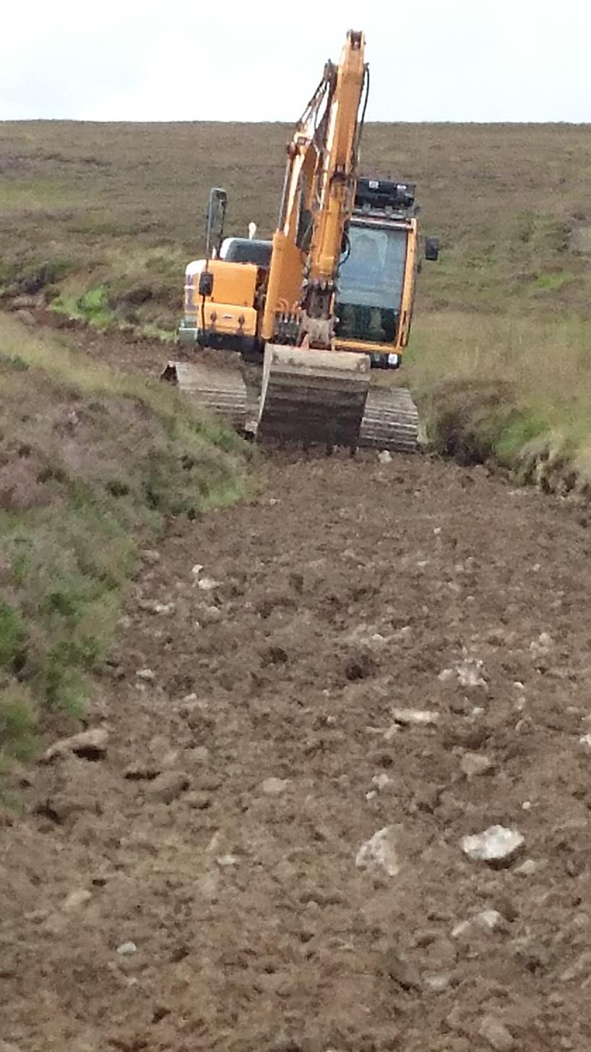

*Maintenance/repair – or more substantial upgrade requiring   
Prior Notification? Glen Clova, summer 2017.*

1. The Campaign is less confident about the interpretation and application of the legislation with respect to agricultural tracks. Hillwalkers have drawn the Campaign’s attention to several cases of what seemed to be current or recent track works, expressing concern at the scale of the works and the impact on open hillsides. In these cases the Campaign reviewed relevant planning lists to look for evidence of a Prior Notification. If this could not be found, the Campaign contacted the relevant planning authority to establish whether the works were the subject of a Prior Notification of which the Campaign was not aware, whether it was considered that the work constituted genuine maintenance (and was therefore exempt from a requirement for Prior Notification) - or whether the work had been undertaken without respect for, or out of, ignorance of the requirement for Prior Notification. A number of these cases were considered by planning authorities to constitute “maintenance/repair” whilst the Campaign felt they **constituted more substantial “alteration” that should have required a Prior Notification.**
2. **Damage can and has been done in this way due to the wording of the legislation, sometimes to relatively unobtrusive, historic and/or culturally-significant routes. Enforcement is difficult in such cases - once work has been carried out it is difficult to prove the original scale and/or condition of the track, unless there is reliable photographic evidence to illustrate this.**

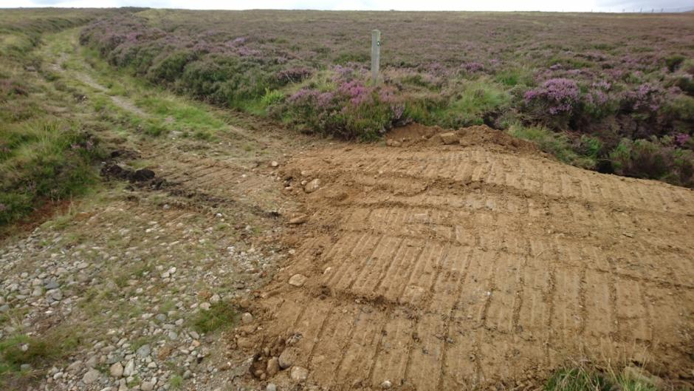

*Maintenance/repair – or more substantial upgrade requiring Prior Notification? Glen Clova, summer 2017. Note Right of Way sign in background.*

1. **The following Case Studies illustrate some of the difficulties that can be encountered in the assessment of whether a Prior Notification is required or a track is merely undergoing small scale repairs or maintenance.**

**CASE STUDY 1**

|  |  |
| --- | --- |
| **Planning case reference** | **N/A** |
| Location | Invergeldie |
| Planning authority area | Perth & Kinross Council |
| Date | August 2016 |
| Type | N/A |
| Purpose | N/A |
| Campaign observations | Members of the public alerted the Campaign to a Facebook post which discussed how a digger had been hired “to mend and create the hill roads” to get ready for the Glorious Twelfth. No evidence of a Prior Notification. Works constituted more than maintenance and should therefore have required a Prior Notification, if not a full planning application due to sporting use. |
| Campaign representation | LINK Hill Tracks Campaign had extensive correspondence with the planning authority and pursued enforcement over a period of around 6 months. |
| Outcome | Eventual site visit by planning officials; original aspiration of planning authority to take out enforcement action was dropped as they were persuaded by the landowner who claimed works constituted repair of existing tracks. |

**CASE STUDY 2**

|  |  |
| --- | --- |
| **Planning case reference** | **17/00401/PRIORN (not located online)** |
| Location | Glen Clova |
| Planning authority area | Angus Council |
| Date | July 2017 |
| Type | Prior Notification |
| Purpose | N/A |
| Campaign observations | Differences of interpretation as to what constitutes routine maintenance - no evidence of Prior Notification found after a hillwalker alerted the Campaign to work underway. Photos supplied suggested the work was more than routine maintenance and should therefore have required a Prior Notification. |
| Campaign representation | North East Mountain Trust |
| Outcome | Planning authority investigation revealed a Prior Notification had been submitted but the authority had concluded it was not required as the work was considered routine maintenance limited to infilling pot holes and a commitment had been given that the existing track would not be widened. Not available to view online. |

**CASE STUDY 3**

|  |  |
| --- | --- |
| **Planning case reference** | **N/A** |
| Location | Borestane, Pentland Hills Regional Park |
| Planning authority area | Edinburgh City Council |
| Date | July 2017 |
| Type | N/A |
| Purpose | N/A |
| Campaign observations | Differences of interpretation as to what constitutes routine maintenance - no evidence of Prior Notification found online after hillwalker alerted Campaign to c2.5km of substantially-upgraded track with new surface material and a digger on site. Campaign considered this did require Prior Notification. |
| Campaign representation | LINK Hill Tracks Campaign |
| Outcome | Planning officials advised work considered to be maintenance and did not require Prior Notification. |

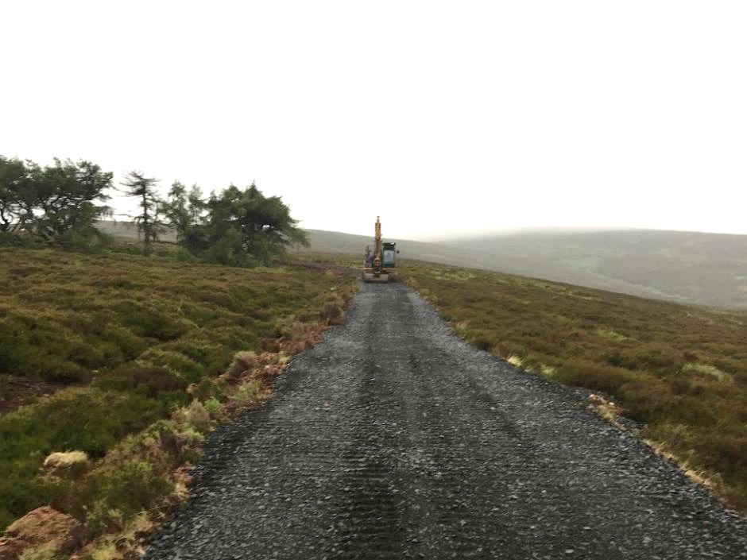

*Borestane, Pentland Hills Regional Park, summer 2017. Work considered to be “maintenance/repair” not requiring Prior Notification*

**CASE STUDY 4**

|  |  |
| --- | --- |
| **Planning case reference** | **N/A** |
| Location | Coilessan Glen (Cowal Way) |
| Planning authority area | Loch Lomond and The Trossachs National Park |
| Date | June 2017 |
| Type | N/A |
| Purpose | Forestry |
| Campaign observations | Differences of interpretation as to what constitutes maintenance. Campaign alerted to widening of/work on a forestry track. No evidence of a Prior Notification found online. |
| Campaign representation | None (the Campaign was aware other parties were pursuing this case). |
| Outcome | Detailed correspondence between correspondent and planning officials in relation to interpretation of Scottish Government Guidance in relation to maintenance and requirements for Prior Notification or otherwise. A Prior Notification had been submitted for one section but additional works appeared to have been carried out 250m from the original proposal and should have been included in the opinion of the correspondent. |

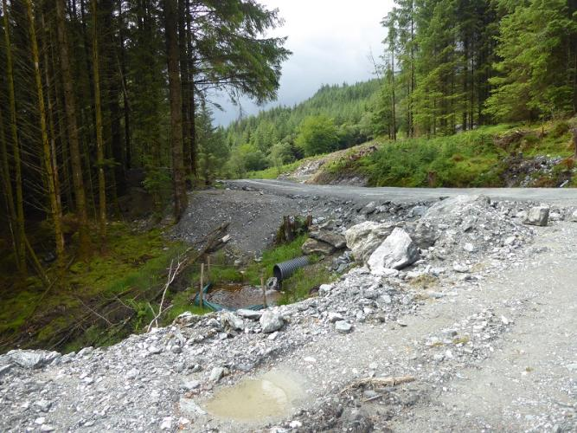

*Coilessan Glen forestry track: restoration anticipated*

**CASE STUDY 5**

|  |  |
| --- | --- |
| **Planning case reference** | N/A(later18/00808/FLL) |
| Location | Ardtalnaig, Loch Tay |
| Planning authority area | Perth & Kinross Council |
| Date | June 2017 |
| Type | N/A |
| Purpose | N/A |
| Campaign observations | Differences of interpretation as to what constitutes maintenance - hillwalker alerted Campaign to newly-constructed tracks/potential further work. |
| Campaign representation | North East Mountain Trust asked planning authority to investigate. |
| Outcome | Planning officials confirmed Prior Notification required due to scale of the work and also expressed concern over qualifying use.  Work was required to stop. A subsequent full planning application was submitted in May 2018 for new tracks in the area and permission, in part in retrospect, for the upgrading of some sections of the existing tracks. Planning permission granted July 2018. |

## *6.4 Grounds for refusal?*

1. The provision in the legislation for a planning authority to make a Prior Notification subject to a requirement for “Prior Approval” has already been discussed earlier in this report. It is often used by planning authorities to obtain more details and give it longer to consider proposals. Some examples of reasons the Campaign observed for a requirement for Prior Approval included the need for further details on track width and materials, water crossing implications, impacts on core paths/rights of way and the need to consider potential archaeological interest.
2. The Scottish Government guidance is clear that requiring Prior Approval does not give the planning authority scope to consider the principle of whether the development should be permitted as this has already been established - assuming all other relevant Permitted Development Rights requirements, including the necessity for, and use of, the track for agricultural or forestry purposes, have been met. However, it also says that planning authorities have the power to refuse Prior Approvals *“where there are clear reasons for doing so”.* Significantly, however, the guidance does not give any examples of reasonable grounds for refusing Prior Approvals. There is a right of appeal against refusal of Prior Approval and against any conditions attached to one.
3. The Campaign noted a number of Prior Notifications that became subject to a requirement for Prior Approval and these are summarised in the table below. The Campaign saw little evidence of Prior Notifications being refused. However, it should be noted that the Campaign did not track all Prior Notifications through the system to see their outcome, only revisiting and following those which raised issues of interest or concern. As a result, the data gathered across the areas will not necessarily reflect the actual proportion of the Prior Notifications recorded that have been subject to Prior Approval or which were ultimately refused. Nonetheless, the Campaign is concerned that there is a likely low proportion overall of Prior Notifications that are subject to a requirement for Prior Approval, and fewer still that are refused. This is presumably due to the fundamental principle that agricultural and forestry tracks have Permitted Development Rights and the difficulties of challenging applicants’ claims as to intended use, with the potential for applicants to initiate time-consuming and costly appeals.

The table below shows the number of Prior Approvals by planning authority area as a percentage of the Prior Notifications observed by the Campaign during the monitoring period (NB the caveat in 3. above).

|  |  |  |  |
| --- | --- | --- | --- |
| **Area** | **Number of PNs noted by area (% of total PNs)** | **Number of PNs noted to go to Prior Approval (% of total PNs observed for area)** | ***Notes*** |
| Aberdeenshire Council | 49 (11%) | 5 (10%) |  |
| Angus Council | 13 (3%) | 1 (8%) |  |
| Argyll & Bute Council | 38 (9%) | 1 (3%) |  |
| Comhairle nan Eilean Siar (Western Isles) | 4 (1%) | 0 (0%) |  |
| Dumfries & Galloway Council | 85 (20%) | 1 (1%) |  |
| Highland Council | 60 (14%) | 10 (17%) | *+ 2 PNs for which it is not known if they were forestry or agriculture (%s do not therefore reach 100%)* |
| Loch Lomond and The Trossachs National Park Authority | 30 (7%) | 3 (10%) |  |
| Moray Council | 17 (4%) | 0 (0%) |  |
| Perth & Kinross Council | 46 (11%) | 4 (9%) |  |
| Scottish Borders Council | 55 (13%) | 8 (15%) |  |
| South Lanarkshire Council | 11 (3%) | 0 (0%) |  |
| Stirling Council | 20 (5%) | 1 (5%) |  |
| **TOTALS (number)** | **428** | **34** | **2** |

The following selected case studies are examples of Prior Notifications that became subject to a requirement for Prior Approval, reasons for this where known and eventual outcome.

**CASE STUDY 1**

|  |  |
| --- | --- |
| **Planning case reference** | **17/00711/PNO** |
| Location | Ben Alder |
| Planning authority area | Highland Council |
| Date | March 2017 |
| Type | Prior Notification |
| Purpose | Forestry-related private ways |
| Campaign observations | Planning authority required Prior Approval, requesting information on the implications for water crossings and core paths and existing rights of way. |
| Campaign representation | None |
| Outcome | Prior Approval required - granted subject to a condition relating to two of the proposed water crossings. |

**CASE STUDY 2**

|  |  |
| --- | --- |
| **Planning case reference** | **18/00225/PNAGRI** |
| Location | Skipness, Tarbert |
| Planning authority area | Argyll & Bute Council |
| Date | January 2018 |
| Type | Prior Notification |
| Purpose | Formation of 2km access track |
| Campaign observations | West of Scotland Archaeology Service commented that, while they were aware that this was not a full planning application, the Council may not have sufficient power to require a programme of archaeological work but hoped its recommendations would be taken on board if the planning authority had the option to attach a condition to any consent. Prior Approval required due to archaeological interest. |
| Campaign representation | None |
| Outcome | Prior Approval required - granted with conditions to protect archaeological interest. |

**CASE STUDY 3**

|  |  |
| --- | --- |
| **Planning case reference** | **17/01554/PN** |
| Location | Duns |
| Planning authority area | Scottish Borders Council |
| Date | November 2017 |
| Type | Prior Notification |
| Purpose | Formation of new road for timber extraction |
| Campaign observations | Insufficient construction details. Prior Approval required due to the need for further details on width and make-up. |
| Campaign representation | None |
| Outcome | Prior Approval granted subject to conditions, including requirement for further information on width and make-up to be submitted and approved before work can commence. |

**CASE STUDY 4**

|  |  |
| --- | --- |
| **Planning case reference** | **16/01582/PN** |
| Location | Old Caberston, Walkerburn |
| Planning authority area | Scottish Borders |
| Date | December 2016 |
| Type | Prior Notification |
| Purpose | Formation of new forestry track, to manage newly established woodland. |
| Campaign observations | Minimal detail given when first submitted. The planning authority raised concerns about visual impact given that it would go to the summit of a prominent local hill within the Tweed Valley Special Landscape Area and requested more details. A more detailed map of the woodland planting proposals was subsequently submitted in support. |
| Campaign representation | None |
| Outcome | Prior Approval required - granted with two conditions relating to mitigating landscape impact attached. |

## *6.5 The Prior Notification system – good enough for our most important landscapes and our natural heritage?*

1. Scotland is world-renowned for its landscapes and its many special plants, animals and habitats. Certain habitats and landscapes have been identified as significant at local, national or international scale and have been designated or given special status as a result. These include Sites of Special Scientific Interest (SSSIs) (for example, due to significant geological or plant species) and wildlife sites such as Ramsar wetlands, Special Areas of Conservation (SACs) and Special Protection Areas (SPAs) which are internationally important for threatened habitats and species. National Parks, National Scenic Areas and, more recently, Wild Land Areas, identify areas that are of particular interest for landscape, scenic and wildness qualities.
2. Special planning considerations generally apply to designated sites in relation to the types o development that are permitted, the consenting process to be followed and special provisions that may need to be followed during the construction phase. There are particular provisions for European nature conservation sites (SPAs and SACs) and they will often require full planning permission, whilst proposals which might damage an SSSI require consent from SNH.
3. Nonetheless the principle of Permitted Development Rights still generally applies to agricultural and forestry tracks, with the sole exception of National Scenic Areas where vehicle tracks do not qualify for the Prior Notification process and must be subject to a full planning application unless they are part of an approved afforestation scheme. Additionally, where a development is likely to have a significant effect on a European site (SPA or SAC) and is not directly connected with, or necessary to, the management of the site, Permitted Development Rights do not apply unless approval is first obtained under the 1994 Regulations.[29] Planning authorities can only grant approval in such circumstances if they conclude that the development will not adversely affect the integrity of the European site.
4. The Campaign considers that the lack of an automatic requirement for full planning permission for tracks that can impact on many of these important landscapes and habitats is a major issue. The Campaign is particularly concerned that there is no requirement for a full planning application for tracks within National Parks and Wild Land Areas, unless the particular site happens also to also be within a National Scenic Area or protected or designated in some other way that triggers a requirement for full planning permission. It is therefore possible for landowners to construct or significantly upgrade tracks in large parts of Scotland’s National Parks and Wild Land Areas without the detailed scrutiny of a full planning application, even though these areas have been given special status and are considered to be of national importance. In the absence of full planning applications, members of the public are also less likely to become aware of proposals that will impact on these landscapes and, crucially, are denied an opportunity to comment even though they may have a particular interest in these cases.
5. The Cairngorms National Park Authority (CNPA) has raised concerns about the impact of hilltrack development in unsuitable locations and/or of poor construction, given the significant adverse impacts these can have on the landscape qualities of the Park. It set out a presumption against further constructed tracks in open moorland in its National Park Partnership Plan published in 2017.[30] More recently it has received broad support for its proposal to amend its Local Development Plan to reflect this policy.
6. The CNPA has highlighted the complexity of the Prior Notification system. A planning guidance note for applicants for agricultural and forestry tracks stresses that *“the rules about planning permission, permitted development and tracks are complicated so you should always to speak to your local authority about what you’d like to do before you act”.[31]*
7. The CNPA has also expressed concern about the extent of control it can exert over track proposals under the Prior Notification system. Unlike the Loch Lomond & Trossachs National Park Authority, the CNPA does not have full planning powers and is reliant on an agreement it has reached with local authorities that allows it to “call-in” Prior Notifications that have been made subject to a requirement for Prior Approval (it sees all Prior Notification applications that are submitted to a local authority within the National Park and advises the relevant local authority if it thinks a proposal is significant and requires Prior Approval). The CNPA noted in a submission to the Scottish Government’s recent Planning Review that *“the new Prior Notification arrangements for private ways and tracks are difficult to make work within the ‘call-in’ system”*.[32]
8. The Loch Lomond and The Trossachs Planning Authority (LL&TNPA) does not appear to have expressed the same degree of concern about the impacts of agricultural and/or forestry tracks. It is understood, nonetheless, that the LL&TNPA suggested to the Scottish Government in 2013-14 that full planning permission for all tracks would be preferable to ensure adequate scrutiny. It is understood that, like other commentators, the Park considers the current system is complex for all parties, especially with respect to protected areas and is subject to variances in interpretation, particularly around what constitutes genuine maintenance/repair and more significant upgrading. It is also understood that the Park is concerned about the potential for cumulative impact from a range of different developments in the same location but each subject to a different form of planning control. All of the Prior Notifications identified by the Campaign during the monitoring period for the LL&TNPA were for forestry purposes, reflecting a generally different pattern of land use in comparison to the open moorlands of the CNPA area.
9. In terms of the practical application of the Prior Notification system, the Campaign’s monitoring suggested that many applicants had low awareness of, or failed to make reference to, the presence of designations that might have a bearing on their proposals in terms of the need for particularly careful design. Lack of reference by applicants to Wild Land Areas, for example, was noted in several cases and to a National Scenic Area in another one. Furthermore, it is unclear what, if any, series of checks planning authorities go through to ensure that the presence of designated sites and Wild Land Areas are not missed and the extent to which these may be missed with planning authorities under pressure to process Prior Notifications within the 28 day time limit.
10. It is vitally important in this context that the Scottish Government’s guidance, and any guidance produced by other bodies, raises awareness of the need to consider the presence of the full suite of potential designations, along with any particular considerations that apply or which are recommended as a result. The Campaign has previously called for the Scottish Government guidance to reference the full suite of potential cultural, built heritage, landscape and natural heritage designations (including Wild Land Areas), the relevance of these and how to approach their protection in relation to proposed track work.[33] The Campaign welcomes the fact that the Scottish Natural Heritage guidance on upland track construction and Highland Council’s guidance on agricultural and forestry tracks detail most of the designations and Wild Land Areas but is concerned that Wild Land Areas are not referenced in the Scottish Government guidance nor, to the Campaign’s knowledge, in any other guidance or planning advice notes relating to agricultural and forestry tracks.
11. Taking all these issues into account, the Campaign considers that the Prior Notification system is not a robust-enough mechanism to ensure that designated and nationally-important sites and landscapes are protected from the potentially adverse impact of tracks. This is illustrated through the following case studies.

**CASE STUDY 1**

|  |  |
| --- | --- |
| **Planning case reference** | **17/02140/PNO (later 17/02816/FUL)** |
| Location | Camusrory, Loch Nevis |
| Planning authority area | Highland Council |
| Date | May 2017 |
| Type | Prior Notification and later full planning application |
| Purpose | Farm-related building works - form a private way (c4.5km length). |
| Campaign observations | Applicant applied under the Prior Notification system in spite of development not qualifying for Permitted Development Rights due to intended sporting use. Site lay within a National Scenic Area and Wild Land Area 18 (Kinlochhourn-Knoydart-Morar) but this was not referenced by the applicant. Constructed track could encourage further intrusion into the WLA by ATVs. |
| Campaign representation | North East Mountain Trust; Scottish Wild Land Group |
| Outcome | Prior Approval refused and applicant advised full application required owing to proposed use for deer management. Applicant advised an LVIA would be required owing to Wild Land Area. Subsequent full planning application approved (SNH noted strong case to upgrade the current ATV/argo routes to minimise damage to surrounding habitats and their associated impacts on the areas special qualities and wild land attributes). |

**CASE STUDY 2**

|  |  |
| --- | --- |
| **Planning case reference** | **PN, then 15/03488/FUL & 15/03488/FUL** |
| Location | Tressady, Rogart |
| Planning authority area | Highland Council |
| Date | September 2015 |
| Type | Prior Notification, then full planning application. |
| Purpose | Construct an access track for estate maintenance and crofter access for management of the hill grazings. |
| Campaign observations | Poor quality Prior Notification lacking adequate construction details in spite of Natura 2000 site and likely requirement for a full planning application. |
| Campaign representation | Scottish Wild Land Group |
| Outcome | Amended from a Prior Notification to a full planning application after assessment of likely impact on designated site. (NB Validation date for Prior Notification was used to validate the full application once it had been amended to this, reducing time available for public comment). Permitted. |

**CASE STUDY 3**

|  |  |
| --- | --- |
| **Planning case reference** | **17/02733/PNO** |
| Location | Loch Ossian |
| Planning authority area | Highland Council |
| Date | June 2017 |
| Type | Prior Notification |
| Purpose | Formation of 2.77km of forestry road for woodland management. |
| Campaign observations | No reference to Wild Land Area and insufficient detail given its location within it. |
| Campaign representation | North East Mountain Trust |
| Outcome | Subject to a requirement for Prior Approval requesting more details due to WLA. Subsequently granted. |

**CASE STUDY 4**

|  |  |
| --- | --- |
| **Planning case reference** | **17/02561/PNO** (CNPA 2017/0226/NOT) |
| Location | Pitmain, Kingussie |
| Planning authority area | Highland Council (CNPA) |
| Date | May 2017 |
| Type | Prior Notification |
| Purpose | Reinstatement of existing track (farm-related building works) |
| Campaign observations | Wild Land Area and National Park. Justification under Permitted Development Rights - likelihood of shooting use. Only a small section might be considered reinstatement. |
| Campaign representation | North East Mountain Trust |
| Outcome | CNPA expressed concern – based on pre-application advice given, a full planning application had been anticipated due to lack of justification for agricultural or forestry use. CNPA made a number of recommendations regarding siting, design and construction to address potential impacts, referencing Wild Land Area and water vole and ground-nesting bird interests. Awaiting Highland Council decision (only application form and location plan can now be seen on Highland Council website). |

# 7. Principles of public engagement

1. Allowing and encouraging the public to get involved in planning is an important democratic principle. Members of the public, whether local to the area where a new development is proposed, or those who have a connection to a particular geographical place, may have a keen interest in decisions that are taken regarding built development and land use.
2. Public involvement in planning also has the potential to improve the planning process - members of the public and non-statutory consultees have local knowledge, experience and specialist skills which can be informative to planning officials when they are assessing proposals, especially where they have limited resources and time.
3. A major failing of the Prior Notification system compared to full planning permission in this respect is that it does not facilitate public involvement – and, in some cases, actively discourages or prevents it.

## *7.1 Denied a voice: Prior Notifications and public comment*

1. In contrast to full planning applications, there is no obligation on planning authorities to accept public comments on Prior Notifications. The Scottish Government guidance makes no reference to the potential for, or desirability of, this. This appears to be reflected in the differences in how different planning authorities treat the issue, leading to confusion and frustration for members of the public where they are interested in particular cases. The Campaign has first-hand experience of this from its attempts to comment on a number of Prior Notifications of concern. Planning authority websites have been set up in different ways with respect to the potential for the public to submit online comments on Prior Notifications. Some websites allow the public to comment on Prior Notifications in the same way as they can for full planning applications, whilst others have a clear message stating that no public comments will be accepted. In these latter cases, if a member of the public wishes to comment they have to have a degree of confidence and tenacity to do so.
2. Feedback from some planning staff to the Campaign has shown, nonetheless, that they recognise the contribution that the public might make to the planning process by submitting comments, even if they cannot take those comments into account when considering Prior Notifications. For example, one planning authority noted that third party comment might be beneficial in drawing planning officials’ attention to aspects they might wish to investigate.
3. The Campaign was advised in another case that there is *“no process for accepting formal letters of representation on Prior Notifications “...[but] this does not mean that contact cannot be made with the Planning Service and concerns expressed that we may look at”.* Indeed, it is sometimes possible to see in the report of handling for Prior Notifications the possibility that public comments may have had a bearing on the scrutiny given to particular aspects of a proposal, though in the vast majority of cases there will have almost certainly been no public comment given the lack of clarity and consistency over this issue.

## *7.2 Public access to Prior Notifications – the importance of full transparency*

1. The Scottish Government guidance encourages planning authorities to publish Prior Notifications online and in other available lists “*in the interests of transparency and public awareness”.* However, there is no statutory requirement to do so. All planning authorities monitored by the Campaign now publish details of Prior Notifications on their websites, although this was not the case at first. However, monitoring suggests that some Prior Notifications do not get uploaded. For example, in November 2017 the Campaign noted on Highland Council’s delegated decisions list that a decision had been taken on a Prior Notification (16/01838/PNO) relating to the repair of a track near Orrin Dam, Muir of Ord. This had not been picked up previously through the monitoring process and it was not possible to locate an online record for this case. It is unclear if this was ever made available online. Volunteers were also concerned that Prior Notifications sometimes seemed to have been added retrospectively to older weekly planning lists and that some only appeared to have been published after decisions had been taken.
2. Public access to Prior Notifications, including all documentation and correspondence relating to a case, is important for the purposes of transparency and to allow for potential comment. It is important that the public can review any submissions by statutory consultees and the course of action and final decision taken by the planning authority to show that a proposal has been thoroughly considered. Monitoring, however, suggested that not all relevant documentation is always displayed, with the existence of additional documentation and correspondence sometimes coming to light when the Campaign has engaged directly with planning authorities on particular cases. For example, direct contact with planning staff to query aspects of a particular proposal sometimes provided reassurance that particular aspects of concern, such as input from the Scottish Environment Protection Agency or Scottish Natural Heritage, had in fact been received. However, if this is not displayed online alongside the other Prior Notification documentation interested parties cannot be confident that Prior Notifications are being given adequate scrutiny.
3. The Campaign also noted that some Prior Notifications did not show the decision that had been reached for some weeks after the expiry of the 28 day period by which planning authorities need to have advised an applicant whether they may proceed with their proposal or that their proposal is subject to Prior Approval. Where this is the case it is therefore unclear whether the planning authority has reached a decision and notified the applicant but not updated the online record, or whether the authority is continuing discussions with the applicant beyond the 28 day period.
4. Monitoring also suggested that documentation for Prior Notification may not be retained online in the same way as for full planning applications. The Campaign encountered some cases where some of the documentation - and even in some cases the entire entry - was removed from websites once a decision had been made, sometimes within a very short time frame. This does not seem to happen with full planning applications and reflects a further democratic deficit in the way the Prior Notification system operates.
5. The lack of a statutory obligation on planning authorities to publish Prior Notifications and lack of any cost recovery for planning authorities as there is no fee for Prior Notifications may impact on the extent to which planning authorities ensure all Prior Notifications (and all relevant information) are always made available online for public viewing. The potential for a very quick turnaround in reaching a decision on Prior Notifications means that, in cases where decisions are reached particularly quickly, it may not be considered worthwhile creating an online record or uploading all the relevant documents. Finally, planning authorities may not appreciate that there is in fact public interest in reviewing Prior Notifications.
6. The effect of all of the above is to add to the democratic deficit as the public will be unaware of some proposals for track works, lack access to important documents, have no chance of submitting comments or be unable to find important information retrospectively, for example if they come across a new track or track of concern whose status they wish to check in the planning system.

## *7.3 The importance of timely publication of Prior Notifications*

1. As noted previously, the Scottish Government’s guidance encourages planning authorities to process Prior Notifications as quickly as possible within the 28 day period – specifically, they need not wait for the 28 day period to expire and can inform the applicant that Prior Approval is not required and that they may proceed with the intended works. In theory, following the Scottish Government guidance means that a planning authority could make a decision on a Prior Notification in a couple of days. The Campaign identified a number of Prior Notifications where this was the case. In these instances there is obviously negligible opportunity for public comment.
2. The lack of a minimum period for processing Prior Notifications means that there is likely to be significant variation in the speed with which Prior Notifications are processed on a case by case basis, both across and within planning authorities and, presumably, depending on workload and staff resources at the time a Prior Notification is received. Members of the public may see a Prior Notification online but they do not know how long they have to review the documentation nor whether there will be time to submit comments before a decision is reached. This represents a serious democratic deficit of the system in comparison to full planning applications where there is a statutory consultation period.
3. The potentially limited window for public engagement is compounded if there is a delay in Prior Notifications or full documentation being listed online. Monitoring identified cases where, by the time Prior Notifications could be viewed online, they had already been in the planning system for some days (ie the clock had started ticking), further reducing the limited window of opportunity for potential comment. The Campaign also identified one case where the date of validation of a Prior Notification that became subject to a requirement for full planning permission was transferred across to the planning application. While this issue may not be widespread, it is considered unreasonable from the perspective of public engagement and demonstrates the differing practices amongst planning authorities.
4. In addition to this, any technical issues with planning authority websites or periods of downtime for essential maintenance - both of which, even if unavoidable, seem to be relatively frequent events - eat into the already potentially limited opportunity for public engagement. Maintenance on websites is often carried out at weekends or in the evenings when these might be the only times that interested members of the public have the opportunity to look in detail at cases of interest.

Some examples of the above concerns are illustrated in the following Case Histories:

**CASE STUDY 1**

|  |  |
| --- | --- |
| **Planning case reference** | **APP/2018/0038** |
| Location | Birse, Aboyne |
| Planning authority area | Aberdeenshire Council |
| Date | January 2018 |
| Type | Prior Notification |
| Purpose | Forestry track |
| Campaign observations | Very quick turnaround leaving little opportunity for public comment - validated 10 January, with a decision taken on 15 January, unsatisfactory from the point of view of the potential for public engagement/comment. |
| Campaign representation | None |
| Outcome | Prior Approval not required |

**CASE STUDY 2**

|  |  |
| --- | --- |
| **Planning case reference** | **17/05544/PNO** |
| Location | Flowerdale, Gairloch |
| Planning authority area | Highland Council |
| Date | December 2017 |
| Type | Prior Notification |
| Purpose | Unknown |
| Issues/observations | No online entry/documents removed from planning authority website. Case identified from weekly list of planning decisions and assumed to have been missed at application stage. No online entry could be located using either the reference number or location details. On enquiry the Campaign was advised that the entry had been removed as it was Permitted Development and the case had been closed. It was therefore impossible for the public to know the exact location or nature of the proposed works as well as unclear if they would have had a chance to review the documentation whilst the planning authority was considering it, with a view to commenting. |
| Campaign representation | Enquiry to planning authority |
| Outcome | Prior Approval not required |

**CASE STUDY 3**

|  |  |
| --- | --- |
| **Planning case reference** | **17/03949/PNO** |
| Location | Glenfeshie |
| Planning authority area | Highland Council (CNPA) |
| Date | August 2017 |
| Type | Prior Notification |
| Purpose | Track work as part of 5-year woodland plan |
| Campaign observations | Documents not initially displayed, reducing the time the public had to review them. On enquiry the Campaign was advised that these did not need be made available as Prior Notifications are not subject to public consultation but subsequently uploaded. |
| Campaign representation | Enquiry to planning authority re display of documents; NEMT comments re visual intrusion, and querying need for permanency of all tracks and potential for track width reduction. |
| Outcome | Prior Approval not required |

**CASE STUDY 4**

|  |  |
| --- | --- |
| **Planning case reference** | **17/03321/PNO** |
| Location | Strathrusdale |
| Planning authority area | Highland Council |
| Date | July 2017 |
| Type | Prior Notification |
| Purpose | Agricultural-related private way - a new road on hill ground and a link between a wind farm construction road with a hydro scheme road. |
| Campaign observations | Documentation relating to requirement for Prior Approval not available online and only possible to know this once report of handling had been uploaded. Original application form cannot be seen online. Public disadvantaged in terms of information available. |
| Campaign representation | None |
| Outcome | Prior Approval granted |

**CASE STUDY 5**

|  |  |
| --- | --- |
| **Planning case reference** | **16/01491/PN** |
| Location | Newcastleton |
| Planning authority area | Scottish Borders Council |
| Date | November 2016 |
| Type | Prior Notification |
| Purpose | Formation of forestry track for timber extraction. |
| Campaign observations | Inadequate display of documents placing public at disadvantage. Decision letter noted that further information had been submitted but planning officer’s report recommending approval does not specify this. |
| Campaign representation | None |
| Outcome | Prior Approval granted |

# 8. Compliance with the Prior Notification system

1. It is difficult to comment on the extent to which track construction and work, which should be notified to the planning authorities, is carried out without reference to the Prior Notification system (as is also true for tracks which should go through the full planning application process). Potentially unlawful works may only come to light some years after construction has taken place owing to the remote locations where agricultural and forestry tracks can be sited, with hillwalkers generally the only people likely to report possible new tracks or work they are concerned about. By the time such reports are received and investigated it can be difficult to prove or disprove the presence or otherwise of a pre-existing track and/or the extent to which work that has taken place could be considered to be genuine maintenance for which there does not need to be Prior Notification. It can also be very difficult to determine when track work was done, so there may also be uncertainty as to whether tracks have been constructed or upgraded since the introduction of the requirement for Prior Notification in 2014. During the monitoring period the Campaign received various reports, queries and photos from members of the public concerned about tracks they had encountered whilst in the hills.

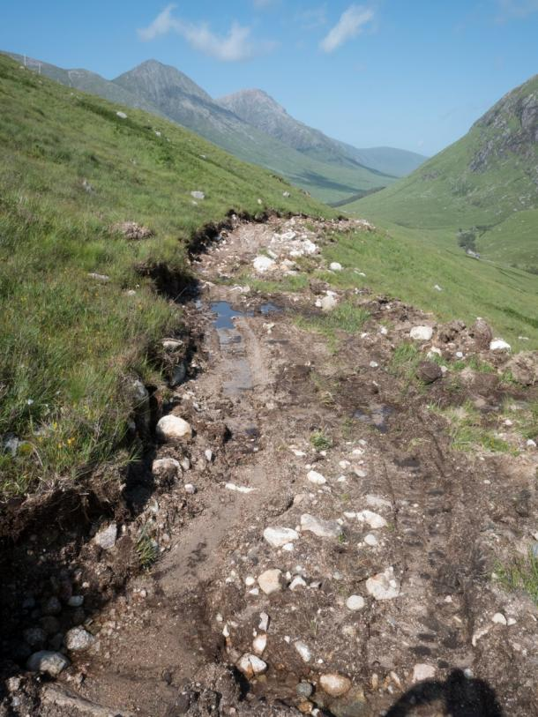

*Glen Etive, summer 2017 - the Campaign received reports of a possible new*

*and unlawful track west of the Allt a'Chaorainn. The Campaign was unable*

*to find any record of a planning application for this track (a full planning*

*application would have been needed owing to the site being within a National*

*Scenic Area).  The Campaign has asked Highland Council to investigate.*

1. Enforcement action may be taken if a developer proceeds without submitting details, or without, or in contravention of, a planning authority’s approval. This means that time is of the essence in investigating potential breaches of planning control. Planning authorities, therefore, need to respond quickly by undertaking site visits where concerns are raised. Works can then be stopped if necessary to allow the proper planning process to take place, minimising the risk and extent of adverse impact and the potentially challenging, costly and time-consuming implications for both landowners and planning authorities of reinstatement where enforcement action is taken. Site visits as a matter of urgency are also important, given that there is a timeframe within which enforcement action can be taken.
2. Feedback from planning officials and documentation, such as the Cairngorms National Park Authority’s Enforcement Register[34], suggest that there have been a number of cases of track construction or upgrade where Prior Notification was required but which had not been sought. Planning officials considered that in these cases land managers had not understood the complexities of what may qualify for Permitted Development Rights and/or the Prior Notification requirements.
3. Robust monitoring by planning authorities of tracks at the construction stage and when they are said to be complete is vital in order to check that they have been built according to the details provided at the Prior Notification stage and that any conditions set as part of the approval process have been met. Site visits are important in this respect and, although they are resource-intensive, they can also help inform future assessments of track proposals and the provision of guidance to applicants.

# 9. Conclusions

1. High levels of vehicle track construction, regardless of their purpose, are having major impacts on Scotland’s valued landscapes and environment and are a source of continued and growing public concern. Some of these tracks, including those for wind farms and hydro-electric schemes, are subject to a requirement for full planning permission where enforceable conditions can be set, yet those for agricultural and forestry purposes are generally exempt, in spite of the potential for equivalent adverse impacts. As such, there is no level playing field.
2. The introduction of a requirement for Prior Notification for agricultural and forestry tracks in 2014 introduced a measure of much-needed control where there was none before, with some positive outcomes. The Campaign recognises that many planning authorities have taken great efforts to take on board the new system and implement it as effectively as possible. However, this report has illustrated the problems anticipated by the Campaign with the Prior Notification system, as distinct from full planning permission, and demonstrates how this falls short of providing the oversight needed to properly protect Scotland’s landscapes. As a result, tracks of potentially questionable justification and with significant adverse impact are continuing to push further and further into Scotland’s wilder landscapes. In some cases, this is in conflict with current government policy, for instance with regard to peatland conservation and restoration and biodiversity targets.
3. As this report has shown, there are several aspects of the Prior Notification system, as distinct from the full planning system, that leave Scotland’s landscapes particularly vulnerable. These fall into the following broad areas:-
4. ***A confusing system***

* the Prior Notification system for agricultural and forestry tracks has introduced a further, distinct planning process that is considered complicated and confusing by various stakeholders, including applicants, planning authorities, campaigners and the wider public;
* several key aspects of the legislation appear to be interpreted differently across planning authorities, particularly around opportunities for public comment and the distinction between “maintenance” and “alteration” of tracks; there also appears to be a lack of clarity around the potential to refuse tracks under Permitted Development Rights;

1. ***Democratic deficit***

* the lack of a sufficiently robust definition of agricultural or forestry use under the legislation relating to Permitted Development Rights results in the potential for abuse of the system, particularly in relation to tracks claimed to be for agricultural use when their primary purpose is almost certainly sporting (in which case a full planning application should be submitted); this is a historic issue but has been brought to the fore with increasing government and public discussions about Scotland’s land as an asset that can deliver greater benefits to the wider public;
* the Prior Notification system gives very limited opportunity for public engagement compared to a requirement for full planning permission – key documents are not always displayed online, not all planning authorities permit public comment nor do they take these into account as they must with full planning applications. This is compounded by the requirement for planning authorities to process Prior Notifications as quickly as possible within a 28 day period, meaning that decisions can be taken before the public are even aware of a proposal;
* there is a disparity in the system, whereby a homeowner has to undertake a rigorous procedure to achieve an alteration to their home’s appearance, which contrasts markedly with the current situation in that a landowner can create an obvious and permanent scar in our finest landscapes without full public accountability.

1. ***Out of control: landscape and environmental damage continues***

* there is insufficient scope with Permitted Development Rights/under the Prior Notification system for planning authorities to adequately control or refuse agricultural and forestry tracks, particularly where they suspect tracks may not qualify for Permitted Development Rights; the limited scope for control can make it difficult to uphold important national and local policies and priorities in relation to, for example, peatland protection, biodiversity, etc;
* whilst vehicle track proposals for National Scenic Areas do not qualify for Permitted Development Rights and are subject to a requirement for full planning permission, other nationally-important landscapes and habitats, including National Parks, Scotland’s flagship Wild Land Areas, Sites of Special Scientific Interest and Natura sites, all of which have been recognised as important for aspects such as landscape, biodiversity, habitats and species, do not have the same protection;
* some applicants appear not to take the Prior Notification requirements seriously, submitting poor quality applications with minimal detail and paying no apparent heed to key documents such as the Scottish Natural Heritage guidance on best practice in upland track construction. This problem, along with the responses of some planning authorities to it, suggests that Prior Notifications are taken less seriously than full planning applications. This can lead to poorly-sited and designed tracks and poor construction techniques;
* the lack of a fee for Prior Notifications means that planning authorities cannot recover any of their costs in processing them in spite of the additional workload this generates; with tight local authority budgets, this may deter the close scrutiny to which these proposals should be subject;
* it is also an anomaly that “borrow” pits for the extraction of construction materials are not covered by the Prior Notification system in spite of their impacts;

1. It is in this context that, four years from the introduction of the Prior Notification system for agricultural and forestry tracks and the Scottish Government’s intention that this would give extra protection to the Scottish countryside, the Campaign considers that the issues it raised in “Track Changes” in 2013 are yet to be resolved. It is an anomaly that agriculture and forestry tracks are generally subject to less scrutiny than other track and built development applications, given that they can have similar or even greater impacts. As such, there remains a pressing need to tighten the legislation to protect against further loss of, and damage to, Scotland’s prized upland landscapes environment.
2. The exemption of agricultural tracks, in particular, from full planning consent remains a specific concern as there is the potential for landowners to exploit Permitted Development Rights and argue that tracks are for agricultural use when, in practice, they are primarily for sporting purposes, for which a full planning application is required.
3. As the government also set out in 2014, planning policy needs to find a balance that meets the needs of rural businesses but at the same time protects Scotland’s environment, amenity and heritage. Since 2014, these latter objectives have been given greater prominence with the growing recognition and understanding of the importance of wild land and landscapes to Scotland’s economy, particularly tourism.
4. More broadly, political and public opinion has also been changing and the importance of greater democracy in decision making relating to land use is now recognised, something denied to the public and other interested stakeholders under the current system of Prior Notification.

# 10. Recommendations

1. On the basis of the evidence presented in this report and the conclusions arising, the Campaign calls again for the Scottish Government to recognise the urgency of adequately controlling the construction and alteration of hilltracks (including those genuinely for agricultural and forestry) to prevent any further damage to Scotland’s landscapes. Any opportunities arising from the current and future reviews of the Scottish planning system and other policy relating to land use and its management or land rights and responsibilities should be used to address this pressing issue.
2. The Campaign specifically recommends that Permitted Development Rights for the construction or alteration of ‘agricultural tracks’ be removed, given the ongoing practice of landowners using Permitted Development Rights to construct tracks where the main purpose is sporting use.
3. The Campaign recognises a requirement for full planning permission would impact on bona fide Prior Notifications for agricultural use, including crofting, but has been unable to establish how the definition of Permitted Development Rights for agriculture could be amended to retain PDRs for genuine agricultural tracks, whilst closing the “qualifying use” loophole. It is also important that proposals for agricultural tracks are subject to close scrutiny and that they are built to a sensitive specification and high standard given the landscape and environmental impacts they can have, and the sensitive/fragile habitats which some cross, for example machair. As such, these tracks may benefit from a greater level of public oversight than is currently the case under the Prior Notification system.
4. With regard to forestry tracks, the Campaign’s monitoring, along with representations from members of the public in relation to particular forestry track cases and impacts, lead the Campaign to conclude that there is a need to consider their status within the planning system more carefully. The requirement for Prior Notification for forestry tracks has introduced greater accountability and a level of scrutiny which has helped to address the issues with some track proposals. Furthermore, the measure of additional regulation of forestry tracks, due to a requirement for forestry plans to be approved by planning authorities for many schemes, generally gives greater confidence that tracks are for legitimate forestry purposes, in comparison with agricultural tracks which have no separate regulation. As such, the Campaign considers that the status quo of Permitted Development Rights could continue to apply to forestry tracks in the immediate future.
5. Nonetheless, the potential for major landscape and other impacts from forestry tracks shows that some forestry track proposals would benefit from much closer scrutiny at the planning stage and from the perspective of the lack of opportunity for public comment. One option might be to retain the Prior Notification system for upgrades to existing tracks or new forestry tracks where there is a previously approved forest plan but for all other forestry tracks to go through the full planning system. It is not currently clear whether removing Permitted Development Rights from forestry tracks would substantially improve outcomes and some of the particular issues arising from forestry track construction. Further study and consideration is required in this respect, with the Scottish Government’s forthcoming review of its forestry strategy bringing a particular opportunity.
6. The Appendix sets out in detail the benefits the Campaign considers would be brought about by a requirement for tracks to be subject to full planning permission in comparison to Prior Notification. These issues are relevant to both agricultural and forestry tracks.

# 11. Appendix

***Benefits of full planning permission for agricultural and forestry tracks, compared to Prior Notification***

This Appendix considers the potential benefits of requiring a full planning application for agricultural and forestry tracks compared to Prior Notification. (It is recognised that full planning permission for agricultural and forestry tracks alone would not address all the problems identified in this report). As outlined in the preceding “Recommendations” section, the Campaign has called for agricultural tracks to be brought into the full planning applications system. However, the benefits outlined below of full planning permission are also relevant to forestry tracks.

1. Planning authorities would have increased powers to prevent the adverse impacts of tracks through refusal or applying enforceable conditions; this would be of particular benefit with respect to tracks that would have an adverse impact on sensitive upland landscapes, especially within National Parks and Wild Land Areas, as well as where local landscape designations apply; this would help to address public concern about the growing impact of built development in remote and sensitive areas.
2. It would be easier for planning authorities to deliver and meet policy objectives in relation to a range of national government and local priorities, including peatland protection, natural heritage considerations, environmental justice and the desirability of public engagement with the planning system.
3. Planning authorities would not have to operate a separate planning process for tracks and there would be a more consistent approach in how applications for tracks were handled across different planning authority areas, as well as greater clarity for planning officials, applicants and the public.
4. The current democratic deficit would be addressed as full documentation for track applications would, by default, always be available for the public to view on planning authority websites, along with an opportunity to comment and for those comments to be taken into account by planning authorities when making their decision. These increased opportunities for public engagement would better reflect the growing public interest in aspects relating to land rights and responsibilities and the Scottish Government’s undertakings to address these, as well as increase public engagement and trust in the planning system.
5. Applicants would be likely to give more accurate and precise statements about intended use as Permitted Development Rights would be irrelevant.
6. Planning authorities would have longer to consider track proposals, allowing for fuller scrutiny and consultation with statutory agencies, as well as increasing the opportunities for public engagement.
7. The standard of application, both in terms of the information provided and the design of the track, would hopefully improve as applicants address the requirements for full planning permission, which includes an application fee, more thoroughly by submitting appropriate and adequately detailed proposals.
8. Planning authorities would be able to recover some of the costs associated with processing proposals for tracks through being able to levy planning application fees.
9. The fact that tracks are subject to a planning application could lead to greater levels of enforcement action being taken, given that there is currently less incentive for planning authorities to use their scarce resources in investigating tracks that are constructed under Permitted Development Rights.

**

**Copyright ©Scottish Environment LINK, 2018**

Scottish Environment LINK is the forum for Scotland’s voluntary environment organisations, with over 35 member bodies representing a range of environmental interests with the common goal of contributing to a more environmentally sustainable society.

LINK is a Scottish charity (No SC000296) and a company limited by guarantee (No SC25089

1. [*www.scotlink.org/public-documents/track-changes-report*](http://www.scotlink.org/public-documents/track-changes-report/)
2. [*https://news.gov.scot/news/protecting-scenic-scotland*](https://news.gov.scot/news/protecting-scenic-scotland)
3. *The Town and Country Planning (General Permitted Development) (Scotland) Amendment (No. 2) Order 2014 (SSI 2014 No. 300)*
4. [*https://consult.gov.scot/environment-forestry/environment-strategy/user_uploads/224042_sct0618871430-001_developing-an-environment-strategy-for-scotland-v3.pdf*](https://consult.gov.scot/environment-forestry/environment-strategy/user_uploads/224042_sct0618871430-001_developing-an-environment-strategy-for-scotland-v3.pdf)

   *Developing an Environment Strategy for Scotland: Scottish Government Discussion Paper, June 2018, pages 4 and 5*
5. [*www.gov.scot/Publications/2007/03/29102736/0*](https://www.gov.scot/Publications/2007/03/29102736/0)
6. [www.gov.scot/Publications/2012/03/8498](https://www.gov.scot/Publications/2012/03/8498)
7. [*www.scotlink.org/public-documents/track-changes-report*](http://www.scotlink.org/public-documents/track-changes-report/)
8. [*https://news.gov.scot/news/protecting-scenic-scotland*](https://news.gov.scot/news/protecting-scenic-scotland)
9. *The Town and Country Planning (General Permitted Development) (Scotland) Amendment (No. 2) Order 2014 (SSI 2014 No. 300)*
10. [*https://beta.gov.scot/publications/agricultural-forestry-private-ways-research-project*](https://beta.gov.scot/publications/agricultural-forestry-private-ways-research-project/)
11. [*www.scotlink.org/workareas/hill-tracks*](http://www.scotlink.org/workareas/hill-tracks)
12. [*www.legislation.gov.uk/ssi/2014/300/introduction/made*](http://www.legislation.gov.uk/ssi/2014/300/introduction/made)
13. [*www.gov.scot/Resource/0053/00533680.pdf*](http://www.gov.scot/Resource/0053/00533680.pdf)
14. [*http://www.gov.scot/Resource/0053/00533680.pdf*](http://www.gov.scot/Resource/0053/00533680.pdf)
15. [*www.scotlink.org/public-documents/link-consultation-response-to-guidance-for-agricultural-and-forestry-private-ways-and-buildings*](http://www.scotlink.org/public-documents/link-consultation-response-to-guidance-for-agricultural-and-forestry-private-ways-and-buildings/)
16. [*www.scotlink.org/public-documents/link-comment-to-scottish-government-on-guidance-relating-to-hill-tracks*](http://www.scotlink.org/public-documents/link-comment-to-scottish-government-on-guidance-relating-to-hill-tracks/)
17. [*www.nature.scot/constructed-tracks-scottish-uplands*](http://www.nature.scot/constructed-tracks-scottish-uplands)
18. [*www.nature.scot/key-natural-heritage-considerations-track-construction-quick-guide-march-2017*](https://www.nature.scot/key-natural-heritage-considerations-track-construction-quick-guide-march-2017)
19. [*www.highland.gov.uk/downloads/file/12339/interim_guidance_on_agricultural_and_forestry_private_ways*](http://www.highland.gov.uk/downloads/file/12339/interim_guidance_on_agricultural_and_forestry_private_ways)
20. [*http://cairngorms.co.uk/wp-content/uploads/2015/07/150402PANForestryandAgriculturalTracks.pdf*](http://cairngorms.co.uk/wp-content/uploads/2015/07/150402PANForestryandAgriculturalTracks.pdf)
21. [*http://scotland.forestry.gov.uk/images/corporate/pdf/briefing-note-3.pdf*](http://scotland.forestry.gov.uk/images/corporate/pdf/briefing-note-3.pdf)
22. [*http://www.gov.scot/Topics/Built-Environment/planning/Roles/Scottish-Government/Guidance/reviewofprior*](http://www.gov.scot/Topics/Built-Environment/planning/Roles/Scottish-Government/Guidance/reviewofprior)
23. [*www.scotlink.org/public-documents/hilltracks-letter-to-roseanna-cunningham-independently-led- expert-group-on-the-environmental-impact-of-grouse-moor-management*](http://www.scotlink.org/public-documents/hilltracks-letter-to-roseanna-cunningham-independently-led-expert-group-on-the-environmental-impact-of-grouse-moor-management/)
24. [*www.gov.scot/Resource/0053/00533680.pdf*](http://www.gov.scot/Resource/0053/00533680.pdf)
25. [*http://www.struttandparker.com/properties/achnasheen*](http://www.struttandparker.com/properties/achnasheen)
26. [*www.gov.scot/Topics/Built-Environment/planning/Roles/Scottish-Government/Guidance/reviewofprior*](http://www.gov.scot/Topics/Built-Environment/planning/Roles/Scottish-Government/Guidance/reviewofprior)
27. [*http://cairngorms.co.uk/resource/docs/boardpapers/29012016/160129Item6PriorNotificationReviewV1.0.pdf*](http://cairngorms.co.uk/resource/docs/boardpapers/29012016/160129Item6PriorNotificationReviewV1.0.pdf)
28. [*www.gov.scot/Resource/0053/00533680.pdf*](https://www.gov.scot/Resource/0053/00533680.pdf)
29. *The Conservation (Natural Habitats &c.) Regulations 1994*
30. [*http://cairngorms.co.uk/wp-content/uploads/2017/07/170707CNPPP17-22FINAL_SinglePage.pdf*](http://cairngorms.co.uk/wp-content/uploads/2017/07/170707CNPPP17-22FINAL_SinglePage.pdf)
31. [*http://cairngorms.co.uk/wp-content/uploads/2015/07/150402PANForestryandAgriculturalTracks.pdf*](http://cairngorms.co.uk/wp-content/uploads/2015/07/150402PANForestryandAgriculturalTracks.pdf)
32. [*www.gov.scot/Resource/0049/00492867.pdf*](http://www.gov.scot/Resource/0049/00492867.pdf)
33. [*www.scotlink.org/wp/files/documents/LINKHilltrackCOnsultationResponse_2015.pdf*](http://www.scotlink.org/wp/files/documents/LINKHilltrackCOnsultationResponse_2015.pdf)
34. [*http://cairngorms.co.uk/wp-content/uploads/2018/03/180322EnforcementRegister-4.pdf*](http://cairngorms.co.uk/wp-content/uploads/2018/03/180322EnforcementRegister-4.pdf)